NATIONAL DIVISIONS DIABETES PROGRAM

DIVISIONS DIABETES & CARDIOVASCULAR QUALITY
IMPROVEMENT PROJECT

COHORT ANALYSIS

DRAFT REPORT

Centre for General Practice Integration Studies
School of Public Health & Community Medicine
University of New South Wales
UNSW 2052

Table of Contents

1. Frequency counts 1
2. Age breakdown across the cohort 3
3. Comparison by age & gender 7
4. Comparison by diabetes type 7
5. Duration of diabetes 1
6. Duration of diabetes (categories) by gender as of 2000 2
7. Statistical tests for HbA1c levels compared for 2000 & 2002 3
8. Statistical tests for HbA1c levels for 2000-2002 10
9. Error bars comparing HbA1c results by diabetes type and year 14
10. Error bars comparing HbA1c results by age groups 14
11. Comparison of error bars for HbA1c levels by duration of diabetes categories 16
12. Statistical tests for (<130/85mmHg) blood pressure 17
13. Statistical tests for systolic blood pressure 19
14. Statistical test for diastolic blood pressure 20
15. Comparison of BP by age group 21
16. Comparison of BP by duration of diabetes 22
17. Statistical tests for total cholesterol levels compared for 2000 & 2002 23
18. Comparison of error bars for total cholesterol levels by diabetes type. 24
19. Comparison of error bars for cholesterol levels by age groups 24
20. Error bars comparing total cholesterol levels by diabetes duration. 25
21. Statistical tests for BMI compared over the period 2000-2002 26
22. Statistical tests for BMI categories (2000-2002) 27
23. Comparison of error bars for BMI levels by diabetes type 28
24. Comparison of error bars for BMI by age groups 28
25. Error bars comparing BMI levels by diabetes duration 29
26. Statistical tests for diabetic retinopathy (2000-2002) 29
27. Statistical tests for high risk foot (2000-2002) 30
28. Statistical tests for HDL levels compared for 2000 & 2002 30
29. Statistical tests for HDL levels compared for 2000 & 2002 31
30. Statistical tests for LDL levels for 2000-2002 32
31. Comparison of patients in LDL (<3.0mmol/L) by year and gender 33
32. Statistical tests for Triglyceride levels (2000-2002) 34
33. Comparison of patients in Triglycerides (<2.0mmol/L) by year 35
34. Statistical tests for microalbuminuria levels 36
35. Microalbuminuria targets compared by age 37
36. Quality of care (2002- 6 items) effect on HbA1c categories in 2002 38
37. Quality of care 2002 (6 items) effect on BP 39
38. Quality of care (6 items) in 2002 - effect on total cholesterol 40
39. Pathology lab tests in 2002 (HbA1c, Total cholesterol, uAlbumin) effect on total cholesterol levels in 2002 42
41. Pathology lab tests (HbA1c, Total cholesterol, uAlbumin) in 2002 - effect on BP. 43
42. Pathology tests (HbA1c, Total cholesterol, uAlbumin,) in 2002 effect on HbA1c. 44
43. HIC tests in 2002 (HbA1c, Total cholesterol, uAlbumin, eys) effect on BP 45
44. HIC tests in 2002 (HbA1c, Total cholesterol, uAlbumin, eys) effect on total cholesterol 46
45. Quality of care 2002 (all items) effect on HbA1c 47
46. Quality of care 2002 (all items) effect on BP 48
47. Quality of care 2002 (all items) effect on total cholesterol 49
48. Multiple regression model for HbA1c 50
49. Multiple regression model for Total cholesterol 51
50. Multiple regression model for BP systolic 52
51. Multiple regression model for BP diastolic 53

Orig_SiteIDS
 |  | Frequency | Percent | Valid Percent | Cumulative Percent
Valid | 42 | 233 | 7.8 | 7.8 | 7.8
Valid | 54 | 551 | 18.4 | 18.4 | 26.1
Valid | 201 | 340 | 11.3 | 11.3 | 37.4
Valid | 248 | 278 | 9.3 | 9.3 | 46.7
Valid | 263 | 20 | .7 | .7 | 47.4
Valid | 351 | 35 | 1.2 | 1.2 | 48.5
Valid | 358 | 430 | 14.3 | 14.3 | 62.9
Valid | 407 | 84 | 2.8 | 2.8 | 65.7
Valid | 409 | 197 | 6.6 | 6.6 | 72.2
Valid | 427 | 79 | 2.6 | 2.6 | 74.9
Valid | 469 | 116 | 3.9 | 3.9 | 78.7
Valid | 564 | 69 | 2.3 | 2.3 | 81.0
Valid | 703 | 124 | 4.1 | 4.1 | 85.1
Valid | 704 | 35 | 1.2 | 1.2 | 86.3
Valid | 862 | 95 | 3.2 | 3.2 | 89.5
Valid | 985 | 316 | 10.5 | 10.5 | 100.0
Valid | Total | 3002 | 100.0 | 100.0

I couldn’t match the estimated diabetes prevalence (over the page) with the Divisions Profile dataset or the DDCQIP Profiles report. How are these figures calculated? Or are they documented in another report?

1. Frequency counts  - The number of patients in the cohort is 3002. The cohort is made up of 16 Divisions each with a functioning register system over the period 2000-2002.  - Patients analysed in the cohort had to have seen a GP at least once in each of the three years 2000, 2001 and 2002.  - Six Divisions were excluded from the analysis. Of these six Divisions three (291, 709, 965) did not have a functioning register across each of the three years and three (612, 654, 761) Divisions had a register that had deteriorated in the course of the 3 years.  - The number of cases in the cohort was compared with estimated diabetes prevalence and percentage provided for each Division.  - The mean across the 16 Divisions was 3.48% and the median was 2.15%. | No of cases by Division
  Division ID | N of cases in cohort study | % in cohort study | Estimated diabetes prevalence | Cohort number % of estimated prevalence
  42 | 233 | 7.8 | 2657 | 8.77
  54 | 551 | 18.4 | 8057 | 6.84
  201 | 340 | 11.3 | 9853 | 3.45
  248 | 278 | 9.3 | 3889 | 7.15
  263 | 20 | .7 | 4930 | 0.41
  351 | 35 | 1.2 | 10978 | 0.32
  358 | 430 | 14.3 | 9360 | 4.59
  407 | 84 | 2.8 | 5747 | 1.46
  409 | 197 | 6.6 | 9162 | 2.15
  427 | 79 | 2.6 | 10164 | 0.78
  469 | 116 | 3.9 | 13697 | 0.85
  564 | 69 | 2.3 | 11788 | 0.59
  703 | 124 | 4.1 | 1466 | 8.46
  704 | 35 | 1.2 | 6585 | 0.53
  862 | 95 | 3.2 | 14389 | 0.66
  985 | 316 | 10.5 | 3634 | 8.70
  Total | 3002 | 100.0
   |  |  | Median | 2.15
   |  |  | Mean | 3.48

N2R_Age groups
N | Valid | 2956
 | Missing | 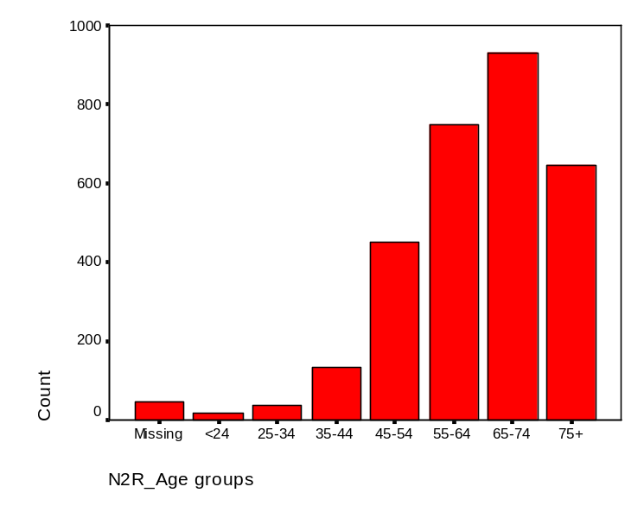46

N2R_Age groups
 |  | Frequency | Percent | Valid Percent | Cumulative Percent
Valid | <24 | 16 | .5 | .5 | .5
Valid | 25-34 | 36 | 1.2 | 1.2 | 1.8
Valid | 35-44 | 131 | 4.4 | 4.4 | 6.2
Valid | 45-54 | 449 | 15.0 | 15.2 | 21.4
Valid | 55-64 | 747 | 24.9 | 25.3 | 46.7
Valid | 65-74 | 931 | 31.0 | 31.5 | 78.1
Valid | 75+ | 646 | 21.5 | 21.9 | 100.0
Valid | Total | 2956 | 98.5 | 100.0
Missing | System | 46 | 1.5
Total |  | 3002 | 100.0

2. Age breakdown across the cohort  The percentages in the cohort study by age group were compared with AusDiab estimates of the 2001Australian population. The cohort study had proportionately more patients in the 55-64 and 65-74 age groups and less in the 35-44, 45-54 and 75+ age groups. | 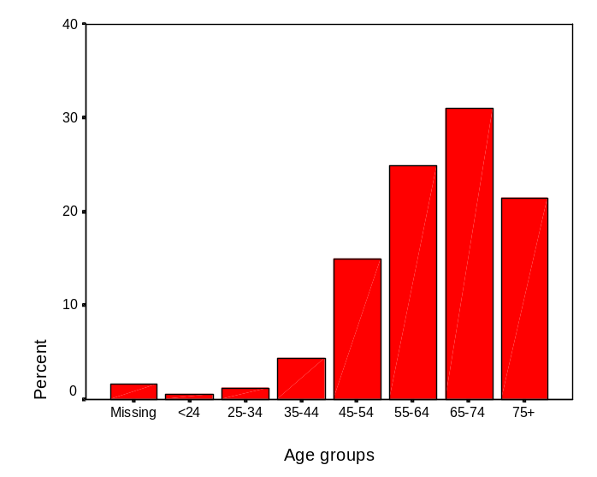
   |  | Frequency | Percent | Ausdiab
  Valid | <24 | 16 | .5
   | 25-34 | 36 | 1.2 | 0.85
   | 35-44 | 131 | 4.4 | 7.43
   | 45-54 | 449 | 15.0 | 16.5
   | 55-64 | 747 | 24.9 | 23.88
   | 65-74 | 931 | 31.0 | 24.67
   | 75+ | 646 | 21.5 | 26.67
   | Total | 2956 | 98.5
  Missing | System | 46 | 1.5
  Total |  | 3002 | 100.0 | 100.0
 | 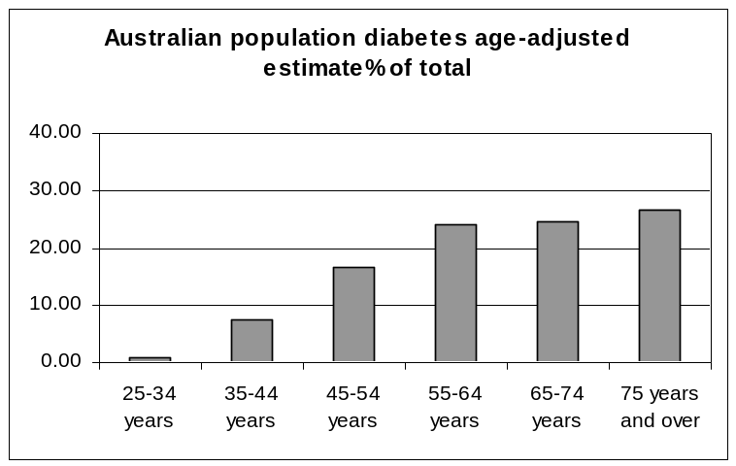
  Age adjusted prevalence of diabetes (25 years and over) in Australia using AusDiab figures.
   | Male | Female | Total | Prevalence estimate | % of total
  0-4 years | 638084 | 605862 | 1243946
  5-14 years | 1369867 | 1298634 | 2668501
  15-24 years | 1305878 | 1260457 | 2566335
  25-34 years | 1341163 | 1382367 | 2723530 | 8171 | 0.85
  35-44 years | 1408604 | 1459651 | 2868255 | 71706 | 7.43
  45-54 years | 1275786 | 1292429 | 2568215 | 159229 | 16.5
  55-64 years | 884498 | 875095 | 1759593 | 230507 | 23.88
  65-74 years | 615382 | 664680 | 1280062 | 238092 | 24.67
  75 years and over | 427216 | 663490 | 1090706 | 257407 | 26.67
   | 9266478 | 9502665 | 18769143 | 965111
Comparisons with BEACH data based on GP encounters and reported in Senes S, Britt H, A general practice view of cardiovascular disease and diabetes in Australia June 2001. AIHW cat. No. CVD 17 (Cardiovascular Disease Series No. 18). Canberra: AIHW. The BEACH study reported 209 cases of diabetes Type 1 and 2264 cases of Type 2. BEACH figures by age group were compared with the data from the cohort study according to BEACH age brackets as presented below: | 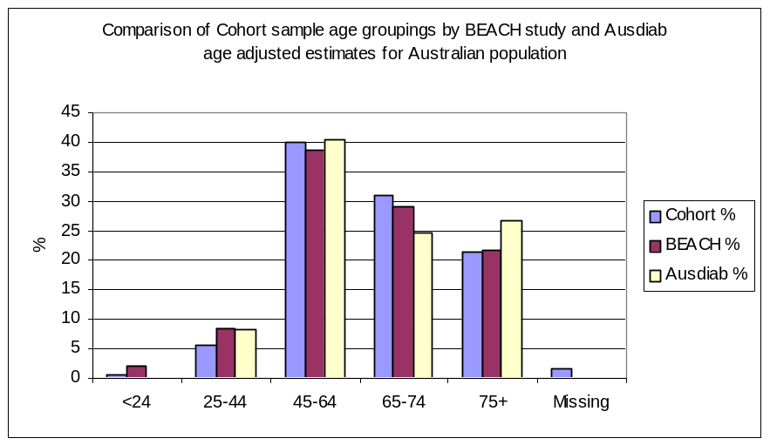
   | Cohort study (n=3002) | BEACH (n=2471) | AusDiab
  <24 | 0.5 | 2.1
  25.-4 | 5.6 | 8.6 | 8.3
  45-65 | 39.9 | 38.7 | 40.4
  65-74 | 31.0 | 29.1 | 24.7
  75+ | 21.5 | 21.6 | 26.7
  Missing data | 1.5

Case Processing Summary
 | N2R_Gender | Cases
 | N2R_Gender | Valid |  | Missing |  | Total
 | N2R_Gender | N | Percent | N | Percent | N | Percent
N2R_Age | Female | 1520 | 98.6% | 21 | 1.4% | 1541 | 100.0%
N2R_Age | Male | 1430 | 98.3% | 25 | 1.7% | 1455 | 100.0%

Descriptives
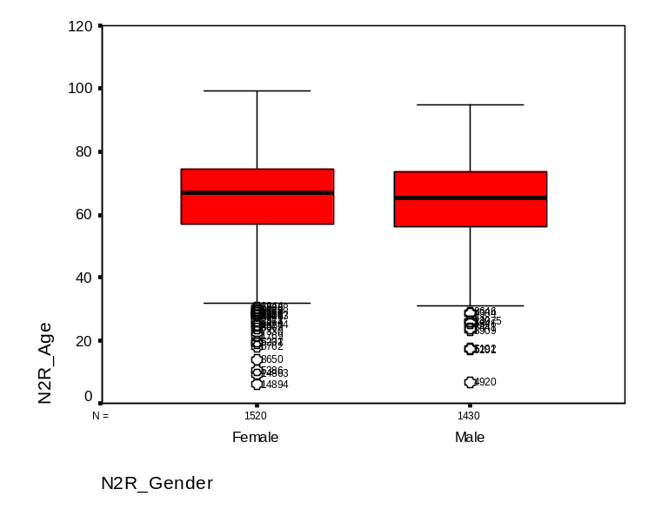
 | N2R_Gender |  |  | Statistic | Std. Error
N2R_Age | Female | Mean |  | 65.17 | .332
N2R_Age | Female | 95% Confidence Interval for Mean | Lower Bound | 64.51
N2R_Age | Female | 95% Confidence Interval for Mean | Upper Bound | 65.82
N2R_Age | Female | 5% Trimmed Mean |  | 65.72
N2R_Age | Female | Median |  | 66.78
N2R_Age | Female | Variance |  | 167.637
N2R_Age | Female | Std. Deviation |  | 12.947
N2R_Age | Female | Minimum |  | 6
N2R_Age | Female | Maximum |  | 99
N2R_Age | Female | Range |  | 93
N2R_Age | Female | Interquartile Range |  | 17.39
N2R_Age | Female | Skewness |  | -.707 | .063
N2R_Age | Female | Kurtosis |  | .920 | .125
N2R_Age | Male | Mean |  | 64.36 | .318
N2R_Age | Male | 95% Confidence Interval for Mean | Lower Bound | 63.73
N2R_Age | Male | 95% Confidence Interval for Mean | Upper Bound | 64.98
N2R_Age | Male | 5% Trimmed Mean |  | 64.71
N2R_Age | Male | Median |  | 65.28
N2R_Age | Male | Variance |  | 144.327
N2R_Age | Male | Std. Deviation |  | 12.014
N2R_Age | Male | Minimum |  | 7
N2R_Age | Male | Maximum |  | 95
N2R_Age | Male | Range |  | 88
N2R_Age | Male | Interquartile Range |  | 17.54
N2R_Age | Male | Skewness |  | -.479 | .065
N2R_Age | Male | Kurtosis |  | .323 | .129

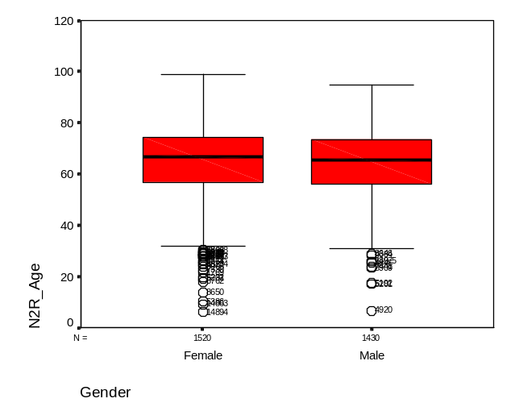 | 3. Comparison by age & gender  - 51.3% (1541) were female  - 48.5% (1455) were male  - 0.2% (6) gender not specified  - Female mean age 65.17 (CI: 64.51-65.82)  - Male mean age 64.36 (CI: 63.73-64.98)  BEACH reported 47.5% females and 52.5% males in their GP encounter sample of Type 1 and Type 2 diabetes patients.

Statistics
Type of diabetes 2002
N | Valid | 2973
 | Missing | 29

 |  | Frequency | Percent | Valid Percent | Cumulative Percent
Valid | Type 1 | 237 | 7.9 | 8.0 | 8.0
Valid | Type 2 | 2731 | 91.0 | 91.9 | 99.8
Valid | GDM | 3 | .1 | .1 | 99.9
Valid | Other | 1 | .0 | .0 | 100.0
Valid | Don't Know | 1 | .0 | .0 | 100.0
Valid | Total | 2973 | 99.0 | 100.0
Missing | System | 29 | 1.0
Total |  | 3002 | 100.0
Case Processing Summary
 | Cases
 | Valid |  | Missing |  | Total
 | N | Percent | N | Percent | N | Percent
Type of diabetes 2002 * N2R_Gender | 2963 | 99.8% | 5 | .2% | 2968 | 100.0%

Type of diabetes 2002 * N2R_Gender Crosstabulation
 |  |  | N2R_Gender |  | Total
 |  |  | Female | Male | Total
Type of diabetes 2002 | Type 1 | Count | 130 | 107 | 237
Type of diabetes 2002 | Type 1 | % within N2R_Gender | 8.5% | 7.5% | 8.0%
Type of diabetes 2002 | Type 2 | Count | 1398 | 1328 | 2726
Type of diabetes 2002 | Type 2 | % within N2R_Gender | 91.5% | 92.5% | 92.0%
Total |  | Count | 1528 | 1435 | 2963
 |  | % within N2R_Gender | 100.0% | 100.0% | 100.0%

Chi-Square Tests
 | Value | df | Asymp. Sig. (2-sided) | Exact Sig. (2-sided) | Exact Sig. (1-sided)
Pearson Chi-Square | 1.112(b) | 1 | .292
Continuity Correction(a) | .973 | 1 | .324
Likelihood Ratio | 1.114 | 1 | .291
Fisher's Exact Test |  |  |  | .310 | .162
Linear-by-Linear Association | 1.111 | 1 | .292
N of Valid Cases | 2963
a Computed only for a 2x2 table → corrects for the use of a continuous approximation to an underlying discrete (count) distribution: same result of insignificance.
b 0 cells (.0%) have expected count less than 5. The minimum expected count is 114.78.
4. Comparison by diabetes type  - There were 2731 Type 2 patients and 237 Type 1 patients. There was a small number of other (GDM and don’t know) cases) and 29 missing cases.  - The table below shows that there were not any significant differences between diabetes type and gender. Chi square = 1.112; df=1 p=.292  Type of diabetes 2002 by gender | Diabetes type
   |  |  |  |  | Total
   |  |  | Female | Male
  Type of diabetes 2002 | Type 1 | Count | 130 | 107 | 237
   |  | % within N2R_Gender | 8.5% | 7.5% | 8.0%
   | Type 2 | Count | 1398 | 1328 | 2726
   |  | % within N2R_Gender | 91.5% | 92.5% | 92.0%
  Total |  | Count | 1528 | 1435 | 2963
   |  | % within N2R_Gender | 100.0% | 100.0% | 100.0%
   |  | Frequency | Percent | Valid Percent | Cumulative Percent
  Valid | Type 1 | 237 | 7.9 | 8.0 | 8.0
   | Type 2 | 2731 | 91.0 | 91.9 | 99.8
   | GDM | 3 | .1 | .1 | 99.9
   | Other | 1 | .0 | .0 | 100.0
   | Don't Know | 1 | .0 | .0 | 100.0
   | Total | 2973 | 99.0 | 100.0
  Missing | System | 29 | 1.0
  Total |  | 3002 | 100.0

N2R_DurDiab

Case Processing Summary
 | Cases
 | Valid |  | Missing |  | Total
 | N | Percent | N | Percent | N | Percent
N2R_DurDiab | 2711 | 90.3% | 291 | 9.7% | 3002 | 100.0%

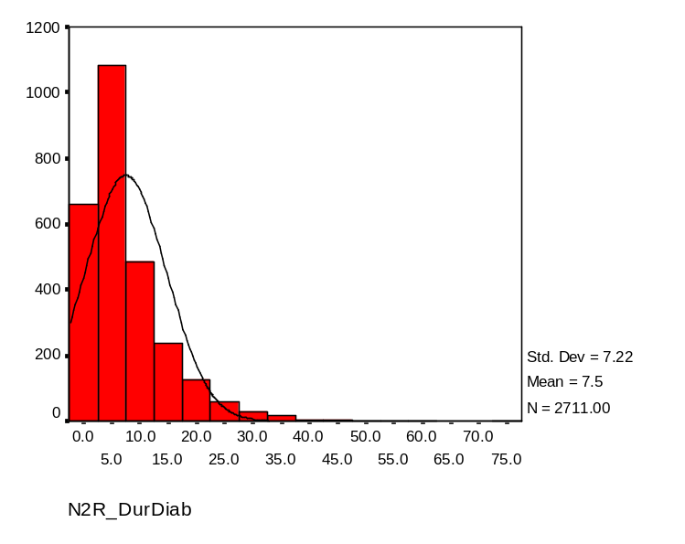
Descriptives
 |  |  | Statistic | Std. Error
N2R_DurDiab | Mean |  | 7.49 | .139
N2R_DurDiab | 95% Confidence Interval for Mean | Lower Bound | 7.22
N2R_DurDiab | 95% Confidence Interval for Mean | Upper Bound | 7.76
N2R_DurDiab | 5% Trimmed Mean |  | 6.67
N2R_DurDiab | Median |  | 5.00
N2R_DurDiab | Variance |  | 52.184
N2R_DurDiab | Std. Deviation |  | 7.224
N2R_DurDiab | Minimum |  | 0
N2R_DurDiab | Maximum |  | 74
N2R_DurDiab | Range |  | 74
N2R_DurDiab | Interquartile Range |  | 7
N2R_DurDiab | Skewness |  | 2.296 | .047
N2R_DurDiab | Kurtosis |  | 8.764 | .094

N2R_Gender

Case Processing Summary
 | N2R_Gender | Cases
 | N2R_Gender | Valid |  | Missing |  | Total
 | N2R_Gender | N | Percent | N | Percent | N | Percent
N2R_DurDiab | Female | 1406 | 91.2% | 135 | 8.8% | 1541 | 100.0%
N2R_DurDiab | Male | 1299 | 89.3% | 156 | 10.7% | 1455 | 100.0%

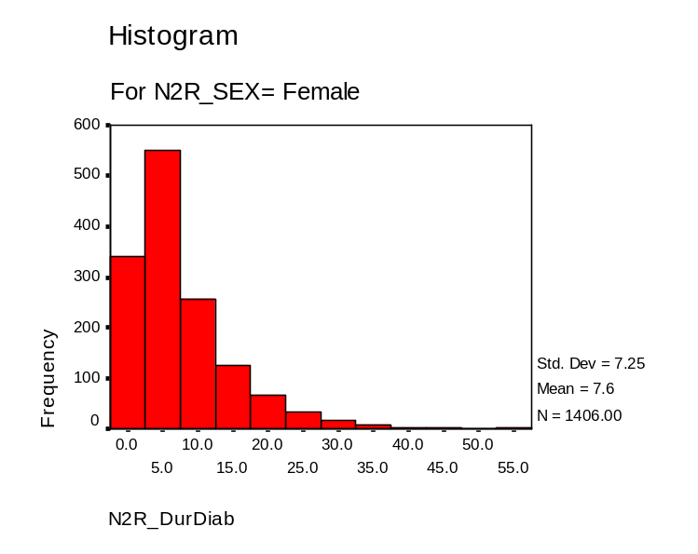
Descriptives
 | N2R_Gender |  |  | Statistic | Std. Error
N2R_DurDiab | Female | Mean |  | 7.61 | .193
N2R_DurDiab | Female | 95% Confidence Interval for Mean | Lower Bound | 7.23
N2R_DurDiab | Female | 95% Confidence Interval for Mean | Upper Bound | 7.99
N2R_DurDiab | Female | 5% Trimmed Mean |  | 6.80
N2R_DurDiab | Female | Median |  | 5.00
N2R_DurDiab | Female | Variance |  | 52.620
N2R_DurDiab | Female | Std. Deviation |  | 7.254
N2R_DurDiab | Female | Minimum |  | 0
N2R_DurDiab | Female | Maximum |  | 53
N2R_DurDiab | Female | Range |  | 53
N2R_DurDiab | Female | Interquartile Range |  | 7.00
N2R_DurDiab | Female | Skewness |  | 2.009 | .065
N2R_DurDiab | Female | Kurtosis |  | 5.692 | 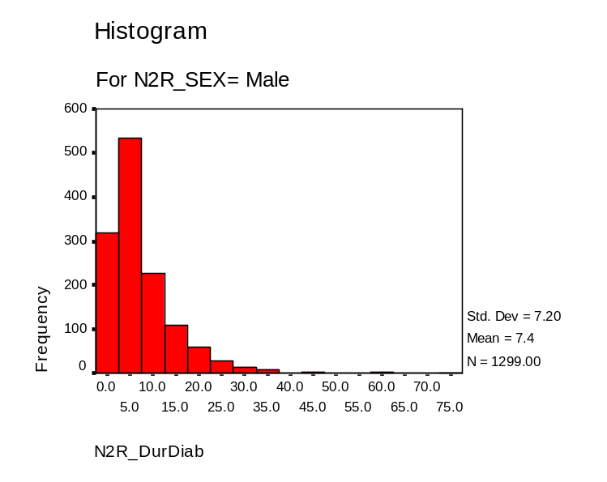  .130
N2R_DurDiab | Male | Mean |  | 7.35 | .200
N2R_DurDiab | Male | 95% Confidence Interval for Mean | Lower Bound | 6.96
N2R_DurDiab | Male | 95% Confidence Interval for Mean | Upper Bound | 7.74
N2R_DurDiab | Male | 5% Trimmed Mean |  | 6.51
N2R_DurDiab | Male | Median |  | 5.00
N2R_DurDiab | Male | Variance |  | 51.797
N2R_DurDiab | Male | Std. Deviation |  | 7.197
N2R_DurDiab | Male | Minimum |  | 0
N2R_DurDiab | Male | Maximum |  | 74
N2R_DurDiab | Male | Range |  | 74
N2R_DurDiab | Male | Interquartile Range |  | 7.00
N2R_DurDiab | Male | Skewness |  | 2.623 | .068
N2R_DurDiab | Male | Kurtosis |  | 12.311 | .136
Tests of Normality
 | N2R_Gender | Kolmogorov-Smirnov(a) |  |  | Shapiro-Wilk
 | N2R_Gender | Statistic | df | Sig. | Statistic | df | Sig.
N2R_DurDiab | Female | .168 | 1406 | .000 | .810 | 1406 | .000
N2R_DurDiab | Male | .174 | 1299 | .000 | .772 | 1299 | .000
a Lilliefors Significance Correction

While variances are approximately equal (can use pooled two-sample t-test), the underlying distributions of each group (sex) violate the normality assumption (shape of histograms suggest right-skewness). This is verified by the qq plots below (substantial deviation from a straight line) and formally by the Shapiro-Wilk test for both males and females (significant p-value rejects null hypothesis of a normal distribution). Questions about validity of t-test comparisons of means must be raised. Must check for robustness of test procedure – do the two distributions have similar shape? (yes) and are sample sizes for each group equal? (yes, given n₁ and n₂ quite large) → robust enough to suggest that sample means will be at least approximately normal. Possibly some outliers can be removed too?
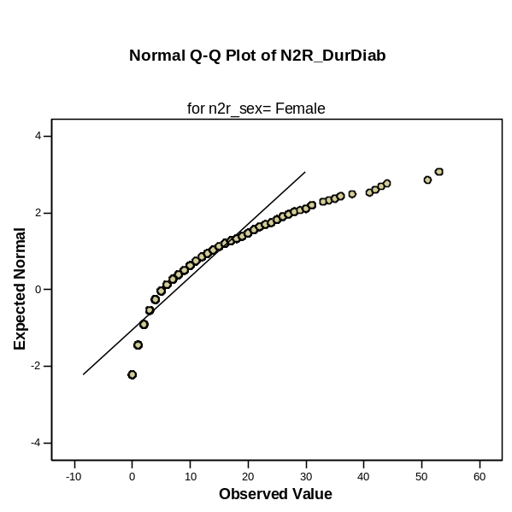
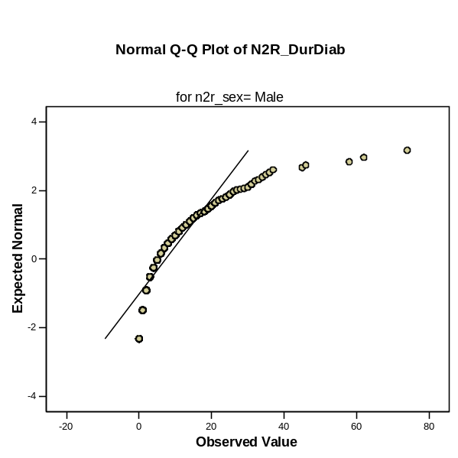

T-Test

Group Statistics
 | N2R_Gender | N | Mean | Std. Deviation | Std. Error Mean
N2R_DurDiab | Female | 1406 | 7.61 | 7.254 | .193
N2R_DurDiab | Male | 1299 | 7.35 | 7.197 | .200

Independent Samples Test
 |  | Levene's Test for Equality of Variances |  | t-test for Equality of Means
 |  | F | Sig. | t | df | Sig. (2-tailed) | Mean Difference | Std. Error Difference | 95% Confidence Interval of the Difference
 |  |  |  |  |  |  |  |  | Lower | Upper
N2R_DurDiab | Equal variances assumed | 1.891 | .169 | .942 | 2703 | .346 | .262 | .278 | -.283 | .807
N2R_DurDiab | Equal variances not assumed |  |  | .942 | 2689.320 | .346 | .262 | .278 | -.283 | .807

There is an insignificant difference between males and females in terms of duration.

Type of diabetes 2002

Case Processing Summary
 | Type of diabetes 2002 | Cases
 | Type of diabetes 2002 | Valid |  | Missing |  | Total
 | Type of diabetes 2002 | N | Percent | N | Percent | N | Percent
N2R_DurDiab | Type 1 | 204 | 86.1% | 33 | 13.9% | 237 | 100.0%
N2R_DurDiab | Type 2 | 2496 | 91.4% | 235 | 8.6% | 2731 | 100.0%

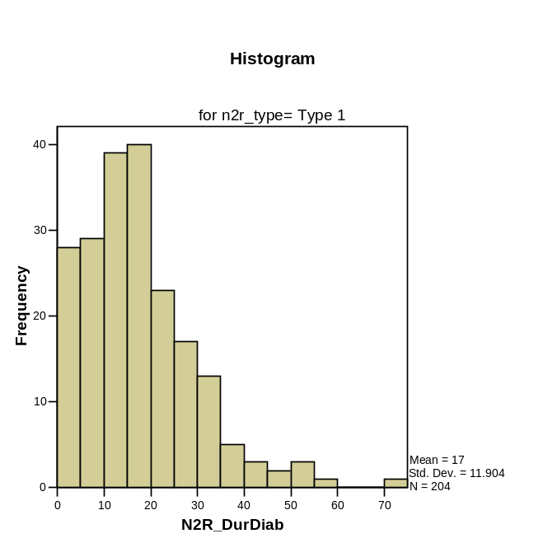
Descriptives
 | Type of diabetes 2002 |  |  | Statistic | Std. Error
N2R_DurDiab | Type 1 | Mean |  | 17.00 | .833
N2R_DurDiab | Type 1 | 95% Confidence Interval for Mean | Lower Bound | 15.35
N2R_DurDiab | Type 1 | 95% Confidence Interval for Mean | Upper Bound | 18.64
N2R_DurDiab | Type 1 | 5% Trimmed Mean |  | 16.00
N2R_DurDiab | Type 1 | Median |  | 15.00
N2R_DurDiab | Type 1 | Variance |  | 141.709
N2R_DurDiab | Type 1 | Std. Deviation |  | 11.904
N2R_DurDiab | Type 1 | Minimum |  | 0
N2R_DurDiab | Type 1 | Maximum |  | 74
N2R_DurDiab | Type 1 | Range |  | 74
N2R_DurDiab | Type 1 | Interquartile Range |  | 14.00
N2R_DurDiab | Type 1 | Skewness |  | 1.354 | 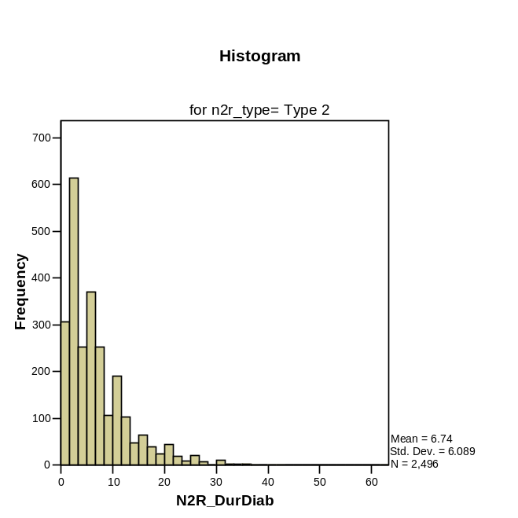  .170
N2R_DurDiab | Type 1 | Kurtosis |  | 2.978 | .339
N2R_DurDiab | Type 2 | Mean |  | 6.74 | .122
N2R_DurDiab | Type 2 | 95% Confidence Interval for Mean | Lower Bound | 6.50
N2R_DurDiab | Type 2 | 95% Confidence Interval for Mean | Upper Bound | 6.98
N2R_DurDiab | Type 2 | 5% Trimmed Mean |  | 6.07
N2R_DurDiab | Type 2 | Median |  | 5.00
N2R_DurDiab | Type 2 | Variance |  | 37.072
N2R_DurDiab | Type 2 | Std. Deviation |  | 6.089
N2R_DurDiab | Type 2 | Minimum |  | 0
N2R_DurDiab | Type 2 | Maximum |  | 62
N2R_DurDiab | Type 2 | Range |  | 62
N2R_DurDiab | Type 2 | Interquartile Range |  | 7.00
N2R_DurDiab | Type 2 | Skewness |  | 1.959 | .049
N2R_DurDiab | Type 2 | Kurtosis |  | 6.093 | .098

Tests of Normality
 | Type of diabetes 2002 | Kolmogorov-Smirnov(a) |  |  | Shapiro-Wilk
 | Type of diabetes 2002 | Statistic | df | Sig. | Statistic | df | Sig.
N2R_DurDiab | Type 1 | .108 | 204 | .000 | .910 | 204 | .000
N2R_DurDiab | Type 2 | .167 | 2496 | .000 | .823 | 2496 | .000
a Lilliefors Significance Correction

Clearly unequal variances so can’t use pooled t-test here. Again normality assumption violated. And since sample sizes are very different, nonparametric methods preferred.
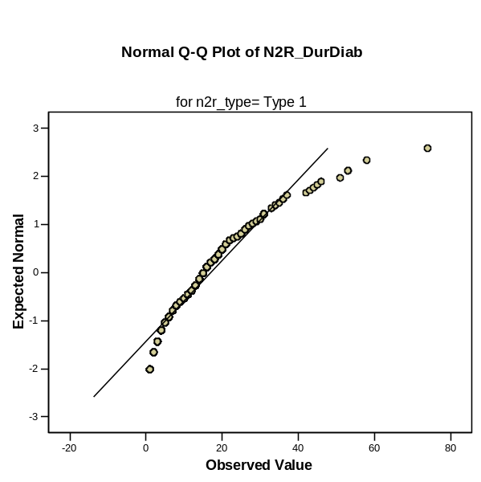
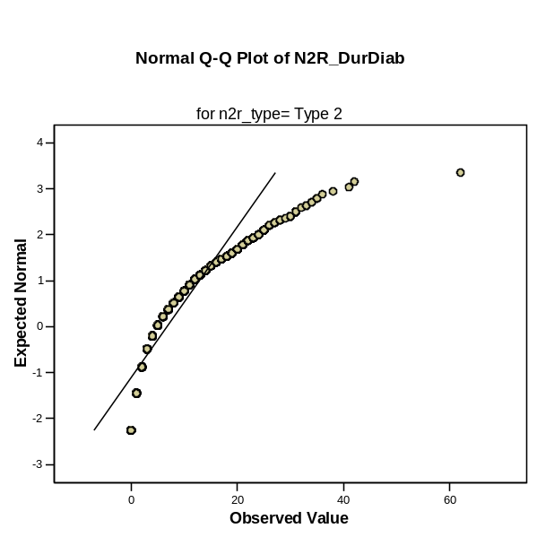

Mann-Whitney Test

Ranks Test Statistics(a)
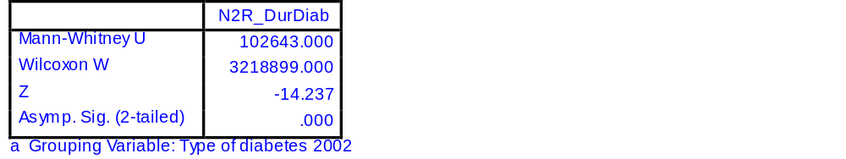
 | Type of diabetes 2002 | N | Mean Rank | Sum of Ranks
N2R_DurDiab | Type 1 | 204 | 2095.35 | 427451.00
N2R_DurDiab | Type 2 | 2496 | 1289.62 | 3218899.00
N2R_DurDiab | Total | 2700

Difference between diabetes types is significant. The parametric t-test is consistent with this finding.

T-Test

Group Statistics
 | Type of diabetes 2002 | N | Mean | Std. Deviation | Std. Error Mean
N2R_DurDiab | Type 1 | 204 | 17.00 | 11.904 | .833
N2R_DurDiab | Type 2 | 2496 | 6.74 | 6.089 | .122

Independent Samples Test
 |  | Levene's Test for Equality of Variances |  | t-test for Equality of Means
 |  | F | Sig. | t | df | Sig. (2-tailed) | Mean Difference | Std. Error Difference | 95% Confidence Interval of the Difference
 |  |  |  |  |  |  |  |  | Lower | Upper
N2R_DurDiab | Equal variances assumed | 179.253 | .000 | 21.014 | 2698 | .000 | 10.259 | .488 | 9.301 | 11.216
N2R_DurDiab | Equal variances not assumed |  |  | 12.179 | 211.766 | .000 | 10.259 | .842 | 8.598 | 11.919

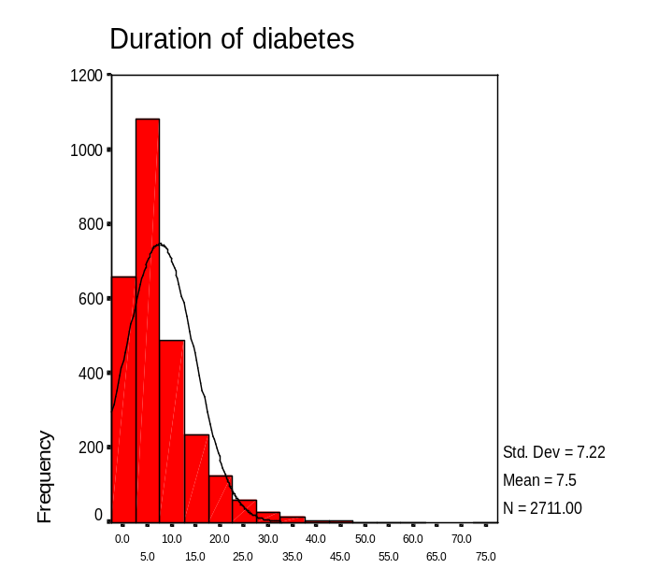 | 5. Duration of diabetes  There was no significant difference in diabetes duration based on gender → formal tests above  Whole sample (n=2711) M =7.49; Md 5.00; 95%CI: 7.22 – 7.76  Females M = 7.61 Md = 5.00; 95%CI: 7.23 – 7.99  Males M = 7.35 Md = 5.00; 95%CI: 6.96 – 7.74  Type 1 M = 17.0 Md= 15.0; 95%CI: 15.35 – 18.64  Type 2 M = 6.74 Md = 5.0; 95%CI: 6.50 – 6.98

6. Duration of diabetes (categories) by gender as of 2000  The duration of diabetes was recoded according to ANDIAB duration categories (0, 1-5, 6-10, 11-15, 16+). There was a fairly even gender spread across each of the categories.  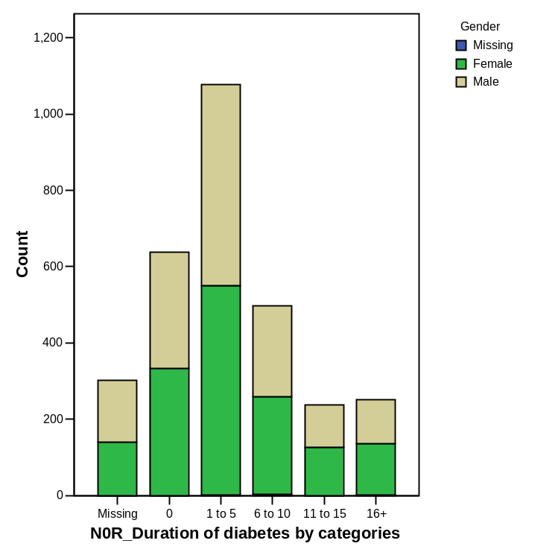 | 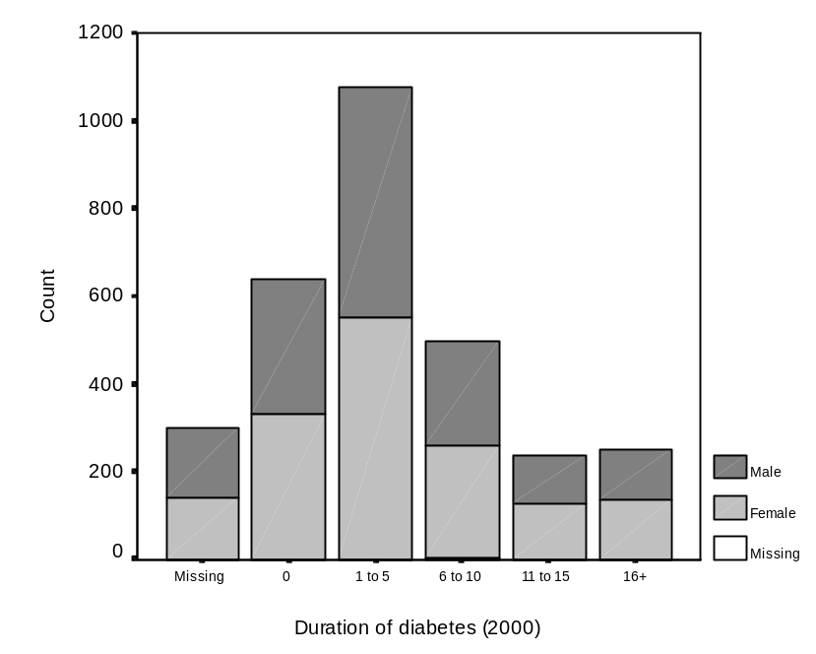

T-Test

Paired Samples Statistics

 |  | Mean | N | Std. Deviation | Std. Error Mean
Pair 1 | N2R_HbA1c | 7.31 | 1928 | 1.29 | .03
Pair 1 | N0R_HbA1c | 7.50 | 1928 | 1.55 | .04

Paired Samples Correlations

 |  | N | Correlation | Sig.
Pair 1 | N2R_HbA1c & N0R_HbA1c | 1928 | .559 | .000

Paired Samples Test

 |  | Paired Differences |  |  |  |  | t | df | Sig. (2-tailed)
 |  | Mean | Std. Deviation | Std. Error Mean | 95% Confidence Interval of the Difference |  | t | df | Sig. (2-tailed)
 |  |  |  |  | Lower | Upper | t | df | Sig. (2-tailed)
Pair 1 | N2R_HbA1c - N0R_HbA1c | -.19 | 1.35 | .03 | -.25 | -.13 | -6.049 | 1927 | .000

Assumption check: are the paired differences normally distributed? Create new variable hbA1c_diff and Explore.
Assumption violated. Removal of three distinct outliers (-11.3, -11.1 and 8.0) still did not alleviate problem.
But since we have large sample size, we find results of parametric t-tests are consistent with nonparametric methods
Nonparametric tests assume the distribution of paired differences is symmetric (which in this case, is!).
Case Processing Summary

 | Cases
 | Valid |  | Missing |  | Total
 | N | Percent | N | Percent | N | Percent
hbA1c_diff | 1928 | 64.2% | 1074 | 35.8% | 3002 | 100.0%

Descriptives

 |  |  | Statistic | Std. Error
hbA1c_diff | Mean |  | -.1860 | .03075
hbA1c_diff | 95% Confidence Interval for Mean | Lower Bound | -.2463
hbA1c_diff | 95% Confidence Interval for Mean | Upper Bound | -.1257
hbA1c_diff | 5% Trimmed Mean |  | -.1263
hbA1c_diff | Median |  | -.1000
hbA1c_diff | Variance |  | 1.823
hbA1c_diff | Std. Deviation |  | 1.35019
hbA1c_diff | Minimum |  | -11.30
hbA1c_diff | Maximum |  | 8.00
hbA1c_diff | Range |  | 19.30
hbA1c_diff | Interquartile Range |  | 1.20
hbA1c_diff | Skewness |  | -1.308 | .056
hbA1c_diff | Kurtosis |  | 8.188 | .111

Tests of Normality

 | Kolmogorov-Smirnov(a) |  |  | Shapiro-Wilk
 | Statistic | df | Sig. | Statistic | df | Sig.
hbA1c_diff | .120 | 1928 | .000 | .896 | 1928 | .000
a Lilliefors Significance Correction
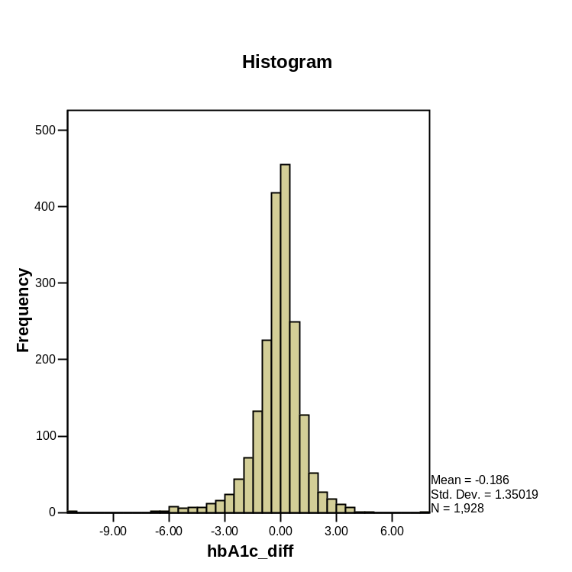
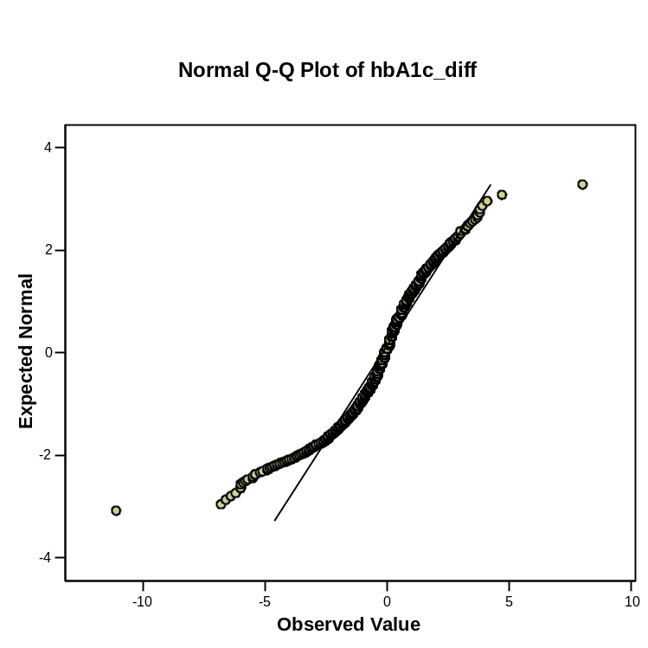

7. Statistical tests for HbA1c levels compared for 2000 & 2002  A paired samples t-test was conducted to evaluate the impact of the change in HbA1c levels across the years 2000-2002. There was a statistically significant decrease in HbA1c levels from 2000 (M=7.50 SD=1.29) to 2002 (M=7.31 SD=1.55) t = -6.05; df=1927; p<0.0005  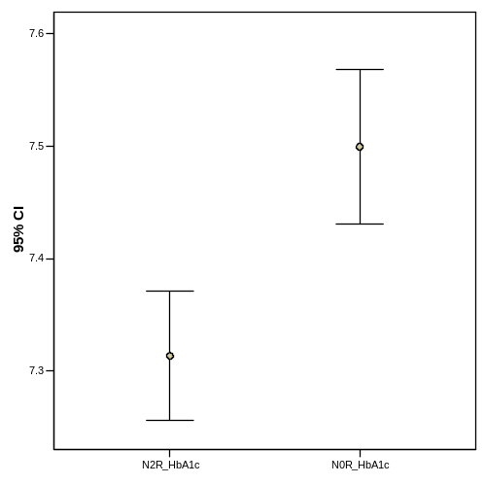 | 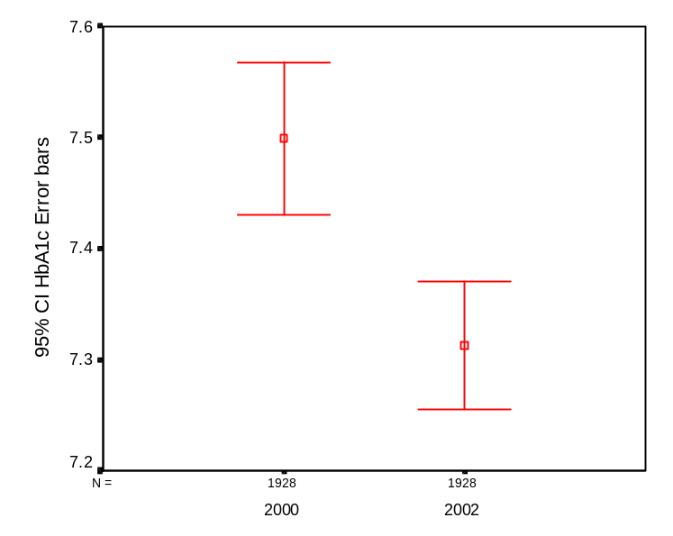

Frequencies
Statistics

 |  | N2R_HbA1c levels in binominal grouping | N1R_HbA1c levels in binominal groupings | N0R_HbA1c levels in binominal groupings
N | Valid | 2273 | 2411 | 2278
N | Missing | 729 | 591 | 724

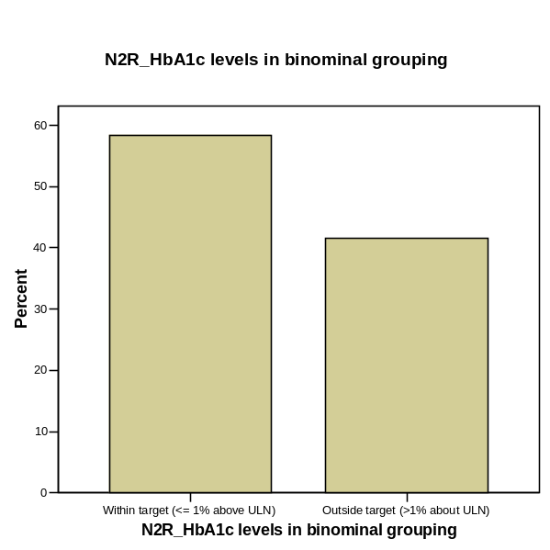

Frequency Table

N2R_HbA1c levels in binominal grouping

 |  | Frequency | Percent | Valid Percent | Cumulative Percent
Valid | Within target (<= 1% above ULN) | 1328 | 44.2 | 58.4 | 58.4
Valid | Outside target (>1% about ULN) | 945 | 31.5 | 41.6 | 100.0
Valid | Total | 2273 | 75.7 | 100.0
Missing | System | 729 | 24.3
Total |  | 3002 | 100.0

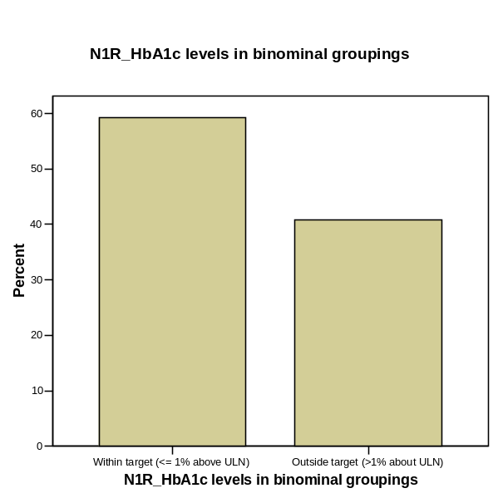
N1R_HbA1c levels in binominal groupings

 |  | Frequency | Percent | Valid Percent | Cumulative Percent
Valid | Within target (<= 1% above ULN) | 1427 | 47.5 | 59.2 | 59.2
Valid | Outside target (>1% about ULN) | 984 | 32.8 | 40.8 | 100.0
Valid | Total | 2411 | 80.3 | 100.0
Missing | System | 591 | 19.7
Total |  | 3002 | 100.0

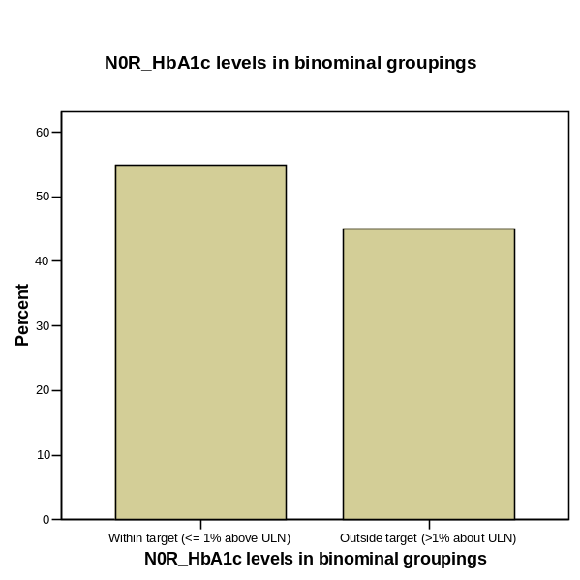
N0R_HbA1c levels in binominal groupings

 |  | Frequency | Percent | Valid Percent | Cumulative Percent
Valid | Within target (<= 1% above ULN) | 1251 | 41.7 | 54.9 | 54.9
Valid | Outside target (>1% about ULN) | 1027 | 34.2 | 45.1 | 100.0
Valid | Total | 2278 | 75.9 | 100.0
Missing | System | 724 | 24.1
Total |  | 3002 | 100.0

→ calculate upper and lower confidence intervals using: sqrt((p(1-p))/n) as s.d.

→ should use McNemar test here as we are dealing with two related dichotomous (binary) variables.

McNemar Test

N2R_HbA1c levels in binominal grouping & N0R_HbA1c levels in binominal groupings

N2R_HbA1c levels in binominal grouping | N0R_HbA1c levels in binominal groupings
N2R_HbA1c levels in binominal grouping | 0 | 1
0 | 852 | 266
1 | 190 | 620

Test Statistics(b)

a Continuity Corrected
 | N2R_HbA1c levels in binominal grouping & N0R_HbA1c levels in binominal groupings
N | 1928
Chi-Square(a) | 12.336
Asymp. Sig. | .000
b McNemar Test

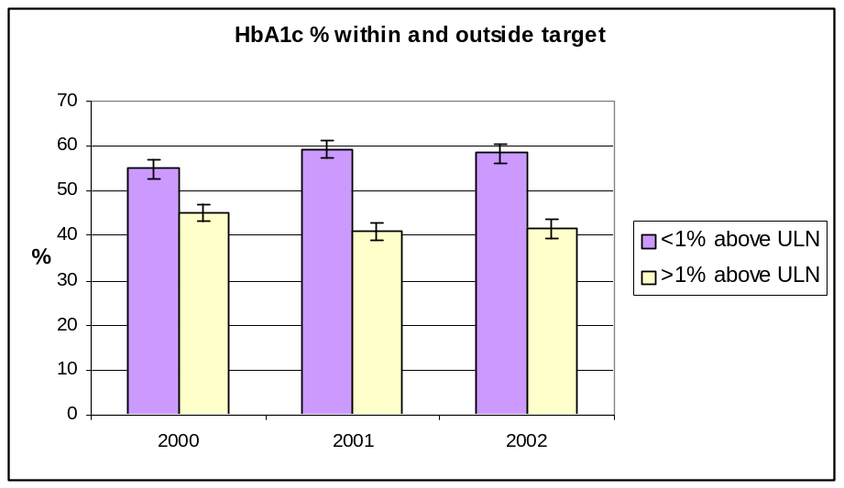 | 8. Statistical tests for HbA1c levels for 2000-2002  The nonparametric Wilcoxon Signed Rank Test was carried out to test the significance of change over the years 2000 and 2002 in the HbA1c categories within target (<=1% above ULN), outside target (>1% above ULN). This test showed a significant difference in the results for 2000 and 2002 (Z= -3.559; p<.0005) → see McNemar  Confidence intervals were also calculated and displayed in accompanying figure. The confidence intervals show that the changes over time in the number within target is significant.
   | 2000  n=2278 | 2001  n=2411 | 2002  n=2273
  Within target | 54.9%  n=1251 | 59.2%  n=1427 | 58.4%  n=1328
  Upper CI | 56.94% | 61.16% | 60.43%
  Lower CI | 52.86% | 57.24% | 56.37%
  Outside target | 45.1%  n=1027 | 40.8%  n=984 | 41.6%  n=945
  Upper CI | 45.68% | 41.35% | 42.18%
  Lower CI | 44.52% | 40.25% | 41.02%

Descriptives
 | Type of diabetes 2002 |  |  | Statistic | Std. Error
N2R_HbA1c | Type 1 | Mean |  | 8.01 | .112
N2R_HbA1c | Type 1 | 95% Confidence Interval for Mean | Lower Bound | 7.79
N2R_HbA1c | Type 1 | 95% Confidence Interval for Mean | Upper Bound | 8.23
N2R_HbA1c | Type 1 | 5% Trimmed Mean |  | 7.98
N2R_HbA1c | Type 1 | Median |  | 7.90
N2R_HbA1c | Type 1 | Variance |  | 1.789
N2R_HbA1c | Type 1 | Std. Deviation |  | 1.338
N2R_HbA1c | Type 1 | Minimum |  | 5.00
N2R_HbA1c | Type 1 | Maximum |  | 13.60
N2R_HbA1c | Type 1 | Range |  | 8.60
N2R_HbA1c | Type 1 | Interquartile Range |  | 1.70
N2R_HbA1c | Type 1 | Skewness |  | .558 | .203
N2R_HbA1c | Type 1 | Kurtosis |  | 1.270 | .403
N2R_HbA1c | Type 2 | Mean |  | 7.26 | .031
N2R_HbA1c | Type 2 | 95% Confidence Interval for Mean | Lower Bound | 7.20
N2R_HbA1c | Type 2 | 95% Confidence Interval for Mean | Upper Bound | 7.33
N2R_HbA1c | Type 2 | 5% Trimmed Mean |  | 7.19
N2R_HbA1c | Type 2 | Median |  | 7.10
N2R_HbA1c | Type 2 | Variance |  | 1.581
N2R_HbA1c | Type 2 | Std. Deviation |  | 1.257
N2R_HbA1c | Type 2 | Minimum |  | 4.00
N2R_HbA1c | Type 2 | Maximum |  | 17.50
N2R_HbA1c | Type 2 | Range |  | 13.50
N2R_HbA1c | Type 2 | Interquartile Range |  | 1.40
N2R_HbA1c | Type 2 | Skewness |  | 1.154 | .061
N2R_HbA1c | Type 2 | Kurtosis |  | 3.360 | .122
N1R_HbA1c | Type 1 | Mean |  | 8.21 | .133
N1R_HbA1c | Type 1 | 95% Confidence Interval for Mean | Lower Bound | 7.95
N1R_HbA1c | Type 1 | 95% Confidence Interval for Mean | Upper Bound | 8.48
N1R_HbA1c | Type 1 | 5% Trimmed Mean |  | 8.09
N1R_HbA1c | Type 1 | Median |  | 8.10
N1R_HbA1c | Type 1 | Variance |  | 2.543
N1R_HbA1c | Type 1 | Std. Deviation |  | 1.595
N1R_HbA1c | Type 1 | Minimum |  | 5.30
N1R_HbA1c | Type 1 | Maximum |  | 16.40
N1R_HbA1c | Type 1 | Range |  | 11.10
N1R_HbA1c | Type 1 | Interquartile Range |  | 1.80
N1R_HbA1c | Type 1 | Skewness |  | 1.688 | .203
N1R_HbA1c | Type 1 | Kurtosis |  | 5.818 | .403
N1R_HbA1c | Type 2 | Mean |  | 7.24 | .034
N1R_HbA1c | Type 2 | 95% Confidence Interval for Mean | Lower Bound | 7.17
N1R_HbA1c | Type 2 | 95% Confidence Interval for Mean | Upper Bound | 7.31
N1R_HbA1c | Type 2 | 5% Trimmed Mean |  | 7.15
N1R_HbA1c | Type 2 | Median |  | 7.00
N1R_HbA1c | Type 2 | Variance |  | 1.813
N1R_HbA1c | Type 2 | Std. Deviation |  | 1.346
N1R_HbA1c | Type 2 | Minimum |  | 3.10
N1R_HbA1c | Type 2 | Maximum |  | 18.60
N1R_HbA1c | Type 2 | Range |  | 15.50
N1R_HbA1c | Type 2 | Interquartile Range |  | 1.60
N1R_HbA1c | Type 2 | Skewness |  | 1.391 | .061
N1R_HbA1c | Type 2 | Kurtosis |  | 4.929 | .122
N0R_HbA1c | Type 1 | Mean |  | 8.40 | .137
N0R_HbA1c | Type 1 | 95% Confidence Interval for Mean | Lower Bound | 8.13
N0R_HbA1c | Type 1 | 95% Confidence Interval for Mean | Upper Bound | 8.67
N0R_HbA1c | Type 1 | 5% Trimmed Mean |  | 8.29
N0R_HbA1c | Type 1 | Median |  | 8.20
N0R_HbA1c | Type 1 | Variance |  | 2.666
N0R_HbA1c | Type 1 | Std. Deviation |  | 1.633
N0R_HbA1c | Type 1 | Minimum |  | 5.20
N0R_HbA1c | Type 1 | Maximum |  | 15.10
N0R_HbA1c | Type 1 | Range |  | 9.90
N0R_HbA1c | Type 1 | Interquartile Range |  | 2.00
N0R_HbA1c | Type 1 | Skewness |  | 1.212 | .203
N0R_HbA1c | Type 1 | Kurtosis |  | 2.559 | .403
N0R_HbA1c | Type 2 | Mean |  | 7.42 | .038
N0R_HbA1c | Type 2 | 95% Confidence Interval for Mean | Lower Bound | 7.35
N0R_HbA1c | Type 2 | 95% Confidence Interval for Mean | Upper Bound | 7.50
N0R_HbA1c | Type 2 | 5% Trimmed Mean |  | 7.31
N0R_HbA1c | Type 2 | Median |  | 7.10
N0R_HbA1c | Type 2 | Variance |  | 2.269
N0R_HbA1c | Type 2 | Std. Deviation |  | 1.506
N0R_HbA1c | Type 2 | Minimum |  | 3.60
N0R_HbA1c | Type 2 | Maximum |  | 21.90
N0R_HbA1c | Type 2 | Range |  | 18.30
N0R_HbA1c | Type 2 | Interquartile Range |  | 1.60
N0R_HbA1c | Type 2 | Skewness |  | 1.920 | .061
N0R_HbA1c | Type 2 | Kurtosis |  | 8.846 | .122

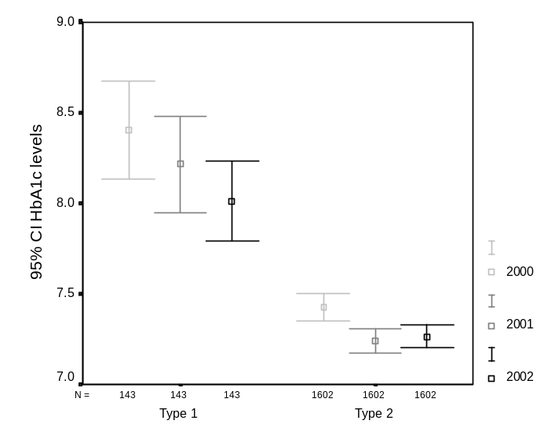 | 9. Error bars comparing HbA1c results by diabetes type and year  Significant results appear stronger for Type 2 patients.  Some discrepancies here.
   | 2000 | 2001 | 2002
  Type 1 mean | 8.34 | 8.16 | 8.04
  CI uppe | 8.58 | 8.39 | 8.24
  CI lower | 8.09 | 7.93 | 7.84
  Type 2 mean | 7.42 | 7.24 | 7.24
  CI upper | 7.49 | 7.31 | 7.29
  CI lower | 7.30 | 7.19 | 7.18
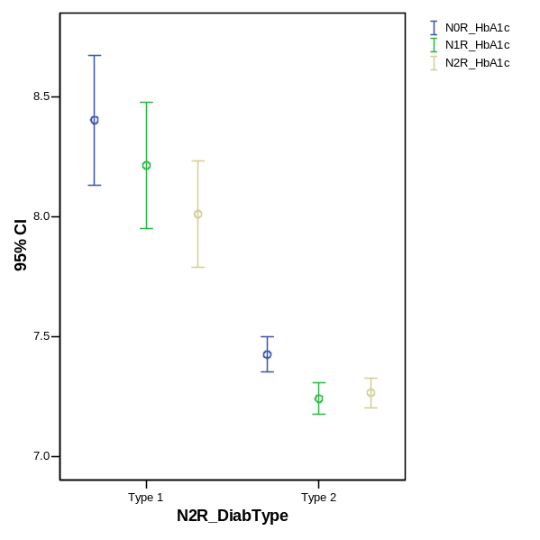

10. Error bars comparing HbA1c results by age groups  The trend is evident across all age groups but strongest and significant in >45 groups.  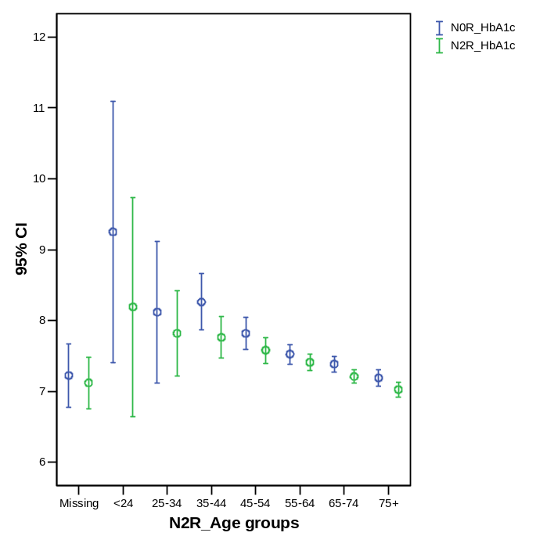 | 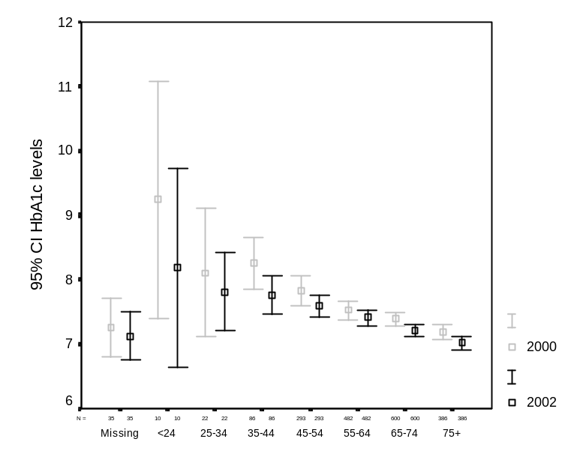
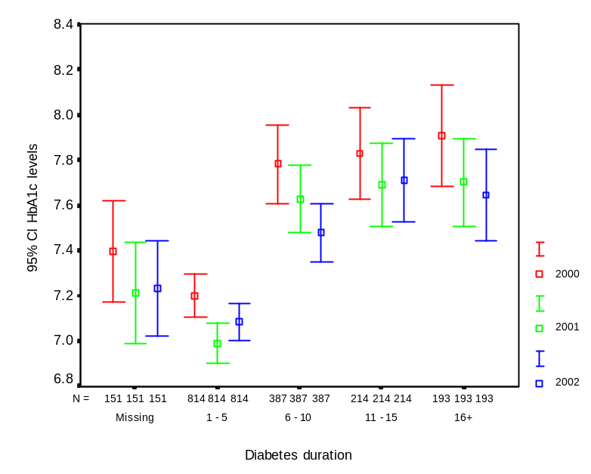 | 11. Comparison of error bars for HbA1c levels by duration of diabetes categories  Each category (0, 1-5, 6-10, 1a-15, 16+) ) shows significant improvement in HbA1c levels across 2000 to 2002. These were strongest in the 1-5 bracket and 6-10 bracket.  NB: In 2002 there were 16 cases were duration of diabetes was recorded as 0. This is an obvious error as all 16 had been in the database since 2000. In the absence of any ability to confirm these data, they were treated as missing data.  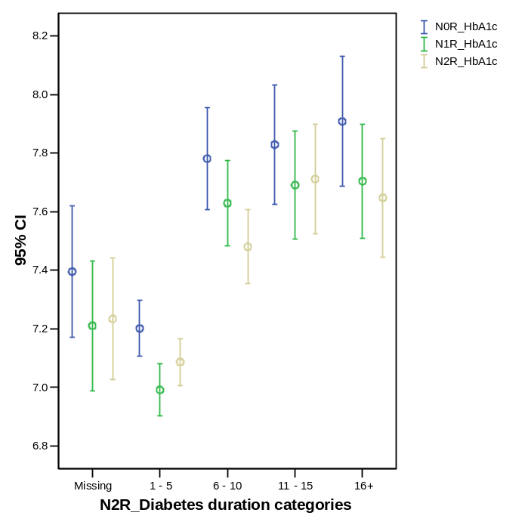

McNemar Test

N2R_Blood pressure categories & N0R_Blood pressure groups

N2R_Blood pressure categories | N0R_Blood pressure groups
N2R_Blood pressure categories | 0 | 1
0 | 223 | 311
1 | 276 | 1306

Test Statistics(b)

 | N2R_Blood pressure categories & N0R_Blood pressure groups
N | 2116
Chi-Square(a) | 1.969
Asymp. Sig. | .161
a Continuity Corrected
b McNemar Test

N0R_Blood pressure groups * Gender Crosstabulation
Count
 |  | Gender |  | Total
 |  | Female | Male | Total
N0R_Blood pressure groups | < 130/85 | 287 | 311 | 598
N0R_Blood pressure groups | >=130/85 | 1016 | 919 | 1935
N0R_Blood pressure groups | No test | 236 | 226 | 462
Total |  | 1539 | 1456 | 2995

N1R_Blood pressure categories * Gender Crosstabulation
Count
 |  | Gender |  | Total
 |  | Female | Male | Total
N1R_Blood pressure categories | <130/85 | 323 | 332 | 655
N1R_Blood pressure categories | >130.85 | 1009 | 900 | 1909
N1R_Blood pressure categories | No test | 208 | 223 | 431
Total |  | 1540 | 1455 | 2995

N2R_Blood pressure categories * N2R_Gender Crosstabulation
Count
 |  | N2R_Gender |  | Total
 |  | Female | Male | Total
N2R_Blood pressure categories | <130/85 | 315 | 320 | 635
N2R_Blood pressure categories | >130/85 | 938 | 872 | 1810
N2R_Blood pressure categories | No test | 288 | 263 | 551
Total |  | 1541 | 1455 | 2996

12. Statistical tests for (<130/85mmHg) blood pressure  The non-parametric McNemar Test was used to check the significance of changes 2000 and 2002 in the blood pressure categories within target <130/85 mmHg), outside target (>130/85mmHg). This test showed a non-significant difference in the results for 2000 and 2002 (n=2116; χ²=1.969; p=0.161). | 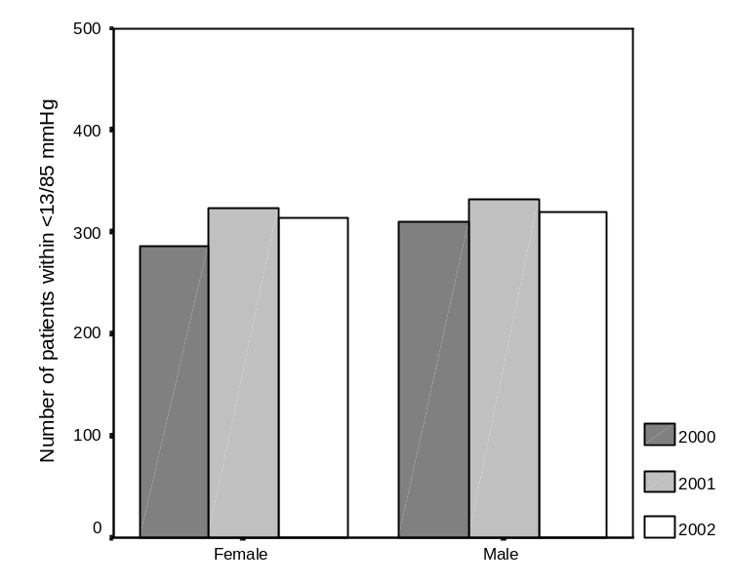
T-Test

Paired Samples Statistics

 |  | Mean | N | Std. Deviation | Std. Error Mean
Pair 1 | N2R_SystolBP | 136.16 | 2116 | 16.497 | .359
Pair 1 | N0R_SystolBP | 137.98 | 2116 | 17.366 | .378
Pair 2 | N1R_SystolBP | 137.15 | 2238 | 17.424 | .368
Pair 2 | N0R_SystolBP | 138.10 | 2238 | 17.372 | .367
Pair 3 | N2R_SystolBP | 135.87 | 2135 | 16.314 | .353
Pair 3 | N1R_SystolBP | 136.74 | 2135 | 17.486 | .378

Paired Samples Correlations

 |  | N | Correlation | Sig.
Pair 1 | N2R_SystolBP & N0R_SystolBP | 2116 | .391 | .000
Pair 2 | N1R_SystolBP & N0R_SystolBP | 2238 | .490 | .000
Pair 3 | N2R_SystolBP & N1R_SystolBP | 2135 | .497 | .000

Paired Samples Test

 |  | Paired Differences |  |  |  |  | t | df | Sig. (2-tailed)
 |  | Mean | Std. Deviation | Std. Error Mean | 95% Confidence Interval of the Difference |  | t | df | Sig. (2-tailed)
 |  |  |  |  | Lower | Upper | t | df | Sig. (2-tailed)
Pair 1 | N2R_SystolBP - N0R_SystolBP | -1.824 | 18.702 | .407 | -2.621 | -1.027 | -4.487 | 2115 | .000
Pair 2 | N1R_SystolBP - N0R_SystolBP | -.945 | 17.566 | .371 | -1.674 | -.217 | -2.546 | 2237 | .011
Pair 3 | N2R_SystolBP - N1R_SystolBP | -.870 | 16.985 | .368 | -1.591 | -.149 | -2.366 | 2134 | .018

Since the paired differences are not normally distributed, useful to check whether nonparametric tests (Wilcoxon signed ranks, sign test) are consistent with these findings.
Conflicting findings for Pair 3 → inconclusive result for the change in systolic BP between 2001-02.

Wilcoxon Signed Ranks Test Sign Test

Test Statistics(b) Test Statistics(a)
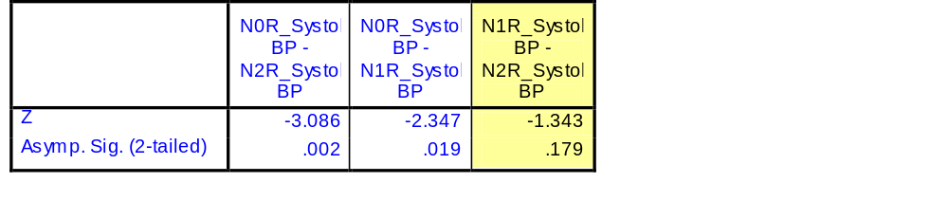
 | N0R_SystolBP - N2R_SystolBP | N0R_SystolBP - N1R_SystolBP | N1R_SystolBP - N2R_SystolBP
Z | -4.422(a) | -3.238(a) | -1.856(a)
Asymp. Sig. (2-tailed) | .000 | .001 | .063
a Based on negative ranks. a Sign Test
b Wilcoxon Signed Ranks Test

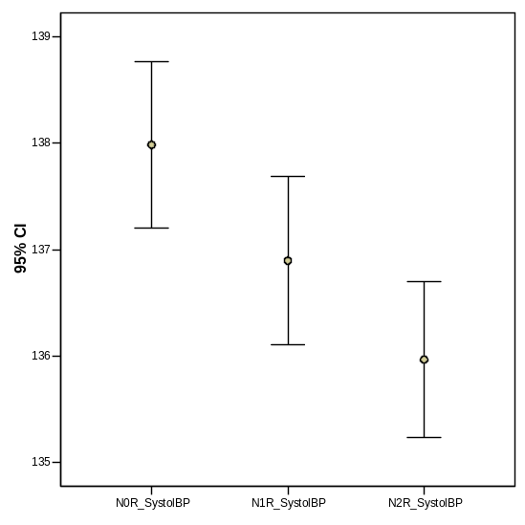  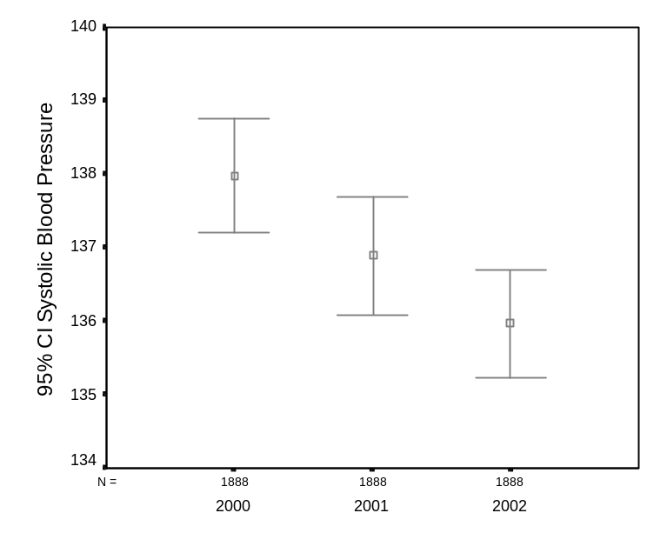 | 13. Statistical tests for systolic blood pressure  A paired samples t-test was conducted to evaluate the impact of the change in systolic BP levels across the years 2000-2002. There was a statistically significant decrease in systolic BP levels from 2000 (M=137.98 SD=17.366) to 2002 (M=136.16 SD=16.497)  t= -4.487; df=2115; p<0.0005.  A paired samples t-test was also conducted to evaluate the impact of the change in systolic BP levels across the years 2000-2001. There was a statistically significant decrease in systolic BP levels from 2000 (M=138.10 SD=17.372) to 2001 (M=137.15 SD=17.424)  t= -2.546; df=2237; p<.05  A paired samples t-test was also conducted to evaluate the impact of the change in systolic BP levels across the years 2001-2002. There was a statistically significant decrease in systolic BP levels from 2001 (M=136.74 SD=17.486) to 2002 (M=135.87 SD=16.314)  t= -2.366; df=2134; p<.05
T-Test

Paired Samples Statistics

 |  | Mean | N | Std. Deviation | Std. Error Mean
Pair 1 | N2R_DiastBP | 78.16 | 2116 | 9.056 | .197
Pair 1 | N0R_DiastBP | 79.54 | 2116 | 9.045 | .197
Pair 2 | N1R_DiastBP | 78.53 | 2238 | 9.205 | .195
Pair 2 | N0R_DiastBP | 79.51 | 2238 | 8.940 | .189
Pair 3 | N2R_DiastBP | 78.18 | 2135 | 8.928 | .193
Pair 3 | N1R_DiastBP | 78.45 | 2135 | 9.137 | .198

Paired Samples Correlations

 |  | N | Correlation | Sig.
Pair 1 | N2R_DiastBP & N0R_DiastBP | 2116 | .352 | .000
Pair 2 | N1R_DiastBP & N0R_DiastBP | 2238 | .377 | .000
Pair 3 | N2R_DiastBP & N1R_DiastBP | 2135 | .436 | .000

Paired Samples Test

 |  | Paired Differences |  |  |  |  | t | df | Sig. (2-tailed)
 |  | Mean | Std. Deviation | Std. Error Mean | 95% Confidence Interval of the Difference |  | t | df | Sig. (2-tailed)
 |  |  |  |  | Lower | Upper | t | df | Sig. (2-tailed)
Pair 1 | N2R_DiastBP - N0R_DiastBP | -1.379 | 10.301 | .224 | -1.818 | -.940 | -6.158 | 2115 | .000
Pair 2 | N1R_DiastBP - N0R_DiastBP | -.978 | 10.131 | .214 | -1.398 | -.558 | -4.565 | 2237 | .000
Pair 3 | N2R_DiastBP - N1R_DiastBP | -.277 | 9.593 | .208 | -.684 | .130 | -1.333 | 2134 | .183

Nonparametric tests confirm these results, particularly for Pair 3.

Wilcoxon Signed Ranks Test Sign Test

Test Statistics(b) Test Statistics(a)

 | N0R_DiastBP - N2R_DiastBP | N0R_DiastBP - N1R_DiastBP | 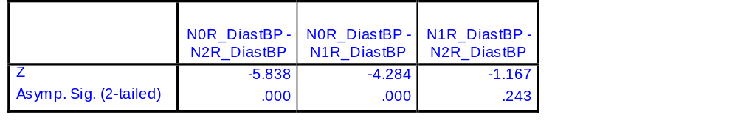  N1R_DiastBP - N2R_DiastBP
Z | -6.203(a) | -4.470(a) | -1.461(a)
Asymp. Sig. (2-tailed) | .000 | .000 | .144
a Based on negative ranks. a Sign Test
b Wilcoxon Signed Ranks Test

14. Statistical test for diastolic blood pressure  A paired samples t-test was conducted to evaluate the impact of the change in diastolic BP levels across the years 2000-2002. There was a statistically significant decrease in diastolic BP levels from 2000 (M=78.16 SD=9.056) to 2002 (M=79.54 SD=9.045) t= -6.158; df=2115; p<0.0005.  A paired samples t-test was also conducted to evaluate the impact of the change in diastolic BP levels across the years 2000-2001. There was not a statistically significant decrease in diastolic BP levels from 2000 (M=79.51 SD=8.94) to 2001 (M=78.53 SD=8.940) t= -4.565; df=2237; p<.0005.  A paired samples t-test was also conducted to evaluate the impact of the change in diastolic BP levels across the years 2001-2002. There was not a statistically significant decrease in diastolic BP levels from 2001 (M=78.45 SD=9.137) to 2002 (M=78.18 SD=8.928) t= -1.333; df=2134; p=.183. | 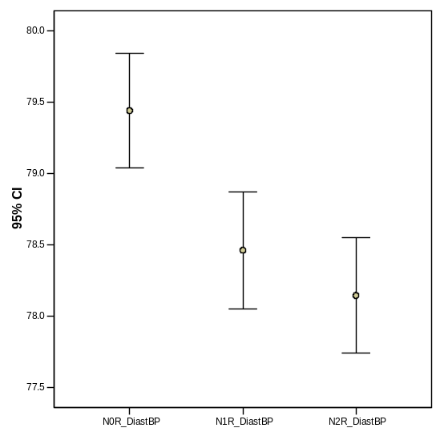  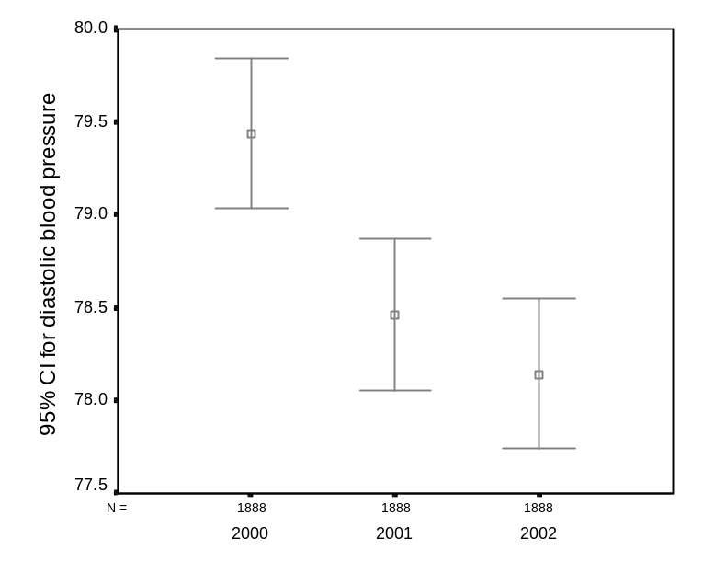

N0R_Blood pressure groups * N2R_Age groups Crosstabulation
Count
 |  | N2R_Age groups |  |  |  |  |  |  | Total
 |  | <24 | 25-34 | 35-44 | 45-54 | 55-64 | 65-74 | 75+ | Total
N0R_Blood pressure groups | < 130/85 | 8 | 14 | 44 | 106 | 156 | 167 | 97 | 592
N0R_Blood pressure groups | >=130/85 | 3 | 10 | 63 | 276 | 468 | 629 | 457 | 1906
N0R_Blood pressure groups | No test | 5 | 12 | 24 | 67 | 123 | 135 | 92 | 458
Total |  | 16 | 36 | 131 | 449 | 747 | 931 | 646 | 2956

N1R_Blood pressure categories * N2R_Age groups Crosstabulation
Count
 |  | N2R_Age groups |  |  |  |  |  |  | Total
 |  | <24 | 25-34 | 35-44 | 45-54 | 55-64 | 65-74 | 75+ | Total
N1R_Blood pressure categories | <130/85 | 7 | 17 | 50 | 131 | 160 | 168 | 113 | 646
N1R_Blood pressure categories | >130.85 | 3 | 13 | 62 | 258 | 476 | 618 | 452 | 1882
N1R_Blood pressure categories | No test | 6 | 6 | 19 | 60 | 111 | 145 | 81 | 428
Total |  | 16 | 36 | 131 | 449 | 747 | 931 | 646 | 2956

N2R_Blood pressure categories * N2R_Age groups Crosstabulation
Count
 |  | N2R_Age groups |  |  |  |  |  |  | Total
 |  | <24 | 25-34 | 35-44 | 45-54 | 55-64 | 65-74 | 75+ | Total
N2R_Blood pressure categories | <130/85 | 7 | 16 | 47 | 110 | 150 | 171 | 120 | 621
N2R_Blood pressure categories | >130/85 | 4 | 11 | 63 | 262 | 465 | 590 | 396 | 1791
N2R_Blood pressure categories | No test | 5 | 9 | 21 | 77 | 132 | 170 | 130 | 544
Total |  | 16 | 36 | 131 | 449 | 747 | 931 | 646 | 2956

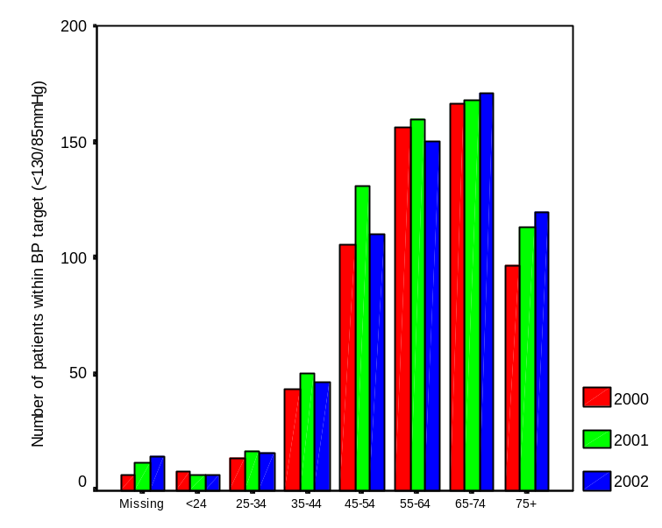 | 15. Comparison of BP by age group  The number of patients within target (<130/85mmHg) improved in each age group across the years 2000-2002. The effect was largest within the 65+ age brackets.
N0R_Blood pressure groups * N2R_Diabetes duration categories Crosstabulation
Count
 |  | N2R_Diabetes duration categories |  |  |  | Total
 |  | 1 - 5 | 6 - 10 | 11 - 15 | 16+ | Total
N0R_Blood pressure groups | < 130/85 | 311 | 125 | 56 | 47 | 539
N0R_Blood pressure groups | >=130/85 | 854 | 411 | 249 | 217 | 1731
N0R_Blood pressure groups | No test | 200 | 101 | 35 | 44 | 380
Total |  | 1365 | 637 | 340 | 308 | 2650

N1R_Blood pressure categories * N2R_Diabetes duration categories Crosstabulation
Count
 |  | N2R_Diabetes duration categories |  |  |  | Total
 |  | 1 - 5 | 6 - 10 | 11 - 15 | 16+ | Total
N1R_Blood pressure categories | <130/85 | 326 | 143 | 58 | 62 | 589
N1R_Blood pressure categories | >130.85 | 853 | 404 | 238 | 197 | 1692
N1R_Blood pressure categories | No test | 186 | 90 | 44 | 49 | 369
Total |  | 1365 | 637 | 340 | 308 | 2650

N2R_Blood pressure categories * N2R_Diabetes duration categories Crosstabulation
Count
 |  | N2R_Diabetes duration categories |  |  |  | Total
 |  | 1 - 5 | 6 - 10 | 11 - 15 | 16+ | Total
N2R_Blood pressure categories | <130/85 | 310 | 123 | 66 | 67 | 566
N2R_Blood pressure categories | >130/85 | 802 | 401 | 224 | 199 | 1626
N2R_Blood pressure categories | No test | 253 | 113 | 50 | 42 | 458
Total |  | 1365 | 637 | 340 | 308 | 2650

16. Comparison of BP by duration of diabetes  There were increases in the numbers of patients within target (<130/85 mmHg) blood pressure across the years 2000-2002 and duration period. The most obvious category where improvement occurred was in the 1-5 year category. The 0 category is based on questionable data and may be better analysed as missing data.  → this graph does not coincide with the numbers above | 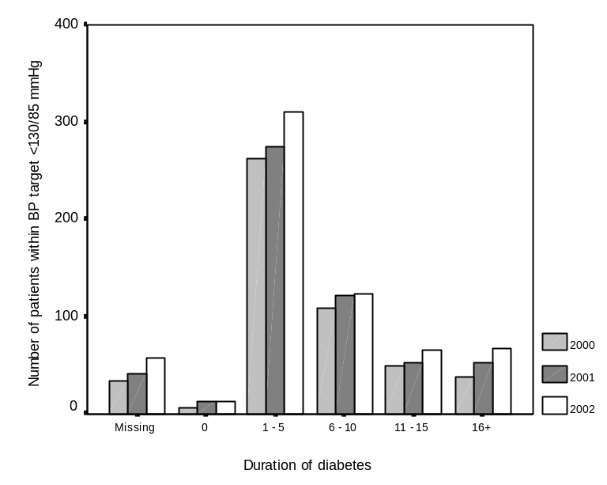
T-Test

Paired Samples Statistics
 |  | Mean | N | Std. Deviation | Std. Error Mean
Pair 1 | N2R_LipChol | 4.82 | 1477 | .921 | .024
Pair 1 | N0R_LipChol | 5.14 | 1477 | .993 | .026

Paired Samples Correlations
 |  | N | Correlation | Sig.
Pair 1 | N2R_LipChol & N0R_LipChol | 1477 | .440 | .000

Paired Samples Test
 |  | Paired Differences |  |  |  |  | t | df | Sig. (2-tailed)
 |  | Mean | Std. Deviation | Std. Error Mean | 95% Confidence Interval of the Difference |  | t | df | Sig. (2-tailed)
 |  |  |  |  | Lower | Upper | t | df | Sig. (2-tailed)
Pair 1 | N2R_LipChol - N0R_LipChol | -.316 | 1.015 | .026 | -.368 | -.265 | -11.986 | 1476 | .000

Wilcoxon and sign tests confirm this significant difference.
McNemar Test

N2R_Cholesterol categories & N0R_Total cholesterol categories

N2R_Cholesterol categories | N0R_Total cholesterol categories
N2R_Cholesterol categories | 0 | 1
0 | 526 | 332
1 | 145 | 474

Test Statistics(b)

 | N2R_Cholesterol categories & N0R_Total cholesterol categories
N | 1477
Chi-Square(a) | 72.528
Asymp. Sig. | .000

a Continuity Corrected
b McNemar Test

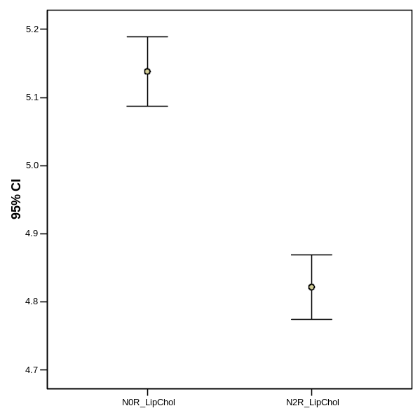  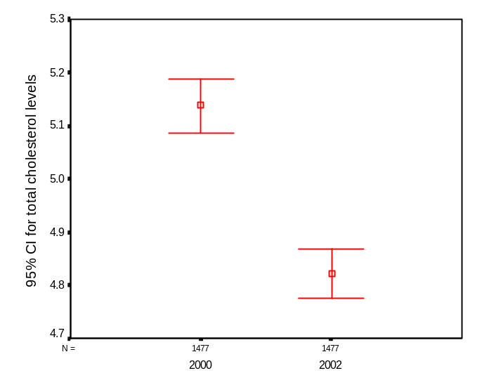 | 17. Statistical tests for total cholesterol levels compared for 2000 & 2002  A paired samples t-test was conducted to evaluate the impact of the change in total cholesterol levels across the years 2000-2002. There was a statistically significant decrease in cholesterol levels from 2000 (M=5.14 SD=0.92) to 2002 (M=4.82 SD=0.99) t= -11.986; df=1476; p<0.0005  The nonparametric Wilcoxon Signed Rank Test was carried out to test the significance of change over the years 2000 and 2002 in the total cholesterol categories within target (<5.0mmol/L) and outside target (>= 5.0mmol/L). This test showed a significant difference in the results for 2000 and 2002 (Z= -8.562; p<0.005).→ see McNemar
18. Comparison of error bars for total cholesterol levels by diabetes type.  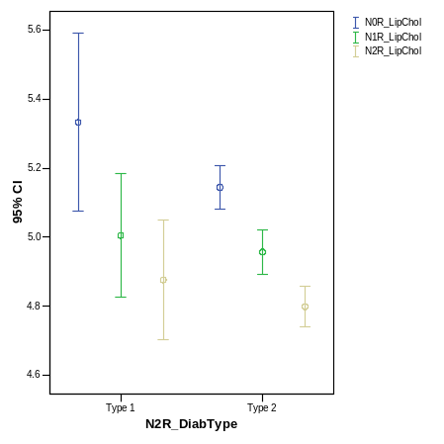  Significant results appear for Type 1 and 2 diabetes. | 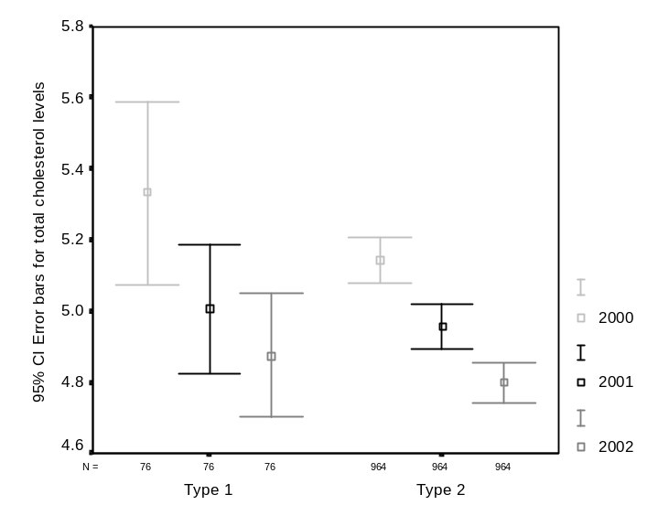
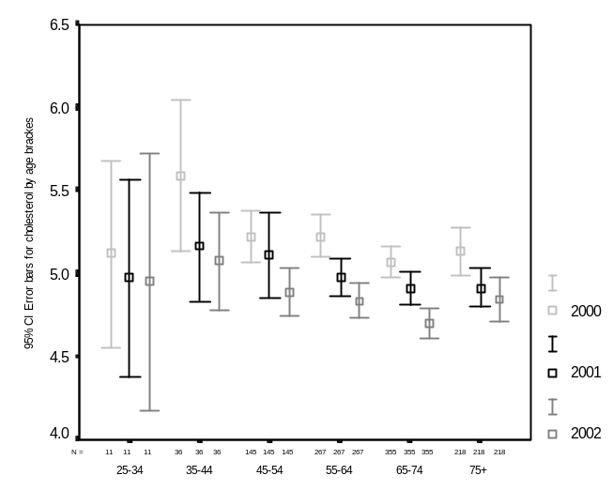 | 19. Comparison of error bars for cholesterol levels by age groups  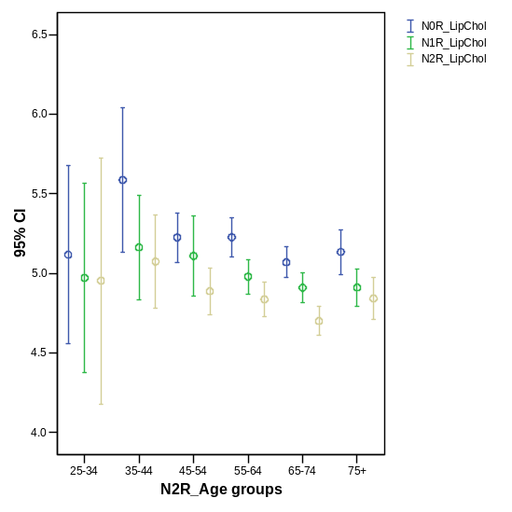  The trend is strongest among the 45+ age groups.
20. Error bars comparing total cholesterol levels by diabetes duration.  Each category (<=, 4-8, 9+) shows significant improvement in total cholesterol levels across 2000 to 2002.  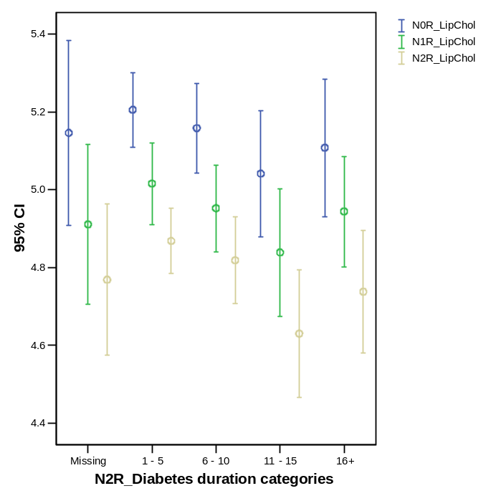 | 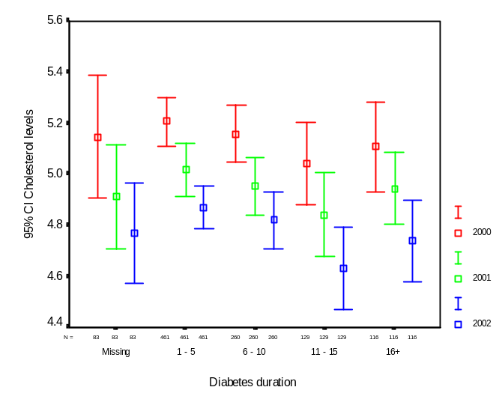

T-Test

Paired Samples Statistics
 |  | Mean | N | Std. Deviation | Std. Error Mean
Pair 1 | N2R_BMIkg_m2 | 30.3059 | 1640 | 5.93089 | .14645
Pair 1 | N0R_BMIkg_m2 | 30.4095 | 1640 | 5.98201 | .14772

Paired Samples Correlations
 |  | N | Correlation | Sig.
Pair 1 | N2R_BMIkg_m2 & N0R_BMIkg_m2 | 1640 | .914 | .000

Paired Samples Test
 |  | Paired Differences |  |  |  |  | t | df | Sig. (2-tailed)
 |  | Mean | Std. Deviation | Std. Error Mean | 95% Confidence Interval of the Difference |  | t | df | Sig. (2-tailed)
 |  |  |  |  | Lower | Upper | t | df | Sig. (2-tailed)
Pair 1 | N2R_BMIkg_m2 - N0R_BMIkg_m2 | -.10360 | 2.46921 | .06097 | -.22319 | .01600 | -1.699 | 1639 | .089

→ Nonparametric tests concur with this result.

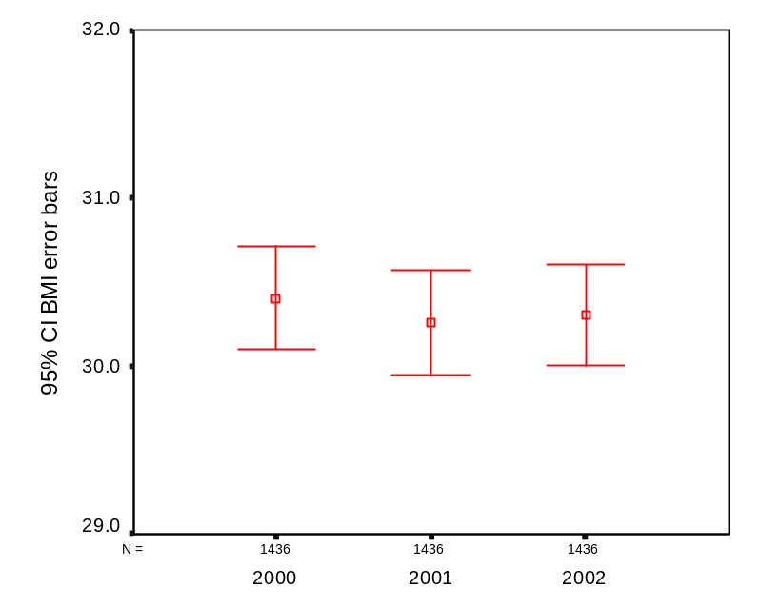 | 21. Statistical tests for BMI compared over the period 2000-2002  The confidence intervals for mean BMI scores compared for the years 2000, 2001 and 2002 show an insignificant decrease in the means. The paired sample t-test showed a statistically insignificant decrease in BMI levels from 2000 (M=30.3 SD=5.9) to 2002 (M=30.4 SD=5.9) t=-1.699; df=1639; p=0.089.  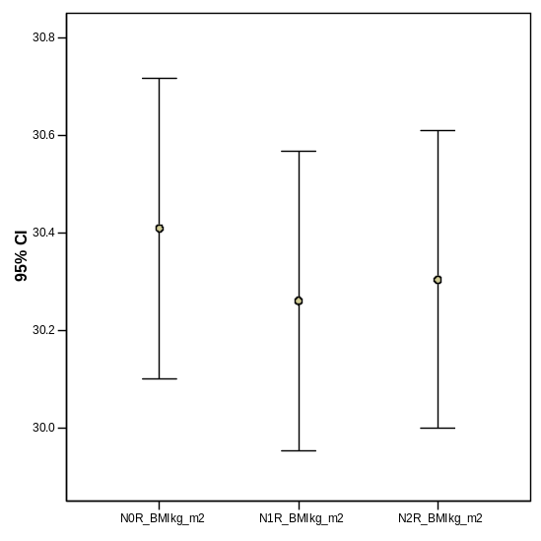
BMI by categories * N0R_BMI categories Crosstabulation

Count
 |  | N0R_BMI categories |  |  | Total
 |  | <= 25 | >25 & <30 | => 30 | Total
BMI by categories | <= 25 | 231 | 47 | 7 | 285
BMI by categories | >25 & <30 | 62 | 441 | 77 | 580
BMI by categories | >= 30 | 1 | 73 | 701 | 775
Total |  | 294 | 561 | 785 | 1640

Wilcoxon Signed Ranks Test
Ranks

 |  | N | Mean Rank | Sum of Ranks
N0R_BMI categories - BMI by categories | Negative Ranks | 136(a) | 130.98 | 17813.50
N0R_BMI categories - BMI by categories | Positive Ranks | 131(b) | 137.13 | 17964.50
N0R_BMI categories - BMI by categories | Ties | 1373(c)
N0R_BMI categories - BMI by categories | Total | 1640
a N0R_BMI categories < BMI by categories
b N0R_BMI categories > BMI by categories
c N0R_BMI categories = BMI by categories

Test Statistics(b)

 | N0R_BMI categories - BMI by categories
Z | -.068(a)
Asymp. Sig. (2-tailed) | .946
a Based on negative ranks.
b Wilcoxon Signed Ranks Test

N2R_BMI in two categories * N0R_BMI in two categories Crosstabulation

Count
 |  | N0R_BMI in two categories |  | Total
 |  | <=25 BMI | > 25 BMI | Total
N2R_BMI in two categories | <=25 BMI | 231 | 54 | 285
N2R_BMI in two categories | > 25 BMI | 63 | 1292 | 1355
Total |  | 294 | 1346 | 1640

McNemar Test

Test Statistics(b)
 | N2R_BMI in two categories & N0R_BMI in two categories
N | 1640
Chi-Square(a) | .547
Asymp. Sig. | .460
a Continuity Corrected
b McNemar Test

22. Statistical tests for BMI categories (2000-2002)  The non parametric Wilcoxon Signed Rank Test was carried out to test the significance of change over the years 2000 and 2002 in the BMI categories within target (<=25 BMI) and outside target (>25 & <30 BMI) and outside target 2 (=>30 BMI). This test showed a non-significant difference in the results for 2000 and 2002 (Z= -0.68; p=0.946).  The McNemar test using binomial distribution for BMI below (<=25) and above (>25) target was used to compare 2000 and 2002. This test showed a non-significant difference (n=1640; Chi Square=.547; p=.460) | 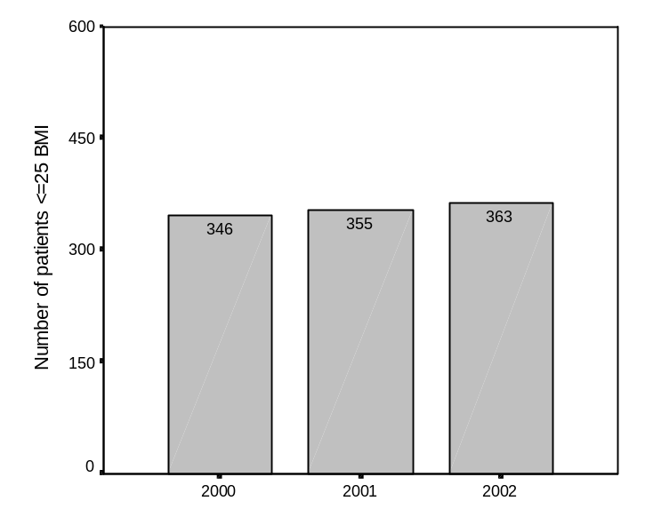
   | 2000
  2002 | Within target | Outside target
  0 | 231 | 54
  1 | 63 | 1292
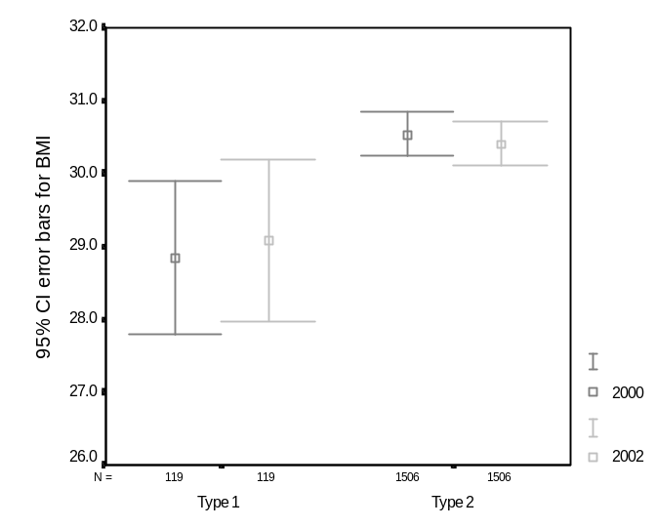 | 23. Comparison of error bars for BMI levels by diabetes type  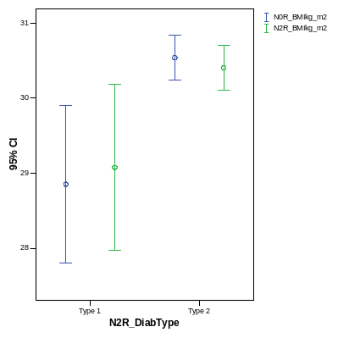  There were no significant differences for BMI levels in Type 1 or Type 2 diabetes. Type 1 patients however, had lower BMI scores than Type 2.
24. Comparison of error bars for BMI by age groups  There were no significant differences for BMI levels by age groups except possibly for the 75+ group.  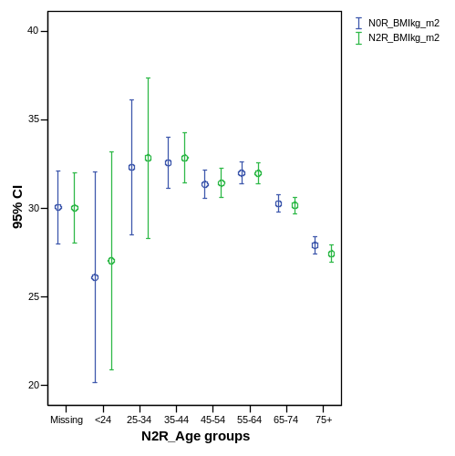 | 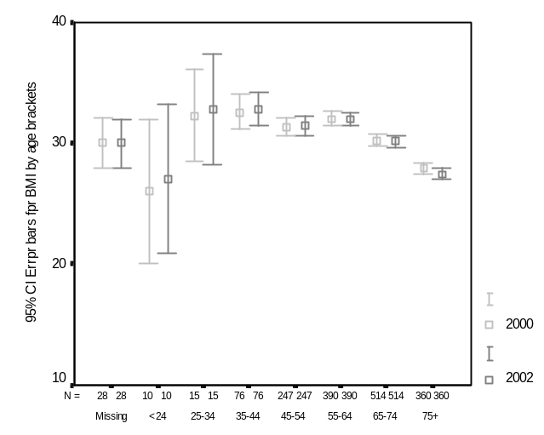
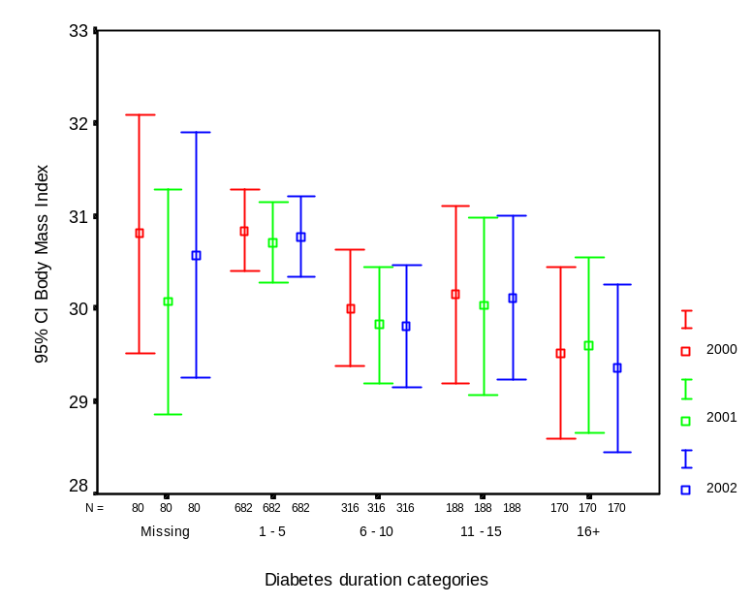 | 25. Error bars comparing BMI levels by diabetes duration  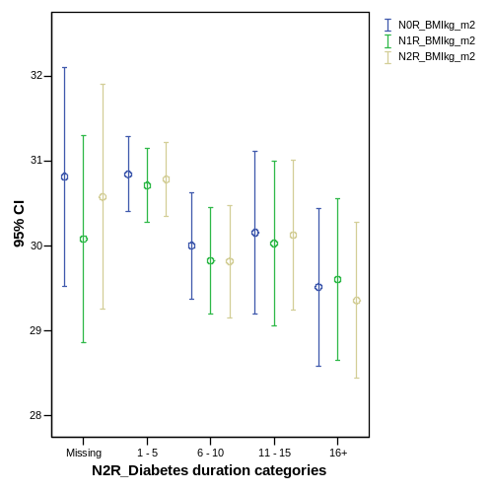  There was no significant difference for BMI levels across diabetes duration groups.

 | 26. Statistical tests for diabetic retinopathy (2000-2002)  The non-parametric McNemar Test was used to check the significance of changes to the number of patients with diabetic retinopathy between the years 2000 – 2002. This test showed a non-significant difference in the results from 2000 to 2002 (n=1026; χ² =0.674; p=0.412)
   | 2000
  2002 | No diabetic retinopathy | Diabetic retinopathy
  No diabetic retinopathy | 872 | 52
  Diabetic retinopathy | 43 | 55

N2R_Retinae categories * N0R_Retinae categories Crosstabulation
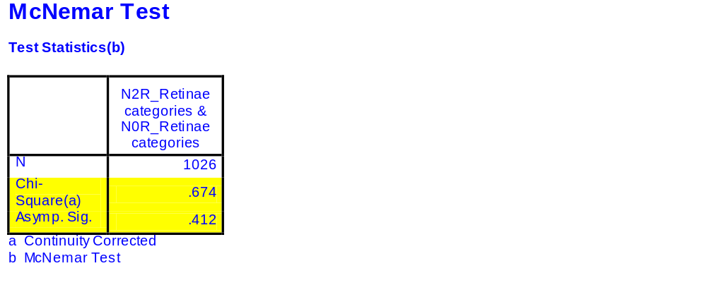
Count
 |  | N0R_Retinae categories |  | Total
 |  | No diabetes retinopathy | Diabetes retinopathy | Total
N2R_Retinae categories | No diabetes retinopathy | 875 | 52 | 927
N2R_Retinae categories | Diabetes retinopathy | 43 | 56 | 99
Total |  | 918 | 108 | 1026

27. Statistical tests for high risk foot (2000-2002)  The non-parametric McNemar Test was used to check the significance of changes to the number of patients with high risk foot between the years 2000 – 2002. This test showed a non-significant difference in the results from 2000 to 2002 (n=1354; χ² =2.805 p=0.094)
   | 2000
  2002 | Without high risk foot | High risk foot
  Without high risk foot | 1032 | 107
  High risk foot | 134 | 81

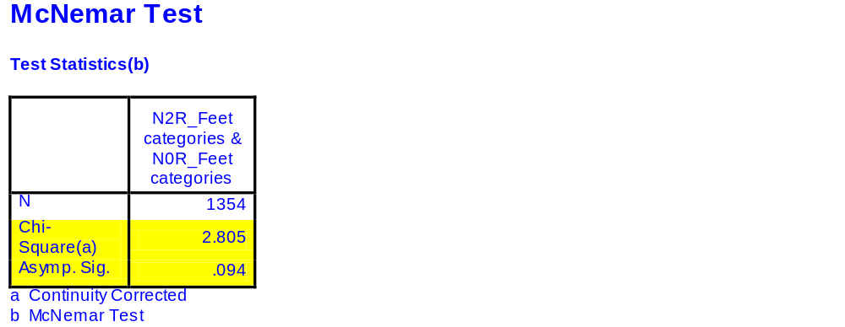
N2R_Feet categories * N0R_Feet categories Crosstabulation

Count
 |  | N0R_Feet categories |  | Total
 |  | Normal | High Risk Foot | Total
N2R_Feet categories | Normal | 1032 | 107 | 1139
N2R_Feet categories | High Risk Foot | 134 | 81 | 215
Total |  | 1166 | 188 | 1354

T Test

Paired Samples Statistics
 |  | Mean | N | Std. Deviation | Std. Error Mean
Pair 1 | N2R_LipHDL | 1.25 | 861 | .368 | .013
Pair 1 | N0R_LipHDL | 1.24 | 861 | .431 | .015

Paired Samples Test
 |  | Paired Differences |  |  |  |  | t | df | Sig. (2-tailed)
 |  | Mean | Std. Deviation | Std. Error Mean | 95% Confidence Interval of the Difference |  | t | df | Sig. (2-tailed)
 |  |  |  |  | Lower | Upper | t | df | Sig. (2-tailed)
Pair 1 | N2R_LipHDL - N0R_LipHDL | .016 | .372 | .013 | -.009 | .041 | 1.236 | 860 | .217

→ Wilcoxon and sign tests suggest difference in HDL between 2000-02 was significant!

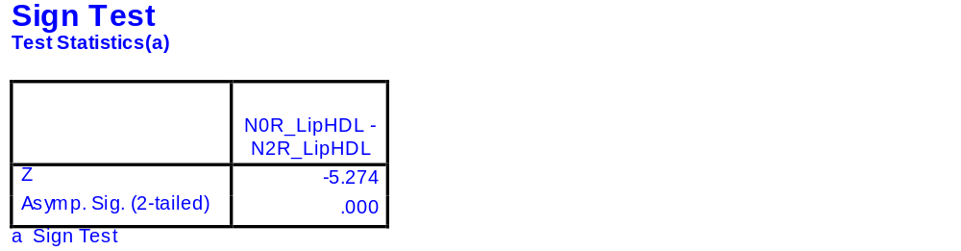
Wilcoxon Signed Ranks Test

Test Statistics(b)
 | N0R_LipHDL - N2R_LipHDL
Z | -4.380(a)
Asymp. Sig. (2-tailed) | .000
a Based on positive ranks.
b Wilcoxon Signed Ranks Test

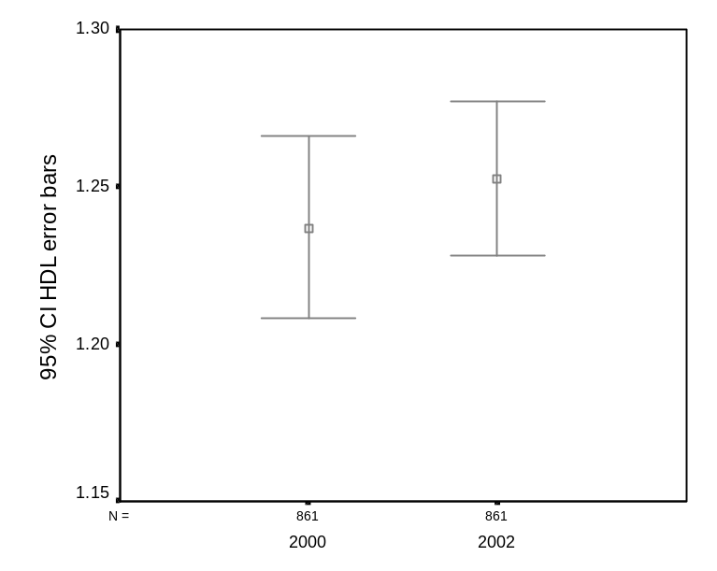 | 28. Statistical tests for HDL levels compared for 2000 & 2002  A paired samples t-test was conducted to evaluate the impact of the change in HDL levels across the years 2000-2002. There was a non- significant increase in HDL levels from 2000 (M=1.24 SD= 0.43) to 2002 (M=1.25 SD=0.37) t=1.236; df=860; p=0.217.  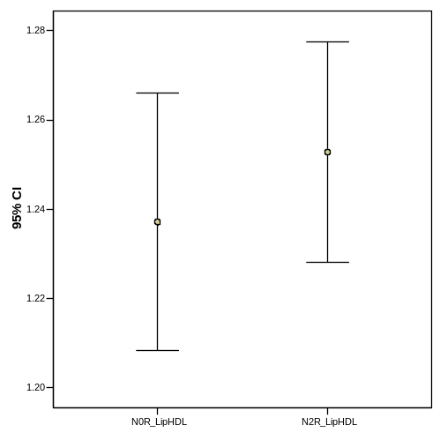

29. Statistical tests for HDL levels compared for 2000 & 2002  The non-parametric McNemar Test was used to check the significance of changes to the number of patients with normal HDL levels (>= 1.0mmol/L) and abnormal HDL levels (<1.0mmol/L) between the years 2000 – 2002. This test showed a significant difference in the results from 2000 to 2002 (n=861; χ² =12.49 p=0.0005) | 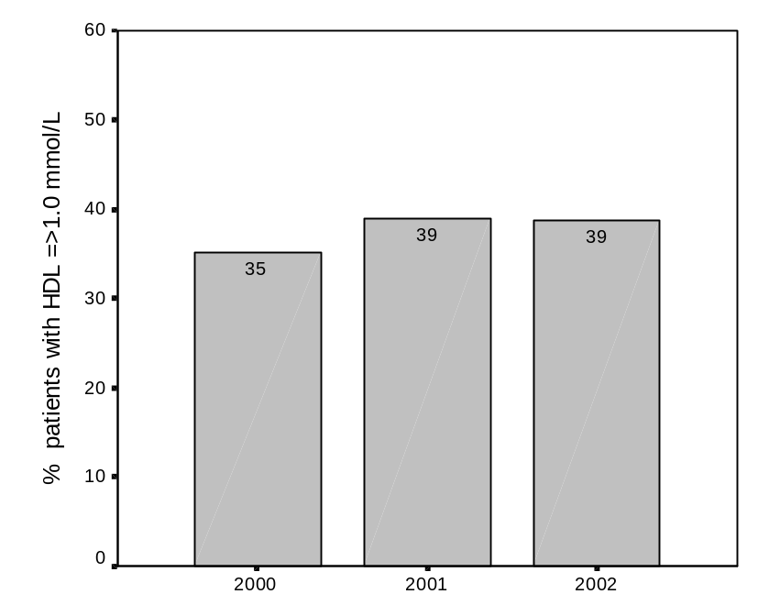
   | 2000
  2002 | >= 1.0mmol/L | <1 mmol/L
  >= 1.0mmol/L | 588 | 100
  <1 mmol/L | 55 | 118

McNemar Test
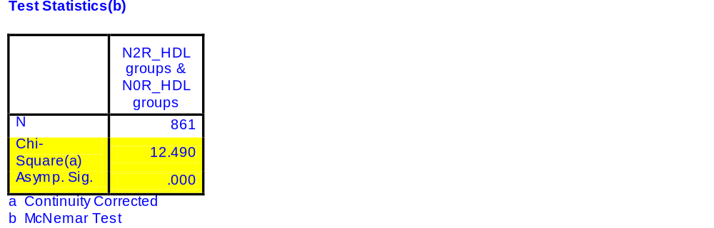
N2R_HDL groups * N0R_HDL groups Crosstabulation

Count
 |  | N0R_HDL groups |  | Total
 |  | >= 1.0mmol/L | <1.0mmol/L | Total
N2R_HDL groups | >= 1.0mmol/L | 588 | 100 | 688
N2R_HDL groups | <1.0mmol/L | 55 | 118 | 173
Total |  | 643 | 218 | 861

T-Test

Paired Samples Statistics

 |  | Mean | N | Std. Deviation | Std. Error Mean
Pair 1 | N2R_LipLDL | 2.719 | 767 | .833 | .030
Pair 1 | N0R_LipLDL | 3.016 | 767 | .892 | .032

Paired Samples Correlations

 |  | N | Correlation | Sig.
Pair 1 | N2R_LipLDL & N0R_LipLDL | 767 | .456 | .000

Paired Samples Test

 |  | Paired Differences |  |  |  |  | t | df | Sig. (2-tailed)
 |  | Mean | Std. Deviation | Std. Error Mean | 95% Confidence Interval of the Difference |  | t | df | Sig. (2-tailed)
 |  |  |  |  | Lower | Upper | t | df | Sig. (2-tailed)
Pair 1 | N2R_LipLDL - N0R_LipLDL | -.297 | .901 | .033 | -.361 | -.233 | -9.123 | 766 | .000

→ Wilcoxon and sign tests concur with the above result.

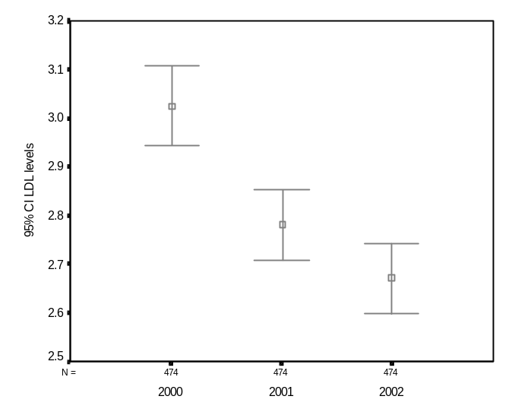 | 30. Statistical tests for LDL levels for 2000-2002  A paired samples t-test was conducted to evaluate the impact of the change in LDL levels across the years 2000-2002. There was a significant decrease in LDL levels from 2000 (M=3.01 SD= 0.891) to 2002 (M=2.72 SD=0.833) t=-9.123; df=766; p<0.0005.  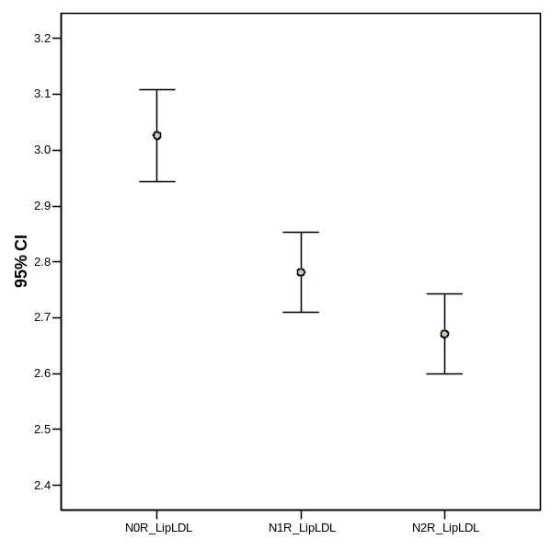
31. Comparison of patients in LDL (<3.0mmol/L) by year and gender  There was a rise in the number of patients in the <3.00mmol/L (controlled) bracket over the years 2000-2002. | 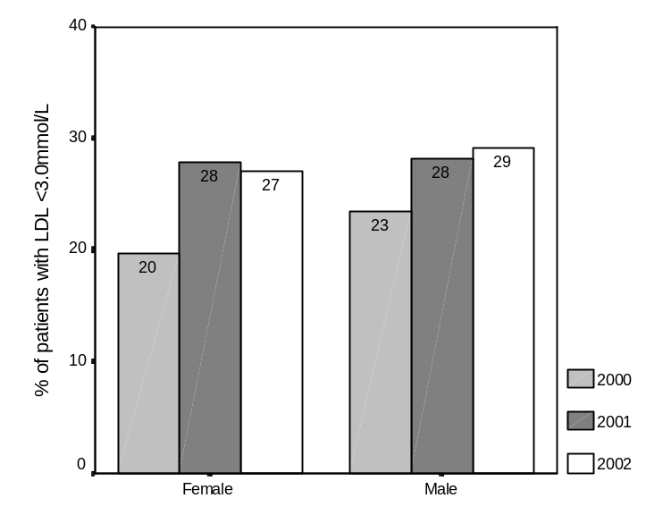

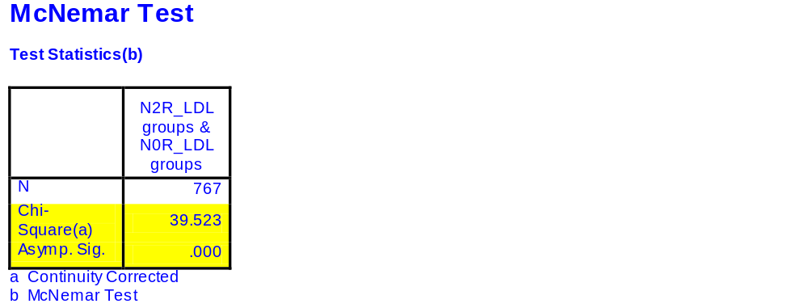
N2R_LDL groups * N0R_LDL groups Crosstabulation

Count
 |  | N0R_LDL groups |  | Total
 |  | <3.0mmol/L | >=3.0mmol/L | Total
N2R_LDL groups | <3.0mmol/L | 308 | 171 | 479
N2R_LDL groups | >=3.0mmol/L | 72 | 216 | 288
Total |  | 380 | 387 | 767

T-Test

Paired Samples Statistics

 |  | Mean | N | Std. Deviation | Std. Error Mean
Pair 1 | N2R_LipTglyc | 2.05 | 1387 | 1.351 | .036
Pair 1 | N0R_LipTglyc | 2.24 | 1387 | 1.438 | .039
Pair 2 | N1R_LipTglyc | 2.11 | 1449 | 1.692 | .044
Pair 2 | N0R_LipTglyc | 2.21 | 1449 | 1.469 | .039
Pair 3 | N2R_LipTglyc | 2.01 | 1329 | 1.280 | .035
Pair 3 | N1R_LipTglyc | 2.08 | 1329 | 1.437 | .039

Paired Samples Correlations

 |  | N | Correlation | Sig.
Pair 1 | N2R_LipTglyc & N0R_LipTglyc | 1387 | .537 | .000
Pair 2 | N1R_LipTglyc & N0R_LipTglyc | 1449 | .550 | .000
Pair 3 | N2R_LipTglyc & N1R_LipTglyc | 1329 | .615 | .000

Paired Samples Test

 |  | Paired Differences |  |  |  |  | t | df | Sig. (2-tailed)
 |  | Mean | Std. Deviation | Std. Error Mean | 95% Confidence Interval of the Difference |  | t | df | Sig. (2-tailed)
 |  |  |  |  | Lower | Upper | t | df | Sig. (2-tailed)
Pair 1 | N2R_LipTglyc - N0R_LipTglyc | -.191 | 1.345 | .036 | -.262 | -.121 | -5.304 | 1386 | .000
Pair 2 | N1R_LipTglyc - N0R_LipTglyc | -.101 | 1.513 | .040 | -.179 | -.023 | -2.546 | 1448 | .011
Pair 3 | N2R_LipTglyc - N1R_LipTglyc | -.072 | 1.201 | .033 | -.137 | -.008 | -2.191 | 1328 | .029

→ Consistent with Wilcoxon and sign tests.
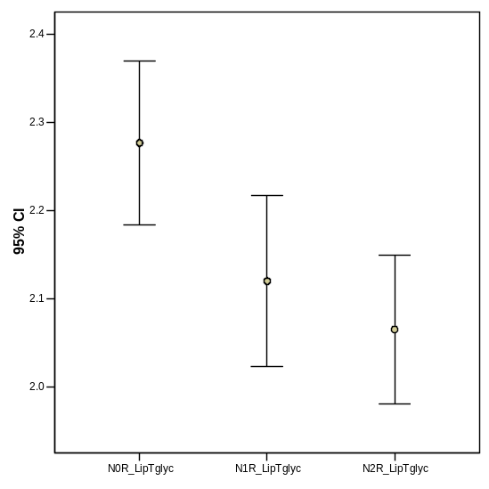  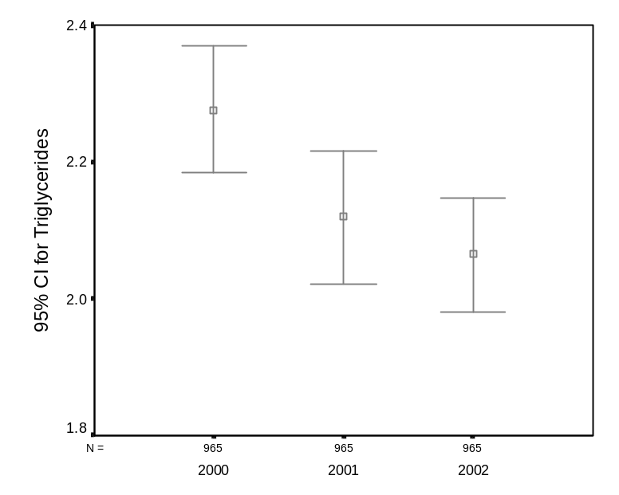 | 32. Statistical tests for Triglyceride levels (2000-2002)  A paired samples t-test was conducted to evaluate the impact of the change in Triglyceride levels across the years 2000-2002. There was a significant decrease in Triglyceride levels from 2000 (M=2.24 SD= 1.48) to 2002 (M=2.05 SD=1.35) t=-5.304; df=1386; p<0.0005.  A paired samples t-test was conducted to evaluate the impact of the change in Triglyceride levels across the years 2000-2001. There was a significant decrease in Triglyceride levels from 2000 (M=2.21 SD= 1.47) to 2001 (M=2.11 SD=1.69) t=-2.54; df=1448; p<.05.  A paired samples t-test was conducted to evaluate the impact of the change in Triglyceride levels across the years 2001-2002. There was a significant decrease in Triglyceride levels from 2001 (M=2.08 SD= 1.44) to 2002 (M=2.01 SD=1.29) t=-2.19; df=1328; p<.05.
33. Comparison of patients in Triglycerides (<2.0mmol/L) by year  The non-parametric McNemar Test was used to check the significance of changes to the number of patients with normal triglyceride levels (< 2.0mmol/L) and abnormal triglyceride levels (>=2.0mmol/L) between the years 2000 – 2002. This test showed a significant difference in the results from 2000 to 2002 (n=1387; χ² =29.45 p=0.0005) | 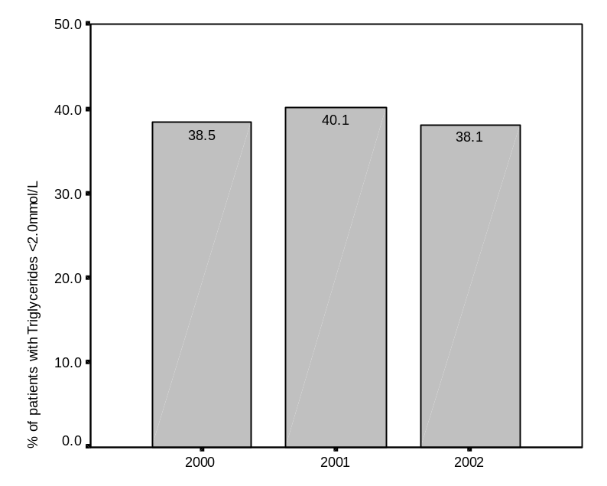
   | N0R_Triglyceride groups
  N2R_Triglyceride groups | <2.0mmol/L | >=2.0mmol/L
  <2.0mmol/L | 593 | 244
  >=2.0mmol/L | 137 | 413

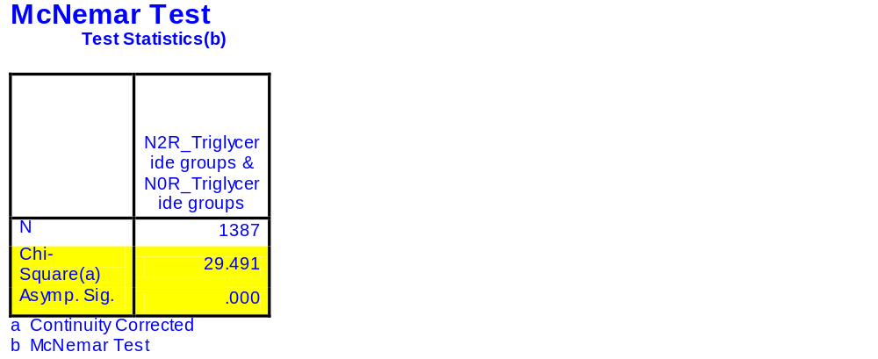
N2R_Triglyceride groups * N0R_Triglyceride groups Crosstabulation

Count
 |  | N0R_Triglyceride groups |  | Total
 |  | <2.0mmol/L | >= 2.0mmol/L | Total
N2R_Triglyceride groups | <2.0mmol/L | 593 | 244 | 837
N2R_Triglyceride groups | >= 2.0mmol/L | 137 | 413 | 550
Total |  | 730 | 657 | 1387

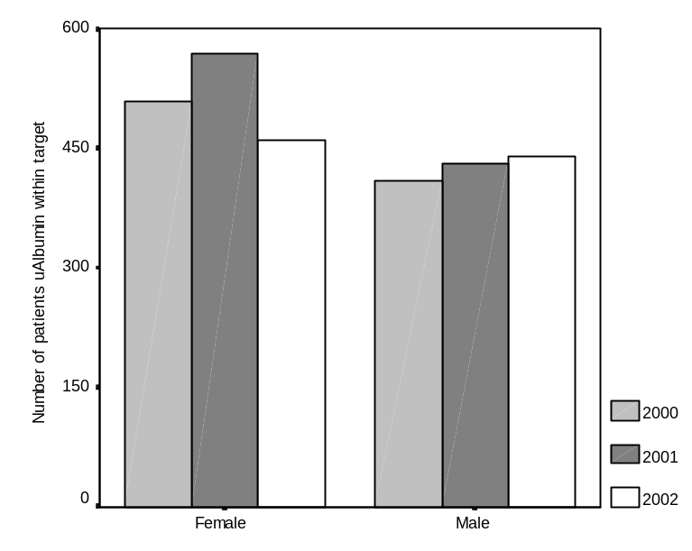 | 34. Statistical tests for microalbuminuria levels  The non parametric Wilcoxon Signed Rank Test was carried out to test the significance of change over the years 2000 to 2002 in the microalbumin levels that are normal (within target), microalbuminuria and macroalbuminuria.  This test showed a non-sginificant difference in the results for 2000 and 2002 (Z=-1.41; p=0.888)

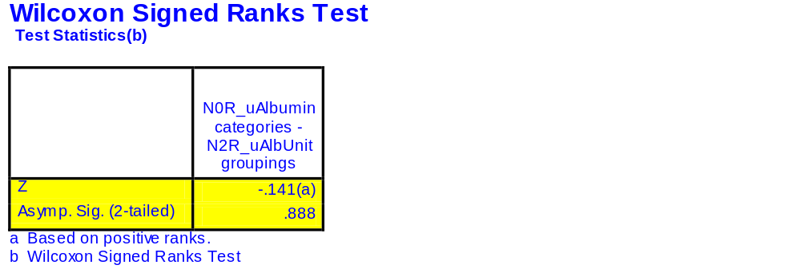
N2R_uAlbUnit groupings * N0R_uAlbumin categories Crosstabulation

Count
 |  | N0R_uAlbumin categories |  |  | Total
 |  | Normal | Microalbuminuria | Macroalbuminuria | Total
N2R_uAlbUnit groupings | Normal | 436 | 67 | 5 | 508
N2R_uAlbUnit groupings | Microalbuminuria | 71 | 60 | 11 | 142
N2R_uAlbUnit groupings | Macroalbuminuria | 5 | 9 | 9 | 23
Total |  | 512 | 136 | 25 | 673

35. Microalbuminuria targets compared by age  Improvements in the number of patients attaining within target albuminuria levels occurred in the <65 age brackets only. | 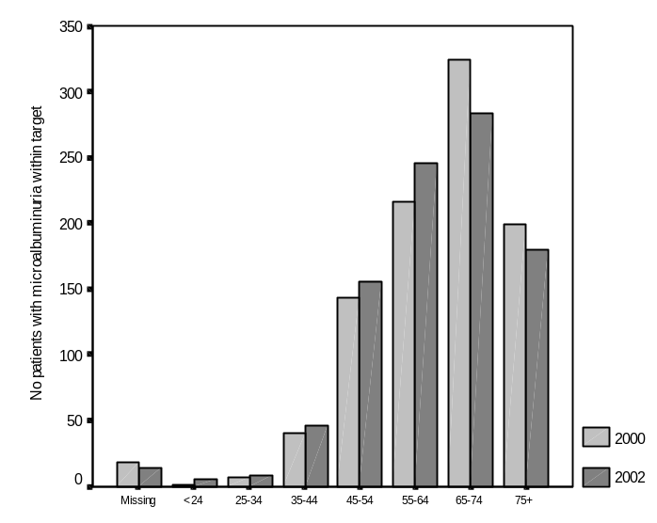
N2R_Grouped HbA1c * N2R_Six QOC checks in 2002 Crosstabulation

 |  |  | N2R_Six QOC checks in 2002 |  | Total
 |  |  | Less than 6 QOC items | Six or more QOC items | Total
N2R_Grouped HbA1c | <= 1% above ULN | Count | 601 | 727 | 1328
N2R_Grouped HbA1c | <= 1% above ULN | % within N2R_Six QOC checks in 2002 | 57.1% | 59.6% | 58.4%
N2R_Grouped HbA1c | >1% <=2% above ULN | Count | 228 | 284 | 512
N2R_Grouped HbA1c | >1% <=2% above ULN | % within N2R_Six QOC checks in 2002 | 21.7% | 23.3% | 22.5%
N2R_Grouped HbA1c | >2% above ULN | Count | 224 | 209 | 433
N2R_Grouped HbA1c | >2% above ULN | % within N2R_Six QOC checks in 2002 | 21.3% | 17.1% | 19.0%
Total |  | Count | 1053 | 1220 | 2273
 |  | % within N2R_Six QOC checks in 2002 | 100.0% | 100.0% | 100.0%

Chi-Square Tests

 | Value | df | Asymp. Sig. (2-sided)
Pearson Chi-Square | 6.364(a) | 2 | .042
Likelihood Ratio | 6.349 | 2 | .042
Linear-by-Linear Association | 4.039 | 1 | .044
N of Valid Cases | 2273
a 0 cells (.0%) have expected count less than 5. The minimum expected count is 200.59.
N2R_HbA1c levels in binominal grouping * N2R_Six QOC checks in 2002 Crosstabulation

 |  |  | N2R_Six QOC checks in 2002 |  | Total
 |  |  | Less than 6 QOC items | Six or more QOC items | Total
N2R_HbA1c levels in binominal grouping | Within target (<= 1% above ULN) | Count | 601 | 727 | 1328
N2R_HbA1c levels in binominal grouping | Within target (<= 1% above ULN) | % within N2R_Six QOC checks in 2002 | 57.1% | 59.6% | 58.4%
N2R_HbA1c levels in binominal grouping | Outside target (>1% about ULN) | Count | 452 | 493 | 945
N2R_HbA1c levels in binominal grouping | Outside target (>1% about ULN) | % within N2R_Six QOC checks in 2002 | 42.9% | 40.4% | 41.6%
Total |  | Count | 1053 | 1220 | 2273
 |  | % within N2R_Six QOC checks in 2002 | 100.0% | 100.0% | 100.0%

Chi-Square Tests

 | Value | df | Asymp. Sig. (2-sided) | Exact Sig. (2-sided) | Exact Sig. (1-sided)
Pearson Chi-Square | 1.472(b) | 1 | .225
Continuity Correction(a) | 1.370 | 1 | .242
Likelihood Ratio | 1.471 | 1 | .225
Fisher's Exact Test |  |  |  | .232 | .121
Linear-by-Linear Association | 1.471 | 1 | .225
N of Valid Cases | 2273
a Computed only for a 2x2 table
b 0 cells (.0%) have expected count less than 5. The minimum expected count is 437.78.

36. Quality of care (2002- 6 items) effect on HbA1c categories in 2002  HbA1c quality of care target % (<1%ULN; >1&<=2%ULN and >2%ULN) were compared for patients with <6 and =>6 items of care. There are significant differences between the <6 and 6+ categories for patients <1%ULN and >2%ULN (χ²=6.364; df=2; p<.05)  HbA1c levels were also compared by dichotomous variables for within target (<1%ULN) and outside target (>1%ULN). A chi square test showed that the differences were not significant when compared by dichotomous variables (Chi square = 1.472; df=1; p=.225). | 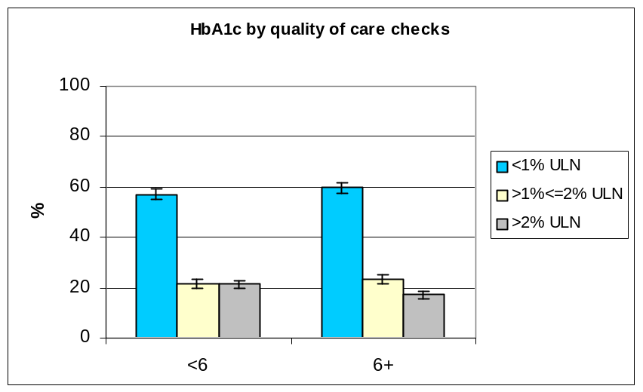  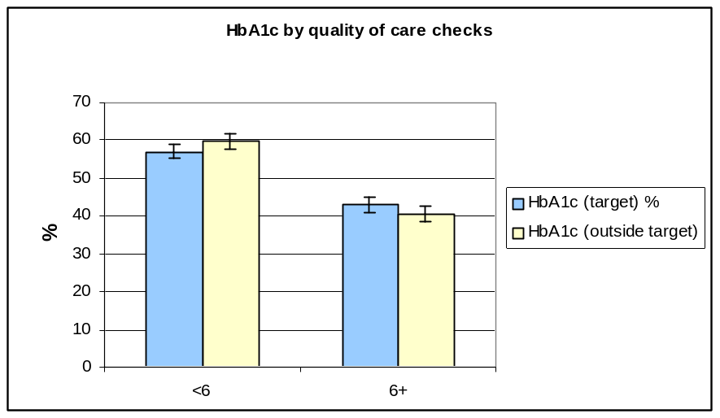
   |  |  |  |  | <6 | 6+ |  | Total
   |  | HbA1c (target) % |  |  | 57.1 | 59.6
   |  | n |  |  | 601 | 727 |  | 1328
   |  | 95%CI |  |  | 2.03 | 2.02
   |  | CI lower |  |  | 55.1 | 57.6
   |  | CI upper |  |  | 59.1 | 61.6
   |  |  |  | <6 |  |  | 6+ |  | Total
   | HbA1c (>1%& <=2%ULN) |  |  | 21.7 |  |  | 23.3
   | n |  |  | 228 |  |  | 284 |  | 512
   | 95%CI |  |  | 1.69 |  |  | 1.74
   | CI lower |  |  | 20.0 |  |  | 21.6
   | CI upper |  |  | 23.4 |  |  | 25.0
   |  |  | <6 |  |  |  | 6+ |  | Total
  HbA1c >2%ULN |  |  | 21.3 |  |  |  | 17.1
  n |  |  | 224 |  |  |  | 209 |  | 433
  95%CI |  |  | 1.68 |  |  |  | 1.55
  CI lower |  |  | 19.6 |  |  |  | 15.6
  CI upper |  |  | 23.0 |  |  |  | 18.6
   |  |  |  |  |  |  |  |  | 2273
T-Test

Group Statistics

 | N2R_Six QOC checks in 2002 | N | Mean | Std. Deviation | Std. Error Mean
N2R_HbA1c | Less than 6 QOC items | 1054 | 7.39 | 1.365 | .042
N2R_HbA1c | Six or more QOC items | 1220 | 7.22 | 1.202 | .034

Independent Samples Test

 |  | Levene's Test for Equality of Variances |  | t-test for Equality of Means
 |  | F | Sig. | t | df | Sig. (2-tailed) | Mean Difference | Std. Error Difference | 95% Confidence Interval of the Difference
 |  |  |  |  |  |  |  |  | Lower | Upper
N2R_HbA1c | Equal variances assumed | 16.356 | .000 | 3.103 | 2272 | .002 | .167 | .054 | .061 | .273
N2R_HbA1c | Equal variances not assumed |  |  | 3.075 | 2115.564 | .002 | .167 | .054 | .061 | .274

The error bar plots compare mean and 95%CI HbA1c levels for patients who had 6 or more quality of care checks and patients who did not. The graph shows a significant difference. An independent samples t test between the two groups confirmed that the difference is significant (t=3.075; df=2115; p<.005).  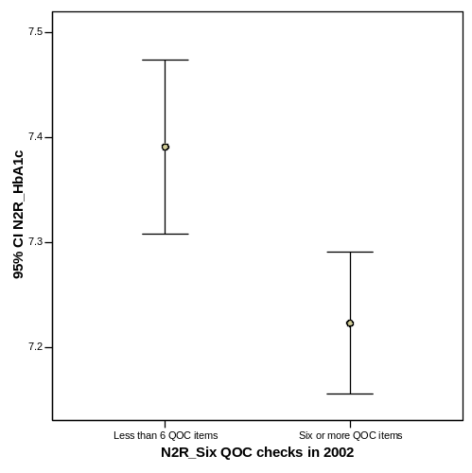 | 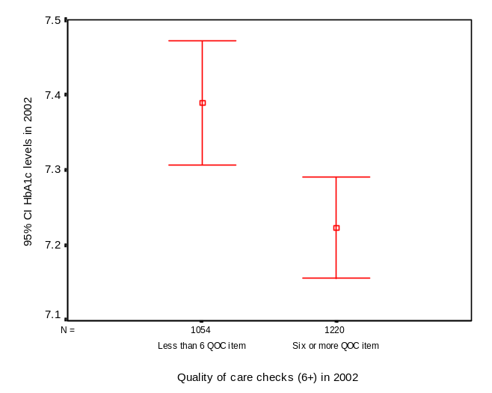

N2R_Blood pressure categories * N2R_Six QOC checks in 2002 Crosstabulation

 |  |  | N2R_Six QOC checks in 2002 |  | Total
 |  |  | Less than 6 QOC items | Six or more QOC items | Total
N2R_Blood pressure categories | <130/85 | Count | 312 | 324 | 636
N2R_Blood pressure categories | <130/85 | % within N2R_Six QOC checks in 2002 | 25.4% | 26.5% | 26.0%
N2R_Blood pressure categories | >130/85 | Count | 916 | 898 | 1814
N2R_Blood pressure categories | >130/85 | % within N2R_Six QOC checks in 2002 | 74.6% | 73.5% | 74.0%
Total |  | Count | 1228 | 1222 | 2450
 |  | % within N2R_Six QOC checks in 2002 | 100.0% | 100.0% | 100.0%

Chi-Square Tests

 | Value | df | Asymp. Sig. (2-sided) | Exact Sig. (2-sided) | Exact Sig. (1-sided)
Pearson Chi-Square | .390(b) | 1 | .532
Continuity Correction(a) | .335 | 1 | .563
Likelihood Ratio | .390 | 1 | .532
Fisher's Exact Test |  |  |  | .549 | .281
Linear-by-Linear Association | .390 | 1 | .532
N of Valid Cases | 2450
a Computed only for a 2x2 table
b 0 cells (.0%) have expected count less than 5. The minimum expected count is 317.22.

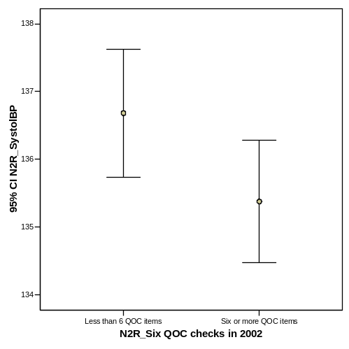
T-Test

Group Statistics

 | N2R_Six QOC checks in 2002 | N | Mean | Std. Deviation | Std. Error Mean
N2R_SystolBP | Less than 6 QOC items | 1228 | 136.68 | 16.918 | .483
N2R_SystolBP | Six or more QOC items | 1222 | 135.38 | 16.087 | .460

Independent Samples Test

 |  | Levene's Test for Equality of Variances |  | t-test for Equality of Means
 |  | F | Sig. | t | df | Sig. (2-tailed) | Mean Difference | Std. Error Difference | 95% Confidence Interval of the Difference
 |  |  |  |  |  |  |  |  | Lower | Upper
N2R_SystolBP | Equal variances assumed | 3.763 | .053 | 1.953 | 2448 | .051 | 1.303 | .667 | -.005 | 2.611
N2R_SystolBP | Equal variances not assumed |  |  | 1.953 | 2442.965 | .051 | 1.303 | .667 | -.005 | 2.611

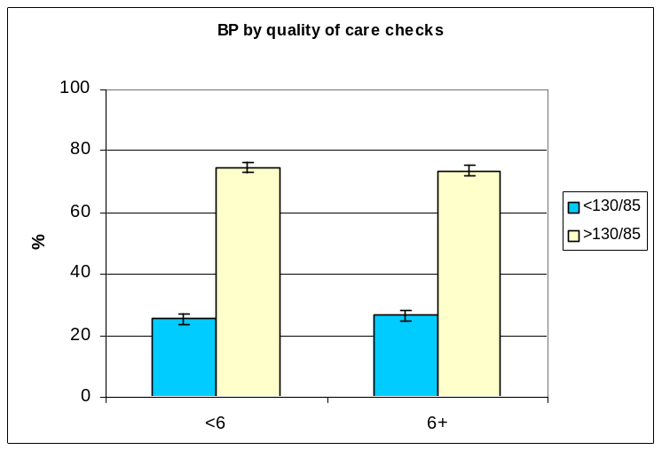  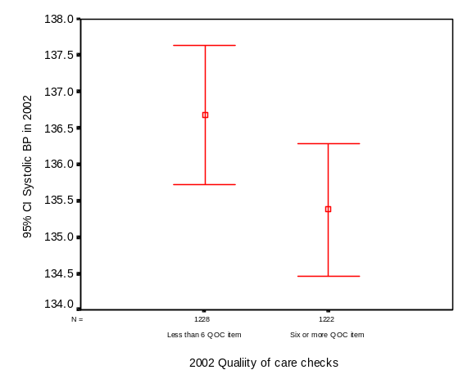 | 37. Quality of care 2002 (6 items) effect on BP  BP quality of care targets (<130/85 & >130/85) were compared for patients with <6 and =>6 items of care. There were not significant differences (χ²=.390; df=1; p=.532).  The error bar plots compare mean systolic BP in 2002 by whether or not patients had 6+ quality of care checks. The graph indicates that there may be a significant difference between the two groups. An independent samples t-test was conducted to compare the two groups and found the results not significant (t=1.953; df=2448; p=.051)
   |  |  | <6 | 6+ | Total
   | BP <130/85) % |  | 25.4 | 26.5
   | n |  | 312 | 324 | 636
   | 95%CI |  | 1.72 | 1.75
   | CI lower |  | 23.7 | 24.8
   | CI upper |  | 27.1 | 28.2
   |  | <6 |  | 6+
  BP >130/85 % |  | 74.6 |  | 73.5
  n |  | 916 |  | 898 |  | 1814
  95%CI |  | 1.72 |  | 1.75
  CI lower |  | 72.9 |  | 71.8
  CI upper |  | 76.3 |  | 75.2
   |  |  |  |  |  | 2450

N2R_Cholesterol categories * N2R_Six QOC checks in 2002 Crosstabulation

 |  |  | N2R_Six QOC checks in 2002 |  | Total
 |  |  | Less than 6 QOC items | Six or more QOC items | Total
N2R_Cholesterol categories | <5.0mmol/L | Count | 418 | 694 | 1112
N2R_Cholesterol categories | <5.0mmol/L | % within N2R_Six QOC checks in 2002 | 53.1% | 59.5% | 56.9%
N2R_Cholesterol categories | >= 5.0mmol/L | Count | 369 | 473 | 842
N2R_Cholesterol categories | >= 5.0mmol/L | % within N2R_Six QOC checks in 2002 | 46.9% | 40.5% | 43.1%
Total |  | Count | 787 | 1167 | 1954
 |  | % within N2R_Six QOC checks in 2002 | 100.0% | 100.0% | 100.0%

Chi-Square Tests

 | Value | df | Asymp. Sig. (2-sided) | Exact Sig. (2-sided) | Exact Sig. (1-sided)
Pearson Chi-Square | 7.742(b) | 1 | .005
Continuity Correction(a) | 7.485 | 1 | .006
Likelihood Ratio | 7.731 | 1 | .005
Fisher's Exact Test |  |  |  | .006 | .003
Linear-by-Linear Association | 7.738 | 1 | .005
N of Valid Cases | 1954
a Computed only for a 2x2 table
b 0 cells (.0%) have expected count less than 5. The minimum expected count is 339.13.
38. Quality of care (6 items) in 2002 - effect on total cholesterol  Total cholesterol quality of care targets (<5.0mmol/L & >=5.0mmol/L) were compared for patients with <6 and =>6 items of care in the following year. The differences between the <6 and 6+ categories were significant (χ²=7.742;df=1; p<.0.05).  The error plot compares total cholesterol levels in 2002 by whether or not patients had six or more quality of care checks in 2002. The plots indicate there was a significant difference. An independent sample t-test was conducted and showed the following significant result: t=1.982; df=1952; p<.05. | 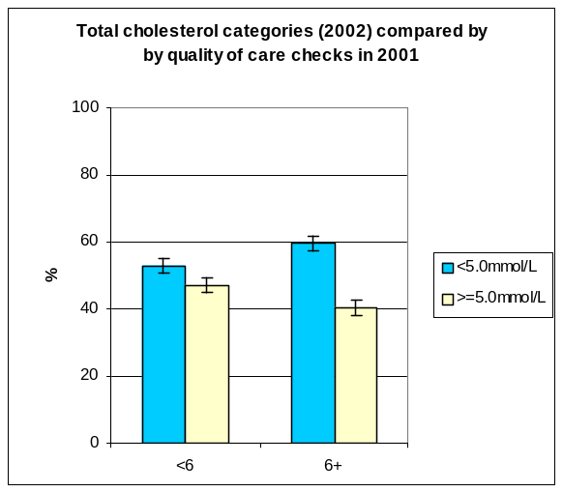  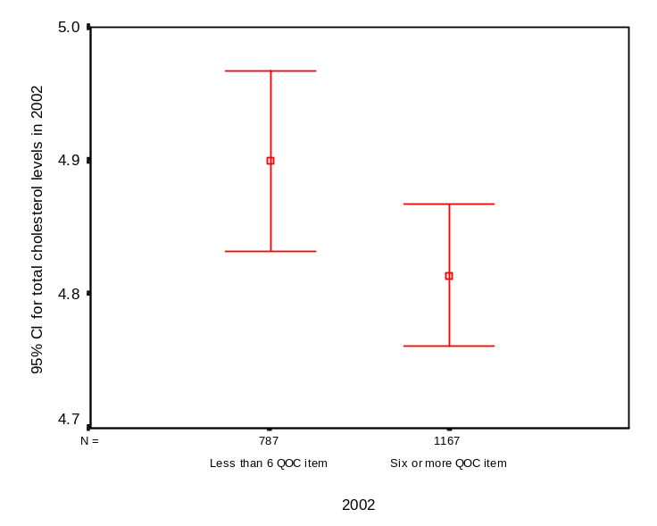
   |  | <6 |  | 6+
   | Tchol <5.0mmol/L % | 53.1 |  | 59.5
   | n | 418 |  | 694 |  |  | 1112
   | 95%CI | 2.21 |  | 2.18
   | CI lower | 50.9 |  | 57.3
   | CI upper | 55.3 |  | 61.7
   |  |  | <6 |  | 6+
  Tchol >= 5.0mmol/L % |  |  | 46.9 |  | 40.5
  n |  |  | 369 |  | 473 | 842
  95%CI |  |  | 2.21 |  | 2.18
  CI lower |  |  | 44.7 |  | 38.3
  CI upper |  |  | 49.1 |  | 42.7
   |  |  |  |  |  | 1954
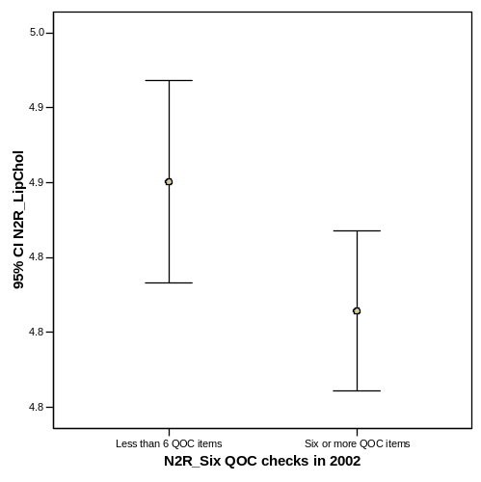

Group Statistics

 | N2R_Six QOC checks in 2002 | N | Mean | Std. Deviation | Std. Error Mean
N2R_LipChol | Less than 6 QOC items | 787 | 4.90 | .965 | .034
N2R_LipChol | Six or more QOC items | 1167 | 4.81 | .927 | .027

Independent Samples Test

 |  | Levene's Test for Equality of Variances |  | t-test for Equality of Means
 |  | F | Sig. | t | df | Sig. (2-tailed) | Mean Difference | Std. Error Difference | 95% Confidence Interval of the Difference
 |  |  |  |  |  |  |  |  | Lower | Upper
N2R_LipChol | Equal variances assumed | 2.478 | .116 | 1.982 | 1952 | .048 | .086 | .043 | .001 | .171
N2R_LipChol | Equal variances not assumed |  |  | 1.967 | 1640.541 | .049 | .086 | .044 | .000 | .172

N2R_Cholesterol categories * N2R_Three pathology lab tests (HbA1c, TChol, uAlb) Crosstabulation

 |  |  | N2R_Three pathology lab tests (HbA1c, TChol, uAlb) |  | Total
 |  |  | Less than 3 pathology tests in 2002 | 3 pathology tests in 2002 | Total
N2R_Cholesterol categories | <5.0mmol/L | Count | 418 | 694 | 1112
N2R_Cholesterol categories | <5.0mmol/L | % within N2R_Three pathology lab tests (HbA1c, TChol, uAlb) | 53.0% | 59.5% | 56.9%
N2R_Cholesterol categories | >= 5.0mmol/L | Count | 370 | 472 | 842
N2R_Cholesterol categories | >= 5.0mmol/L | % within N2R_Three pathology lab tests (HbA1c, TChol, uAlb) | 47.0% | 40.5% | 43.1%
Total |  | Count | 788 | 1166 | 1954
 |  | % within N2R_Three pathology lab tests (HbA1c, TChol, uAlb) | 100.0% | 100.0% | 100.0%

Chi-Square Tests

 | Value | df | Asymp. Sig. (2-sided) | Exact Sig. (2-sided) | Exact Sig. (1-sided)
Pearson Chi-Square | 8.037(b) | 1 | .005
Continuity Correction(a) | 7.775 | 1 | .005
Likelihood Ratio | 8.025 | 1 | .005
Fisher's Exact Test |  |  |  | .005 | .003
Linear-by-Linear Association | 8.033 | 1 | .005 |  | 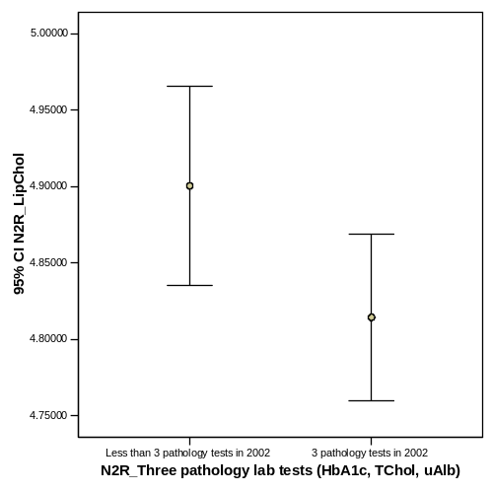
N of Valid Cases | 1954
a Computed only for a 2x2 table
b 0 cells (.0%) have expected count less than 5. The minimum expected count is 339.56.

Group Statistics

 | N2R_Three pathology lab tests (HbA1c, TChol, uAlb) | N | Mean | Std. Deviation | Std. Error Mean
N2R_LipChol | Less than 3 pathology tests in 2002 | 788 | 4.90 | .932 | .033
N2R_LipChol | 3 pathology tests in 2002 | 1166 | 4.81 | .950 | .028

Independent Samples Test

 |  | Levene's Test for Equality of Variances |  | t-test for Equality of Means
 |  | F | Sig. | t | df | Sig. (2-tailed) | Mean Difference | Std. Error Difference | 95% Confidence Interval of the Difference
 |  |  |  |  |  |  |  |  | Lower | Upper
N2R_LipChol | Equal variances assumed | .008 | .927 | 1.974 | 1952 | .048 | .086 | .043 | .001 | .171
N2R_LipChol | Equal variances not assumed |  |  | 1.981 | 1710.049 | .048 | .086 | .043 | .001 | .171

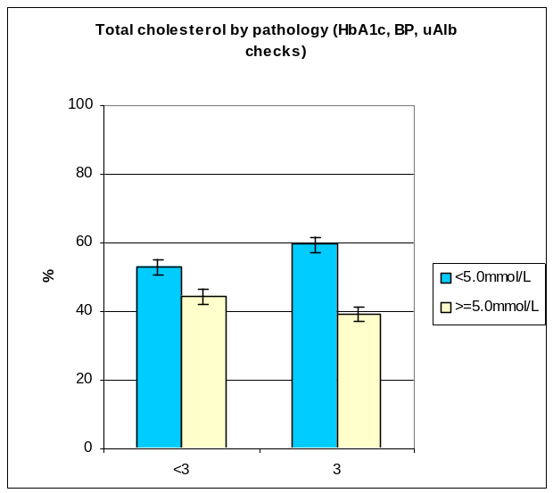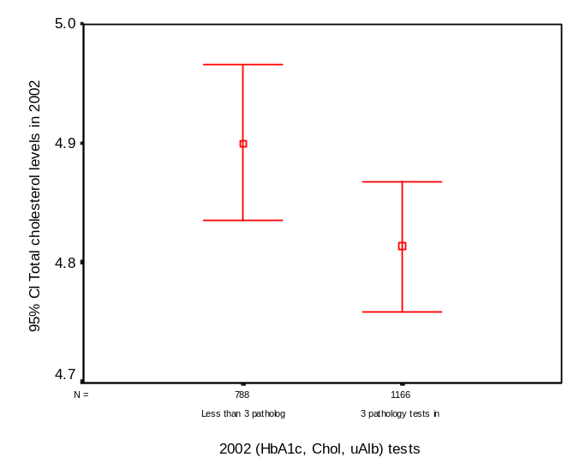 | 39. Pathology lab tests in 2002 (HbA1c, Total cholesterol, uAlbumin) effect on total cholesterol levels in 2002  Total cholesterol quality of care targets (<5.0mmol/L & >=5.0mmol/L) were compared for patients with <3 and 3 pathology lab tests (HbA1c, total cholesterol and uAlbumin). There were significant differences between the <3 and 3 categories (χ²=8.037; df=1; p=.005).  Error bar plots comparing total cholesterol levels for patients with and without three pathology lab tests (HbA1c, total cholesterol and uAlb) showed that there was a significant difference between the two groups.
   |  |  | <3 | 3 |  | Total
   | Tchol <5.0mmol/L % |  | 53 | 59.5
   | n |  | 418 | 694 |  | 1112
   | 95%CI |  | 2.21 | 2.18
   | CI lower |  | 50.8 | 57.3
   | CI upper |  | 55.2 | 61.7
   |  | <3 |  |  | 3
  Tchol >= 5.0mmol/L % |  | 47 |  |  | 40.5
  n |  | 370 |  |  | 472 | 842
  95%CI |  | 2.21 |  |  | 2.18
  CI lower |  | 44.8 |  |  | 38.3
  CI upper |  | 49.2 |  |  | 42.7
   |  | 1954 |  |  | 1954 | 1954
N2R_Blood pressure categories * N2R_Three pathology lab tests (HbA1c, TChol, uAlb) Crosstabulation

 |  |  | N2R_Three pathology lab tests (HbA1c, TChol, uAlb) |  | Total
 |  |  | Less than 3 pathology tests in 2002 | 3 pathology tests in 2002 | Total
N2R_Blood pressure categories | <130/85 | Count | 339 | 297 | 636
N2R_Blood pressure categories | <130/85 | % within N2R_Three pathology lab tests (HbA1c, TChol, uAlb) | 24.9% | 27.3% | 26.0%
N2R_Blood pressure categories | >130/85 | Count | 1022 | 792 | 1814
N2R_Blood pressure categories | >130/85 | % within N2R_Three pathology lab tests (HbA1c, TChol, uAlb) | 75.1% | 72.7% | 74.0%
Total |  | Count | 1361 | 1089 | 2450
 |  | % within N2R_Three pathology lab tests (HbA1c, TChol, uAlb) | 100.0% | 100.0% | 100.0%

Chi-Square Tests

 | Value | df | Asymp. Sig. (2-sided) | Exact Sig. (2-sided) | Exact Sig. (1-sided)
Pearson Chi-Square | 1.760(b) | 1 | .185
Continuity Correction(a) | 1.639 | 1 | .200
Likelihood Ratio | 1.756 | 1 | .185
Fisher's Exact Test |  |  |  | .194 | 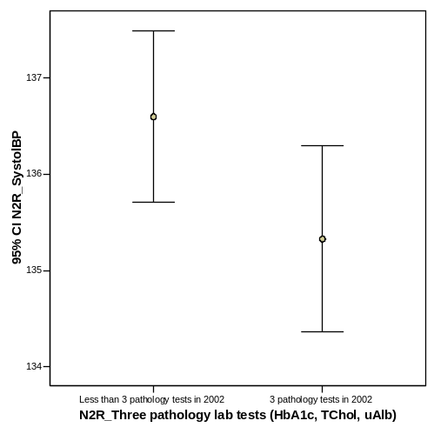  .100
Linear-by-Linear Association | 1.759 | 1 | .185
N of Valid Cases | 2450
a Computed only for a 2x2 table
b 0 cells (.0%) have expected count less than 5. The minimum expected count is 282.70.

T-Test
Group Statistics

 | N2R_Three pathology lab tests (HbA1c, TChol, uAlb) | N | Mean | Std. Deviation | Std. Error Mean
N2R_SystolBP | Less than 3 pathology tests in 2002 | 1361 | 136.60 | 16.716 | .453
N2R_SystolBP | 3 pathology tests in 2002 | 1089 | 135.33 | 16.248 | .492

Independent Samples Test

 |  | Levene's Test for Equality of Variances |  | t-test for Equality of Means
 |  | F | Sig. | t | df | Sig. (2-tailed) | Mean Difference | Std. Error Difference | 95% Confidence Interval of the Difference
 |  |  |  |  |  |  |  |  | Lower | Upper
N2R_SystolBP | Equal variances assumed | .831 | .362 | 1.891 | 2448 | .059 | 1.269 | .671 | -.047 | 2.585
N2R_SystolBP | Equal variances not assumed |  |  | 1.897 | 2358.121 | .058 | 1.269 | .669 | -.043 | 2.581

41. Pathology lab tests (HbA1c, Total cholesterol, uAlbumin) in 2002 - effect on BP.  BP quality of care targets (<130/85 mm/Hg & >130/85mm/Hg) were compared for patients with <3 and 3 pathology lab tests (HbA1c, total cholesterol and uAlbumin). There were no significant differences between the <3 and 3 categories (χ²=1.760; df=1; p=.185).  Error plots compared systolic BP levels in 2002 for patients with or without three pathology tests. The error plots indicate that there was a significant difference.  → insignificant difference according to independent t-test (p-value = 0.059) | 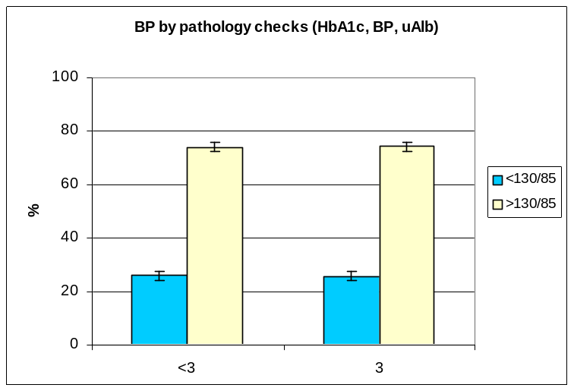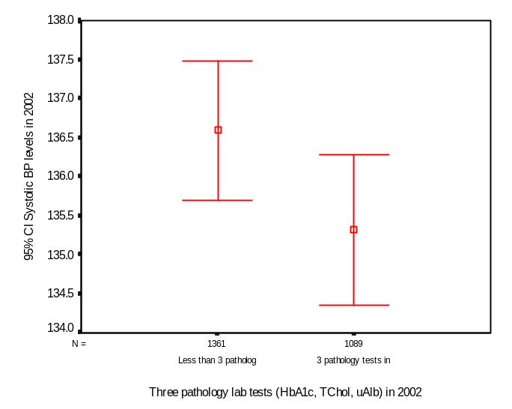
   |  |  | <3 |  | 3 |  | Total
   | BP <130/85) % |  | 24.9 |  | 27.3
   | n |  | 339 |  | 297 |  | 636
   | 95%CI |  | 1.71 |  | 1.76
   | CI lower |  | 23.2 |  | 25.5
   | CI upper |  | 26.6 |  | 29.1
   |  | <3 |  | 3
  BP >130/85 % |  | 75.1 |  | 72.7
   |  | 1022 |  | 792 |  | 1814
   |  | 1.71 |  | 1.76
   |  | 73.4 |  | 70.9
   |  | 76.8 |  | 74.5
  Total sample |  |  |  |  |  | 2450
N2R_Grouped HbA1c * N2R_Three pathology lab tests (HbA1c, TChol, uAlb) Crosstabulation

 |  |  | N2R_Three pathology lab tests (HbA1c, TChol, uAlb) |  | Total
 |  |  | Less than 3 pathology tests in 2002 | 3 pathology tests in 2002 | Total
N2R_Grouped HbA1c | <= 1% above ULN | Count | 640 | 688 | 1328
N2R_Grouped HbA1c | <= 1% above ULN | % within N2R_Three pathology lab tests (HbA1c, TChol, uAlb) | 57.8% | 59.0% | 58.4%
N2R_Grouped HbA1c | >1% <=2% above ULN | Count | 241 | 271 | 512
N2R_Grouped HbA1c | >1% <=2% above ULN | % within N2R_Three pathology lab tests (HbA1c, TChol, uAlb) | 21.8% | 23.2% | 22.5%
N2R_Grouped HbA1c | >2% above ULN | Count | 226 | 207 | 433
N2R_Grouped HbA1c | >2% above ULN | % within N2R_Three pathology lab tests (HbA1c, TChol, uAlb) | 20.4% | 17.8% | 19.0%
Total |  | Count | 1107 | 1166 | 2273
 |  | % within N2R_Three pathology lab tests (HbA1c, TChol, uAlb) | 100.0% | 100.0% | 100.0%

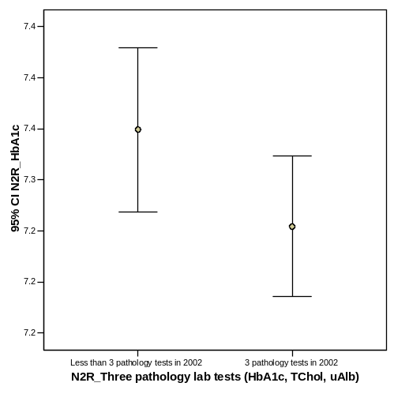
Chi-Square Tests

 | Value | df | Asymp. Sig. (2-sided)
Pearson Chi-Square | 2.797(a) | 2 | .247
Likelihood Ratio | 2.796 | 2 | .247
Linear-by-Linear Association | 1.360 | 1 | .243
N of Valid Cases | 2273
a 0 cells (.0%) have expected count less than 5. The minimum expected count is 210.88.

T-Test

Group Statistics

 | N2R_Three pathology lab tests (HbA1c, TChol, uAlb) | N | Mean | Std. Deviation | Std. Error Mean
N2R_HbA1c | Less than 3 pathology tests in 2002 | 1107 | 7.35 | 1.365 | .041
N2R_HbA1c | 3 pathology tests in 2002 | 1166 | 7.25 | 1.198 | .035

Independent Samples Test
 |  | Levene's Test for Equality of Variances |  | t-test for Equality of Means
 |  | F | Sig. | t | df | Sig. (2-tailed) | Mean Difference | Std. Error Difference | 95% Confidence Interval of the Difference
 |  |  |  |  |  |  |  |  | Lower | Upper
N2R_HbA1c | Equal variances assumed | 13.053 | .000 | 1.766 | 2271 | .077 | .095 | .054 | -.010 | .201
N2R_HbA1c | Equal variances not assumed |  |  | 1.760 | 2198.657 | .078 | .095 | .054 | -.011 | .201

For binomial grouping (within/outside target) → no significant difference
N2R_HbA1c levels in binominal grouping * N2R_Three pathology lab tests (HbA1c, TChol, uAlb) Crosstabulation

 |  |  | N2R_Three pathology lab tests (HbA1c, TChol, uAlb) |  | Total
 |  |  | Less than 3 pathology tests in 2002 | 3 pathology tests in 2002 | Total
N2R_HbA1c levels in binominal grouping | Within target (<= 1% above ULN) | Count | 640 | 688 | 1328
N2R_HbA1c levels in binominal grouping | Within target (<= 1% above ULN) | % within N2R_Three pathology lab tests (HbA1c, TChol, uAlb) | 57.8% | 59.0% | 58.4%
N2R_HbA1c levels in binominal grouping | Outside target (>1% about ULN) | Count | 467 | 478 | 945
N2R_HbA1c levels in binominal grouping | Outside target (>1% about ULN) | % within N2R_Three pathology lab tests (HbA1c, TChol, uAlb) | 42.2% | 41.0% | 41.6%
Total |  | Count | 1107 | 1166 | 2273
 |  | % within N2R_Three pathology lab tests (HbA1c, TChol, uAlb) | 100.0% | 100.0% | 100.0%
Chi-Square Tests

 | Value | df | Asymp. Sig. (2-sided) | Exact Sig. (2-sided) | Exact Sig. (1-sided)
Pearson Chi-Square | .332(b) | 1 | .565
Continuity Correction(a) | .285 | 1 | .594
Likelihood Ratio | .332 | 1 | .565
Fisher's Exact Test |  |  |  | .580 | .297
Linear-by-Linear Association | .332 | 1 | .565
N of Valid Cases | 2273
a Computed only for a 2x2 table
b 0 cells (.0%) have expected count less than 5. The minimum expected count is 460.24.

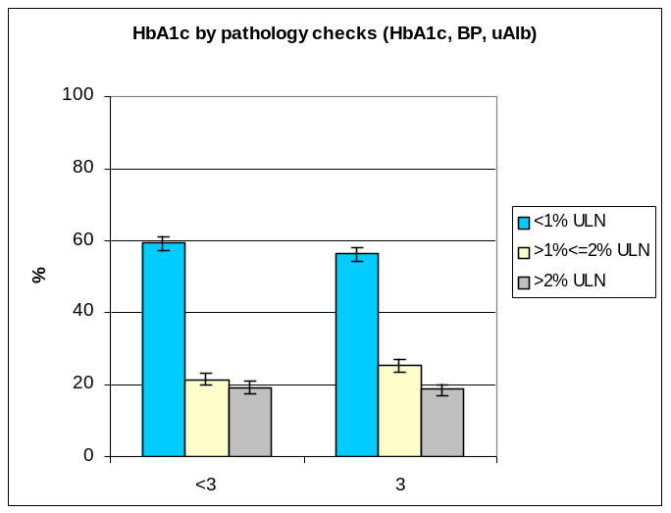  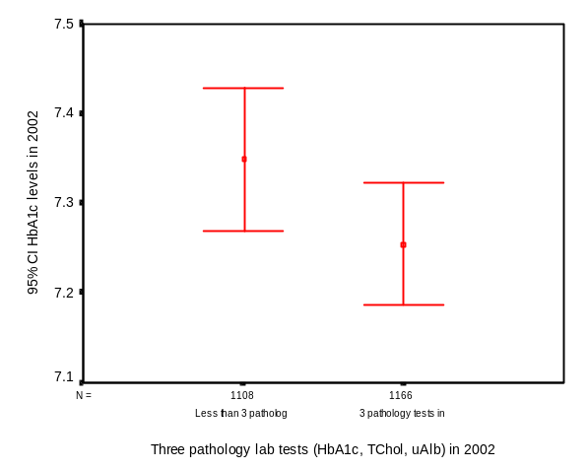 | 42. Pathology tests (HbA1c, Total cholesterol, uAlbumin,) in 2002 effect on HbA1c.  HbA1c quality of care targets (<=1% above ULN, >1% <= 2% above ULN >2% above ULN) were compared for patients with <4 and 4 HIC tests (HbA1c, total cholesterol, and uAlbumin). There were no significant differences between the <4 and 4 categories (χ²=2.797; df=2; p=.247).  .Error bar plots compared 2002 HbA1c levels by the groups (with and without) three pathology tests. The plots show a significant difference. → again inconsistent with t-test.
   |  |  |  |  | <3 | 3 |  |  |  | Total
   |  | HbA1c (target) % |  |  | 57.8 | 59
   |  | n |  |  | 640 | 688 |  |  |  | 1328
   |  | 95%CI |  |  | 2.03 | 2.02
   |  | CI lower |  |  | 55.8 | 57.0
   |  | CI upper |  |  | 59.8 | 61.0
   |  |  |  | <3 |  |  | 3
   | HbA1c (>1%& <=2%ULN) % |  |  | 19.4 |  |  | 20.4
   | n |  |  | 700 |  |  | 639 | 512
   | 95%CI |  |  | 1.63 |  |  | 1.66
   | CI lower |  |  | 17.8 |  |  | 18.7
   | CI upper |  |  | 21.0 |  |  | 22.1
   |  |  | <3 |  |  |  | 3
  HbA1c >2%ULN % |  |  | 21.4 |  |  |  | 18.1
  n |  |  | 772 |  |  |  | 566 |  | 433
  95%CI |  |  | 1.69 |  |  |  | 1.58
  CI lower |  |  | 19.7 |  |  |  | 16.5
  CI upper |  |  | 23.1 |  |  |  | 19.7
  Total sample |  |  | 2273 |  |  |  | 2273 |  | 2273
N2R_Blood pressure categories * N2R_Four HIC tests (HbA1c, TChol, uAlb, eyes) Crosstabulation
 |  |  | N2R_Four HIC tests (HbA1c, TChol, uAlb, eyes) |  | Total
 |  |  | Less than 4 HIC tests in 2002 | 4 HIC tests in 2002 | Total
N2R_Blood pressure categories | <130/85 | Count | 437 | 199 | 636
N2R_Blood pressure categories | <130/85 | % within N2R_Four HIC tests (HbA1c, TChol, uAlb, eyes) | 25.7% | 26.6% | 26.0%
N2R_Blood pressure categories | >130/85 | Count | 1266 | 548 | 1814
N2R_Blood pressure categories | >130/85 | % within N2R_Four HIC tests (HbA1c, TChol, uAlb, eyes) | 74.3% | 73.4% | 74.0%
Total |  | Count | 1703 | 747 | 2450
 |  | % within N2R_Four HIC tests (HbA1c, TChol, uAlb, eyes) | 100.0% | 100.0% | 100.0%

Chi-Square Tests
 | Value | df | Asymp. Sig. (2-sided) | Exact Sig. (2-sided) | Exact Sig. (1-sided)
Pearson Chi-Square | .259(b) | 1 | .611
Continuity Correction(a) | .211 | 1 | .646
Likelihood Ratio | .258 | 1 | .611
Fisher's Exact Test |  |  |  | .617 | .322
Linear-by-Linear Association | .259 | 1 | .611
N of Valid Cases | 2450
a Computed only for a 2x2 table
b 0 cells (.0%) have expected count less than 5. The minimum expected count is 193.92.
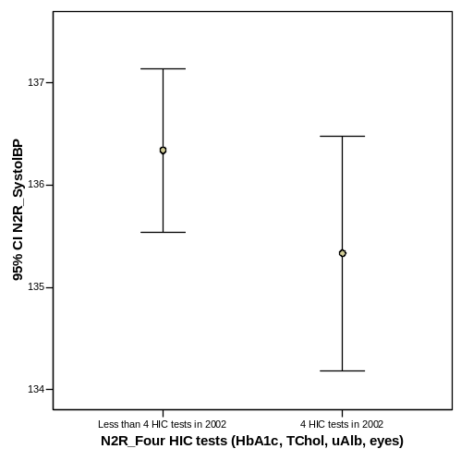
T-Test

Group Statistics

 | N2R_Four HIC tests (HbA1c, TChol, uAlb, eyes) | N | Mean | Std. Deviation | Std. Error Mean
N2R_SystolBP | Less than 4 HIC tests in 2002 | 1703 | 136.34 | 16.758 | .406
N2R_SystolBP | 4 HIC tests in 2002 | 747 | 135.33 | 15.946 | .583

Independent Samples Test

 |  | Levene's Test for Equality of Variances |  | t-test for Equality of Means
 |  | F | Sig. | t | df | Sig. (2-tailed) | Mean Difference | Std. Error Difference | 95% Confidence Interval of the Difference
 |  |  |  |  |  |  |  |  | Lower | Upper
N2R_SystolBP | Equal variances assumed | 3.123 | .077 | 1.388 | 2448 | .165 | 1.006 | .725 | -.416 | 2.427
N2R_SystolBP | Equal variances not assumed |  |  | 1.415 | 1490.608 | .157 | 1.006 | .711 | -.389 | 2.400

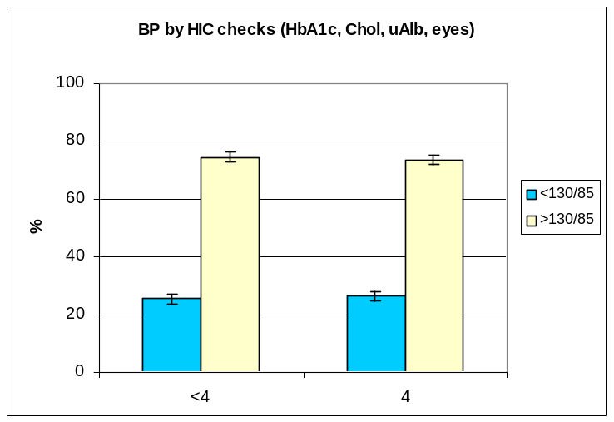  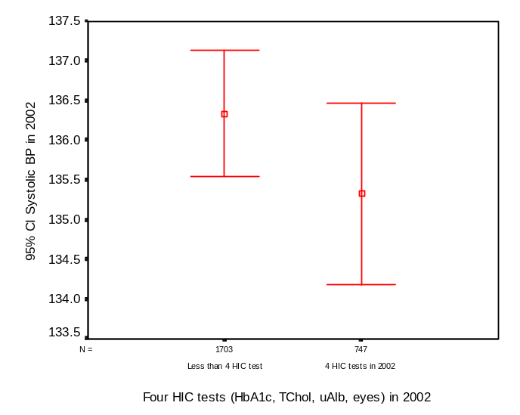 | 43. HIC tests in 2002 (HbA1c, Total cholesterol, uAlbumin, eys) effect on BP  BP quality of care targets (<130/85 mmHg, >103/85 mmHg) were compared for patients with <4 and 4 HIC tests (HbA1c, total cholesterol, eyes and uAlbumin). There were no significant differences between the <4 and 4 categories (χ²=0.259;df=1; p=0.611).  Error bars plots for diastolic systolic BP levels in 2002 compared patients with and without the four HIC tests. The error plots show that there was not a significant difference.
   |  |  | <4 | 4 |  | Total
   | BP <130/85) % |  | 25.7 | 26.6
   | n |  | 437 | 199 |  | 636
   | 95%CI |  | 1.73 | 1.75
   | CI lower |  | 24.0 | 24.9
   | CI upper |  | 27.4 | 28.3
   |  | <4 |  |  | 4
  BP >130/85 % |  | 74.3 |  |  | 73.4
  n |  | 1266 |  |  | 548 | 1814
  95%CI |  | 1.73 |  |  | 1.75
  CI lower |  | 72.6 |  |  | 71.7
  CI upper |  | 76.0 |  |  | 75.1
  Total sample |  |  |  |  |  | 2450
N2R_Cholesterol categories * N2R_Four HIC tests (HbA1c, TChol, uAlb, eyes) Crosstabulation
 |  |  | N2R_Four HIC tests (HbA1c, TChol, uAlb, eyes) |  | Total
 |  |  | Less than 4 HIC tests in 2002 | 4 HIC tests in 2002 | Total
N2R_Cholesterol categories | <5.0mmol/L | Count | 649 | 463 | 1112
N2R_Cholesterol categories | <5.0mmol/L | % within N2R_Four HIC tests (HbA1c, TChol, uAlb, eyes) | 54.7% | 60.4% | 56.9%
N2R_Cholesterol categories | >= 5.0mmol/L | Count | 538 | 304 | 842
N2R_Cholesterol categories | >= 5.0mmol/L | % within N2R_Four HIC tests (HbA1c, TChol, uAlb, eyes) | 45.3% | 39.6% | 43.1%
Total |  | Count | 1187 | 767 | 1954
 |  | % within N2R_Four HIC tests (HbA1c, TChol, uAlb, eyes) | 100.0% | 100.0% | 100.0%

Chi-Square Tests
 | Value | df | Asymp. Sig. (2-sided) | Exact Sig. (2-sided) | Exact Sig. (1-sided)
Pearson Chi-Square | 6.150(b) | 1 | .013
Continuity Correction(a) | 5.920 | 1 | .015
Likelihood Ratio | 6.169 | 1 | .013
Fisher's Exact Test |  |  |  | .013 | .007
Linear-by-Linear Association | 6.147 | 1 | .013
N of Valid Cases | 1954
a Computed only for a 2x2 table
b 0 cells (.0%) have expected count less than 5. The minimum expected count is 330.51.
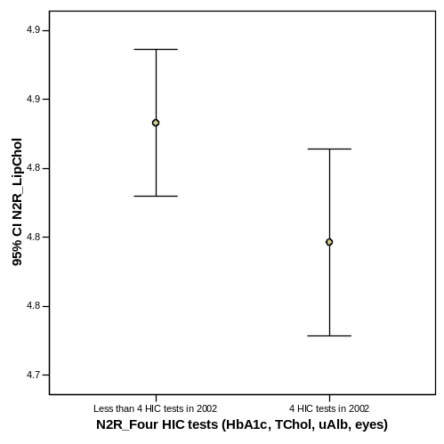
T-Test

Group Statistics

 | N2R_Four HIC tests (HbA1c, TChol, uAlb, eyes) | N | Mean | Std. Deviation | Std. Error Mean
N2R_LipChol | Less than 4 HIC tests in 2002 | 1187 | 4.88 | .934 | .027
N2R_LipChol | 4 HIC tests in 2002 | 767 | 4.80 | .956 | .035

Independent Samples Test

 |  | Levene's Test for Equality of Variances |  | t-test for Equality of Means
 |  | F | Sig. | t | df | Sig. (2-tailed) | Mean Difference | Std. Error Difference | 95% Confidence Interval of the Difference
 |  |  |  |  |  |  |  |  | Lower | Upper
N2R_LipChol | Equal variances assumed | .127 | .722 | 1.980 | 1952 | .048 | .087 | .044 | .001 | .172
N2R_LipChol | Equal variances not assumed |  |  | 1.971 | 1607.994 | .049 | .087 | .044 | .000 | .173

44. HIC tests in 2002 (HbA1c, Total cholesterol, uAlbumin, eys) effect on total cholesterol  Total cholesterol quality of care targets (<5.0 mmol/L, >=5.0mmol/L) were compared for patients with <4 and 4 HIC tests (HbA1c, total cholesterol, eyes and uAlbumin). There were significant differences between the <4 and 4 categories (χ²=6.150; df=1; p<.05).  Error plots for total cholesterol levels in 2002 compared two groups (those with or without three HIC tests). The plots show a significant difference between the two groups.  → HIC tests effect on hbA1c? | 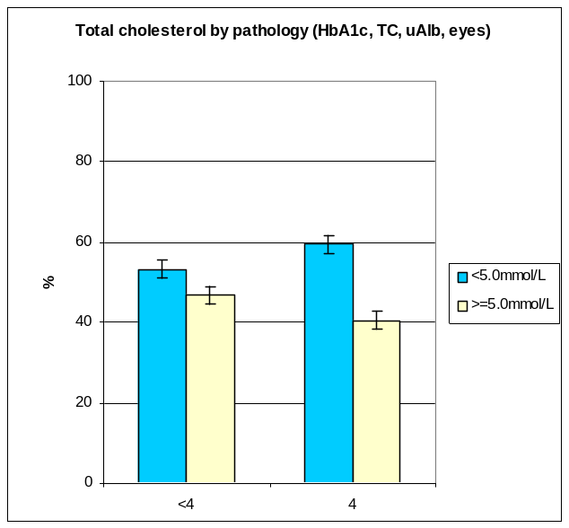  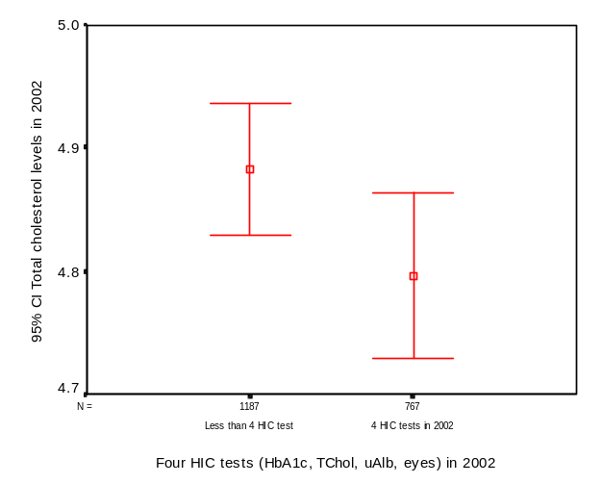
   |  |  | <4 | 4 |  | Total
   | Tchol <5.0mmol/L % |  | 54.7 | 60.4
   | n |  | 649 | 463 |  | 1112
   | 95%CI |  | 2.21 | 2.17
   | CI lower |  | 52.5 | 58.2
   | CI upper |  | 56.9 | 62.6
   |  | <4 |  |  | 4
  Tchol >= 5.0mmol/L % |  | 45.3 |  |  | 39.6
  n |  | 538 |  |  | 304 |  | 842
  95%CI |  | 2.21 |  |  | 2.17
  CI lower |  | 43.1 |  |  | 37.4
  CI upper |  | 47.5 |  |  | 41.8
  Total sample |  |  |  |  |  |  | 1954
N2R_HbA1c levels in binominal grouping * N2R_ Seven QOC checks in 2002 Crosstabulation

 |  |  | N2R_ Seven QOC checks in 2002 |  | Total
 |  |  | Less than 7 QOC checks | Seven QOC checks | Total
N2R_HbA1c levels in binominal grouping | Within target (<= 1% above ULN) | Count | 975 | 353 | 1328
N2R_HbA1c levels in binominal grouping | Within target (<= 1% above ULN) | % within N2R_ Seven QOC checks in 2002 | 58.1% | 59.4% | 58.4%
N2R_HbA1c levels in binominal grouping | Outside target (>1% about ULN) | Count | 704 | 241 | 945
N2R_HbA1c levels in binominal grouping | Outside target (>1% about ULN) | % within N2R_ Seven QOC checks in 2002 | 41.9% | 40.6% | 41.6%
Total |  | Count | 1679 | 594 | 2273
 |  | % within N2R_ Seven QOC checks in 2002 | 100.0% | 100.0% | 100.0%

Chi-Square Tests

 | Value | df | Asymp. Sig. (2-sided) | Exact Sig. (2-sided) | Exact Sig. (1-sided)
Pearson Chi-Square | .333(b) | 1 | .564
Continuity Correction(a) | .279 | 1 | .597
Likelihood Ratio | .333 | 1 | .564
Fisher's Exact Test |  |  |  | .594 | .299
Linear-by-Linear Association | .333 | 1 | .564
N of Valid Cases | 2273
a Computed only for a 2x2 table
b 0 cells (.0%) have expected count less than 5. The minimum expected count is 246.96.

T-Test
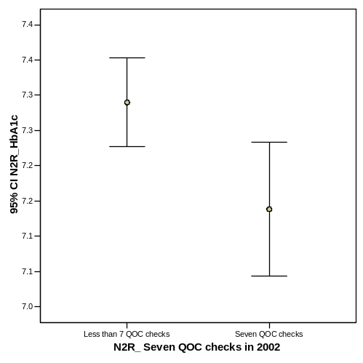
Group Statistics

 | N2R_ Seven QOC checks in 2002 | N | Mean | Std. Deviation | Std. Error Mean
N2R_HbA1c | Less than 7 QOC checks | 1680 | 7.34 | 1.315 | .032
N2R_HbA1c | Seven QOC checks | 594 | 7.19 | 1.179 | .048

Independent Samples Test

 |  | Levene's Test for Equality of Variances |  | t-test for Equality of Means
 |  | F | Sig. | t | df | Sig. (2-tailed) | Mean Difference | Std. Error Difference | 95% Confidence Interval of the Difference
 |  |  |  |  |  |  |  |  | Lower | Upper
N2R_HbA1c | Equal variances assumed | 9.335 | .002 | 2.475 | 2272 | .013 | .151 | .061 | .031 | .271
N2R_HbA1c | Equal variances not assumed |  |  | 2.608 | 1151.474 | .009 | .151 | .058 | .038 | .265

45. Quality of care 2002 (all items) effect on HbA1c  HbA1c levels for 2002 were compared for those who had all seven Quality of Care tests against those that had less than seven tests. An independent samples t-test between the two groups showed a significant difference (t= 2.608; df=1151.47; p<.05).  HbA1c levels for within target (<=1%ULN) and outside target (>1%ULN) were tested using the Chi Square test. The results were not significant (Chi-square = .333; df=1; p=.564). | 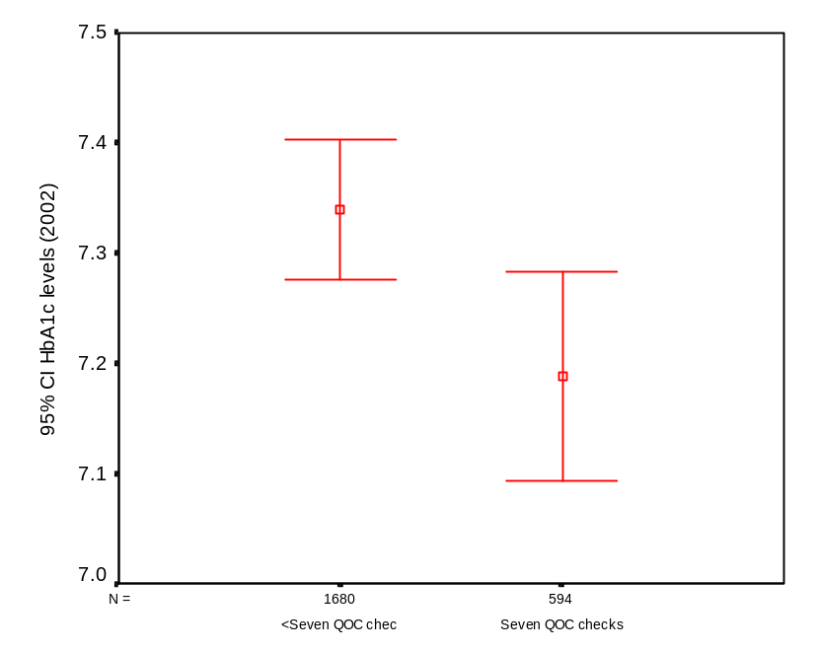
   | N2R_HbA1c levels in binominal grouping |  | Total
   | Within target (<= 1% above ULN) | Outside target (>1% about ULN)
  Less than 7 QOC checks | 975 | 704 | 1679
   | 58.1% | 41.9% | 100.0%
  Seven QOC checks | 353 | 241 | 594
   | 59.4% | 40.6% | 100.0%
   | 1328 | 945 | 2273
   | 58.4% | 41.6% | 100.0%
N2R_Blood pressure categories * N2R_ Seven QOC checks in 2002 Crosstabulation

 |  |  | N2R_ Seven QOC checks in 2002 |  | Total
 |  |  | Less than 7 QOC checks | Seven QOC checks | Total
N2R_Blood pressure categories | <130/85 | Count | 480 | 156 | 636
N2R_Blood pressure categories | <130/85 | % within N2R_ Seven QOC checks in 2002 | 25.9% | 26.3% | 26.0%
N2R_Blood pressure categories | >130/85 | Count | 1376 | 438 | 1814
N2R_Blood pressure categories | >130/85 | % within N2R_ Seven QOC checks in 2002 | 74.1% | 73.7% | 74.0%
Total |  | Count | 1856 | 594 | 2450
 |  | % within N2R_ Seven QOC checks in 2002 | 100.0% | 100.0% | 100.0%

Chi-Square Tests

 | Value | df | Asymp. Sig. (2-sided) | Exact Sig. (2-sided) | Exact Sig. (1-sided)
Pearson Chi-Square | .038(b) | 1 | .846
Continuity Correction(a) | .020 | 1 | .889
Likelihood Ratio | .037 | 1 | .846
Fisher's Exact Test |  |  |  | .872 | .443
Linear-by-Linear Association | .038 | 1 | .846
N of Valid Cases | 2450
a Computed only for a 2x2 table
b 0 cells (.0%) have expected count less than 5. The minimum expected count is 154.20.

T-Test
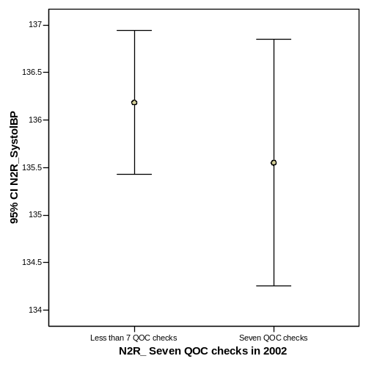

Group Statistics

 | N2R_ Seven QOC checks in 2002 | N | Mean | Std. Deviation | Std. Error Mean
N2R_SystolBP | Less than 7 QOC checks | 1856 | 136.18 | 16.654 | .387
N2R_SystolBP | Seven QOC checks | 594 | 135.55 | 16.089 | .660

Independent Samples Test

 |  | Levene's Test for Equality of Variances |  | t-test for Equality of Means
 |  | F | Sig. | t | df | Sig. (2-tailed) | Mean Difference | Std. Error Difference | 95% Confidence Interval of the Difference
 |  |  |  |  |  |  |  |  | Lower | Upper
N2R_SystolBP | Equal variances assumed | 1.304 | .254 | .815 | 2448 | .415 | .634 | .779 | -.893 | 2.161
N2R_SystolBP | Equal variances not assumed |  |  | .829 | 1030.695 | .407 | .634 | .765 | -.867 | 2.135

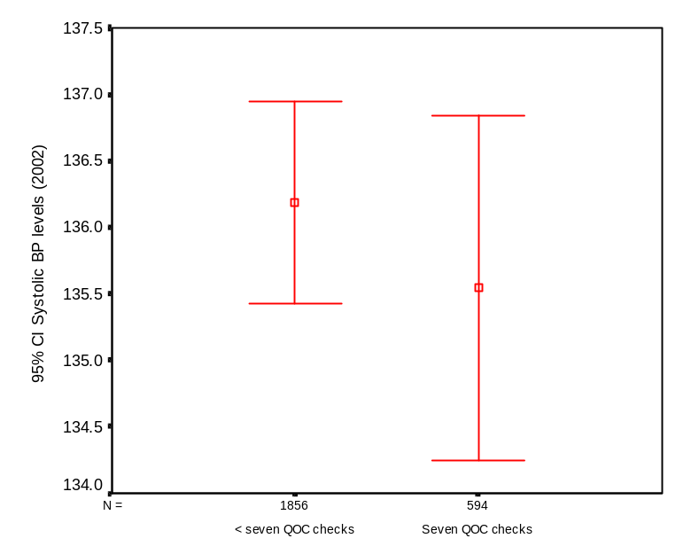 | 46. Quality of care 2002 (all items) effect on BP  Blood pressure systolic levels were compared for those that had all seven QOC tests against those that had less than seven quality of care tests. An independent samples t-test was conducted to compare the two groups and found the results not significant (t=.815; df=2448; p=.415).  BP results for those within target (<130/85) and outside target (>130/85) were compared using the Chi square test and were found to be not significant (Chi square=.038; df=1; p=.846).
   | N2R_Blood pressure categories |  | Total
   | <130/85 | >130/85
  Less than 7 QOC checks | 480 | 1376 | 1856
   | 25.9% | 74.1% | 100.0%
  Seven QOC checks | 156 | 438 | 594
   | 26.3% | 73.7% | 100.0%
   | 636 | 1814 | 2450
   | 26.0% | 74.0% | 100.0%
N2R_Cholesterol categories * N2R_ Seven QOC checks in 2002 Crosstabulation

 |  |  | N2R_ Seven QOC checks in 2002 |  | Total
 |  |  | Less than 7 QOC checks | Seven QOC checks | Total
N2R_Cholesterol categories | <5.0mmol/L | Count | 764 | 348 | 1112
N2R_Cholesterol categories | <5.0mmol/L | % within N2R_ Seven QOC checks in 2002 | 56.2% | 58.6% | 56.9%
N2R_Cholesterol categories | >= 5.0mmol/L | Count | 596 | 246 | 842
N2R_Cholesterol categories | >= 5.0mmol/L | % within N2R_ Seven QOC checks in 2002 | 43.8% | 41.4% | 43.1%
Total |  | Count | 1360 | 594 | 1954
 |  | % within N2R_ Seven QOC checks in 2002 | 100.0% | 100.0% | 100.0%

Chi-Square Tests

 | Value | df | Asymp. Sig. (2-sided) | Exact Sig. (2-sided) | Exact Sig. (1-sided)
Pearson Chi-Square | .979(b) | 1 | .323
Continuity Correction(a) | .883 | 1 | .347
Likelihood Ratio | .981 | 1 | .322
Fisher's Exact Test |  |  |  | .345 | .174
Linear-by-Linear Association | .978 | 1 | .323
N of Valid Cases | 1954
a Computed only for a 2x2 table
b 0 cells (.0%) have expected count less than 5. The minimum expected count is 255.96.

T-Test

Group Statistics

 | N2R_ Seven QOC checks in 2002 | N | Mean | Std. Deviation | Std. Error Mean
N2R_LipChol | Less than 7 QOC checks | 1360 | 4.87 | .938 | .025
N2R_LipChol | Seven QOC checks | 594 | 4.80 | .955 | .039

Independent Samples Test

 |  | Levene's Test for Equality of Variances |  | t-test for Equality of Means
 |  | F | Sig. | t | df | Sig. (2-tailed) | Mean Difference | Std. Error Difference | 95% Confidence Interval of the Difference
 |  |  |  |  |  |  |  |  | Lower | Upper
N2R_LipChol | Equal variances assumed | .347 | .556 | 1.555 | 1952 | .120 | .072 | .046 | -.019 | .163
N2R_LipChol | Equal variances not assumed |  |  | 1.544 | 1111.293 | .123 | .072 | .047 | -.020 | .164

47. Quality of care 2002 (all items) effect on total cholesterol  Total cholesterol levels were compared for those that had all seven QOC tests against those that had less than seven QOC tests. An independent samples t-test was conducted to compare the two groups and found the results not significant (t=1.555; df=1952; p=.120).  Total cholesterol was compared for those within target (<5mmol/L) and those outside target (=>5mmol/L) using a chi-square test and found the differences were not significant (Chi-square = .979; df=1; p=.323) | 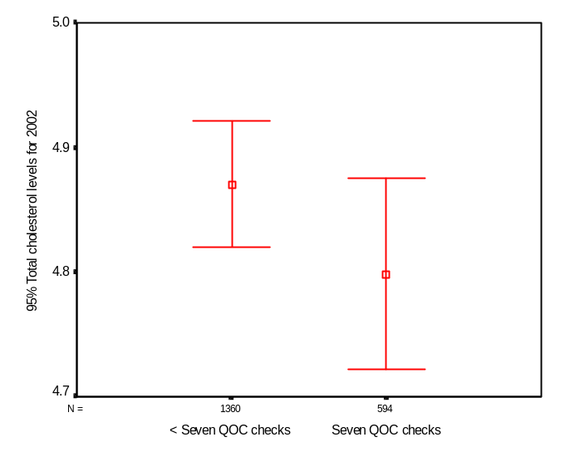
   | N2R_Cholesterol categories |  | Total
   | <5.0mmol/L | >= 5.0mmol/L
  Less than 7 QOC checks | 764 | 596 | 1360
   | 56.2% | 43.8% | 100.0%
  Seven QOC checks | 348 | 246 | 594
   | 58.6% | 41.4% | 100.0%
   | 1112 | 842 | 1954
   | 56.9% | 43.1% | 100.0%
Problems with multiple regression:

- dependent variable regressed against its lagged value (autocorrelation issues) → should develop general linear models (or mixed models) that incorporate repeated measures explicitly (ie both 2000 and 2001 values).

- interaction effects should be considered → despite insignificance in hypothesis testing phase, an explanatory variable may have significant association when modelled with other variables

48. Multiple regression model for HbA1c

Predictors (HbA1c level in 2001; Duration of diabetes; Six quality of care checks; Age)

Model summary: R square = 0.427 (df=4; f=378.71; p<0.0005)

Coefficients (unstandardized):

Constant: 3.606 (SE= 0.179; t=20.105; p<0.0005; 95%CI: 3.254 – 3.958)
2001 HbA1c 0.5558 (SE=0.016; t= 35.066; p<0.0005; 95%CI: 0.527 - 0.589)
Duration of diabetes 0.013 (SE= 0.003; t= 4.3; p<0.0005; 95%CI: 0.007 - 0.019)
Six QoC checks in 2002 -0.132 (SE = 0.044; t= -3.000; p<0.005; 95% CI: -0.218 - -046)
Age -0.006 (SE=0.002; t= -3.749; p<0.0005; 95% CI:-0.010 - -0.003)

Excluded variable:
Gender -0.053 (SE=0.048; t=1.104; p=0.270; 95%CI: -0.041 – 0.148)

49. Multiple regression model for Total cholesterol

Predictors (Total cholesterol level in 2001; gender)

Model summary: R square = 0.311 (df=2; f=318.221; p<0.0005)

Coefficients (unstandardized):

Constant: 2.434 (SE= 0.107; t=22.695; p<0.0005; 95%CI: 2.223 – 2.644)
2001 Total cholesterol 0.500 (SE=0.021; t= 24.398; p<0.0005; 95%CI: 0.460 - 0.541)
Gender -155 (SE= 0.042; t= -3.693; p<0.0005; 95%CI: -0.238 –0.073)

Excluded variables:
Six QoC checks in 2002 -0.122 (SE= 0.42; t= -0.983; p=0.326; 95%CI: -0.126 – 0.041)
Age 0.035 (SE= 0.002; t=-1.565; p=0.118; 95%CI: -0.006 – 0.001)
Duration of diabetes -0.010 (SE=0.003; t= -0.466; p=0.642; 95%CI: -0.007 – 0.004)

50. Multiple regression model for BP systolic

Predictors (Systolic BP in 2001; age

Model summary: R square = 0.253 (df=2; f=360.791; p<0.0005)

Coefficients (unstandardized):

Constant: 66.493 (SE= 2.699; t=24.638; p<0.0005; 95%CI: 61.200 – 71.785)
2001 Systolic BP 0.458 (SE=0.018; t= 25.058; p<0.0005; 95%CI: 0.422 - 0.494)
Age 0.105 (SE= 0.025; t= 4.158; p<0.0005; 95%CI: -0.056 –0.155)

Excluded variables:
Six QoC checks in 2002 -0.429 (SE= 0.630; t= -0.681; p=0.496; 95%CI: -0.1665 – 0.806)
Gender -1.010 (SE= 0.619; t=-1.631; p=0.103; 95%CI: -1.08 – 0.061)
Duration of diabetes -0.023(SE=0.043; t= -0.545; p=0.586; 95%CI: -2.224 – 0.204)

51. Multiple regression model for BP diastolic

Predictors (Diastolic BP in 2001; Duration of diabetes and Age)

Model summary: R square = 0.207 (df=3; f=186.184; p<0.0005)

Coefficients (unstandardized):

Constant: 52.267 (SE= 1.892; t=27.261; p<0.0005; 95%CI: 48.556– 55.978)
2001 Systolic BP 0.403 (SE=0.019; t= 21.046; p<0.0005; 95%CI: 0.365 - 0.441)
Age -0.079 (SE= 0.014; t= -5.626; p<0.0005; 95%CI: -0.107 –0.052)
Duration of diabetes -0.078 (SE=0.014; t=-3.219; p<0.0005; 95%CI: -0.126 - -0.031

Excluded variables:
Six QoC checks in 2002 -0.0283 (SE= 0.353; t= 0.080; p=0.936; 95%CI: -0.664 – 0.721)
Gender 0.282 (SE= 0.347; t=0.812.631; p=0.417; 95%CI: -0.399 – 0.963)

